Key points
- Territory-wide business confidence was +43% in the June quarter 2023, down from +68% in the March quarter 2023, and down from +72% in the June quarter 2022.
- The fall in the quarter was driven by weaker confidence in Darwin, which coincides with growing concerns about community safety and anti-social behaviour.
- The most commonly cited reasons for confidence this quarter were ‘strong customer relations’, ‘business opportunity’ and ‘strong market position’.
- ‘Lack of suitably skilled workers’ remained the most common reason for concern, though fewer businesses reported this as an issue compared with recent quarters.

Territory businesses confidence declines
Territory-wide business confidence was +43% for the June quarter 2023 in response to the question ‘How confident are you about your business prospects over the next 12 months?’ This is a 25 percentage point (ppt) decrease in the quarter and a 29 ppt decrease annually (Table 1).
Concerns about anti-social behaviour contributed to the quarterly decline, while inflation risks and the higher cash rate are also factors (the average cash rate was 0.39% in the June quarter 2022, and 3.83% in the June quarter 2023). More businesses reported increased business costs and weaker sales in the quarter, reflecting the high inflation environment, and the impact of the higher cash rate on investment and consumer spending.
Table 1: Business confidence index
 | Jun qtr 2023 | Quarterly change | Annual change*
Confident | 57% | -19ppt |  | -22ppt
Worried | 13% | +6ppt |  | +7ppt
Net Balance | 43% | -25ppt |  | -29ppt
*Current quarter compared with the same quarter in the previous year.
Figure 1: Responses to the business confidence question and change from previous quarter
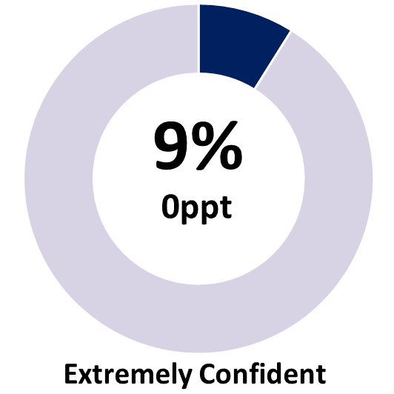 | 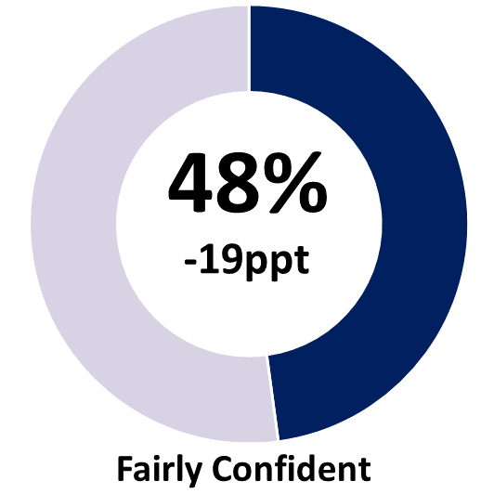 | 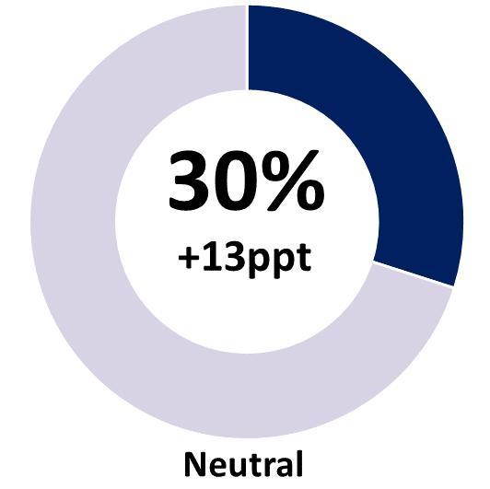
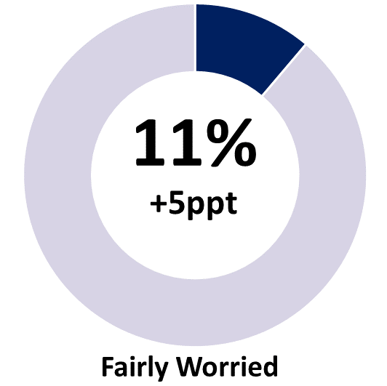 | 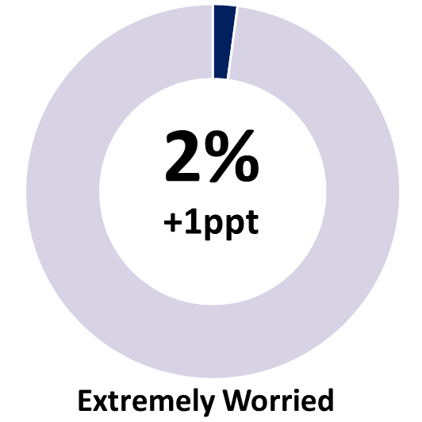 | 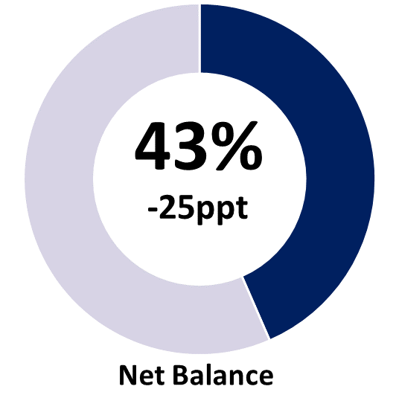
Note: Individual categories may not add to the net balance figure due to rounding.

Average annual business confidence remains high
The proportion of ‘extremely confident’ businesses was unchanged in the quarter at 9%, with a sharp decline in ‘fairly confident’ businesses (down by 19 ppt to 48%) driving the drop, with most transferring to a ‘neutral’ rating and some to the ‘fairly worried’ rating (Chart 1). Average business confidence across 2022-23 was +66%, slightly above 2021-22 and the highest in the series (Chart 2).
Chart 1
Business confidence by quarter (%)
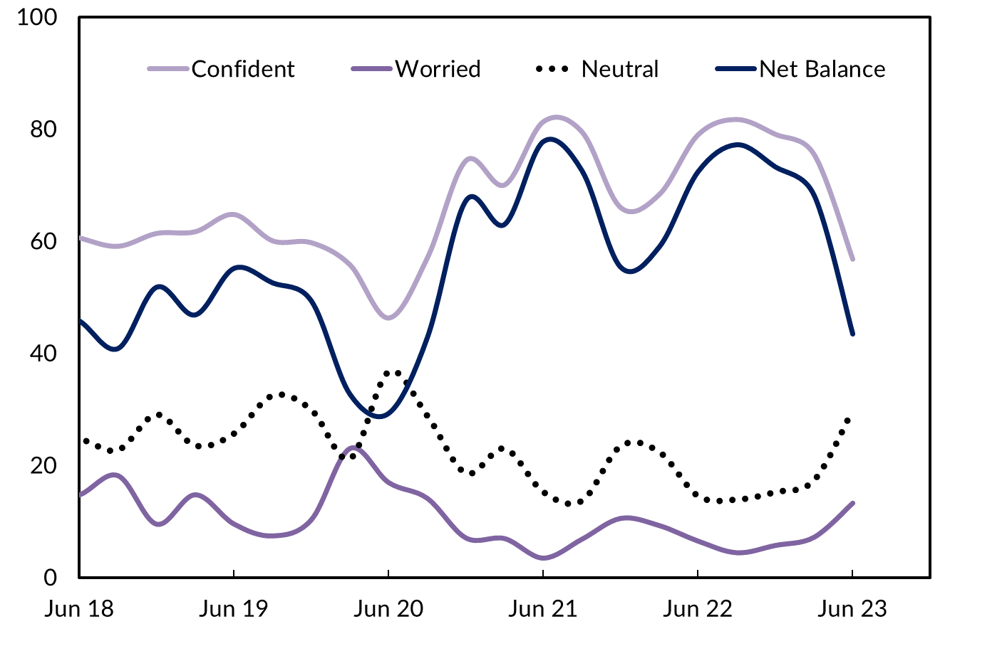
Chart 2
Average business confidence by financial year (%)
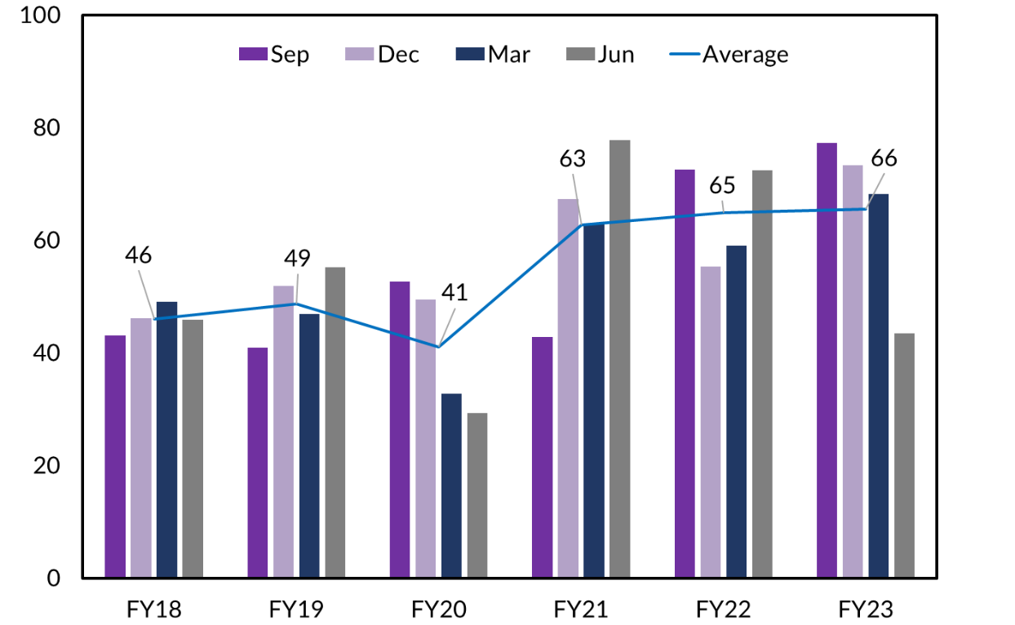

Business performance decreased this quarter
When asked ‘How’s your business performing this year compared to last year?’, 45% of businesses responded with ‘better’, representing a 9 ppt decrease from March quarter 2023 and a 16 ppt decrease from June quarter 2022 (Table 2).
Table 2: Business performance compared to last year
 | Jun qtr 2023 | Quarterly change | Annual change*
Better | 45% | -9ppt | -16ppt
Same | 35% | +2ppt | +7ppt
Worse | 20% | +8ppt | +9ppt
*Current quarter compared with the same quarter in the previous year.
Figure 2: Responses to the business performance question and quarterly change
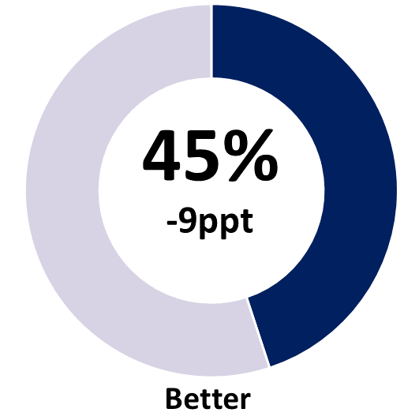 | 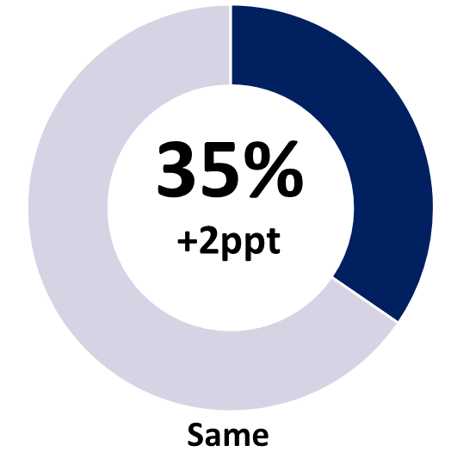 | 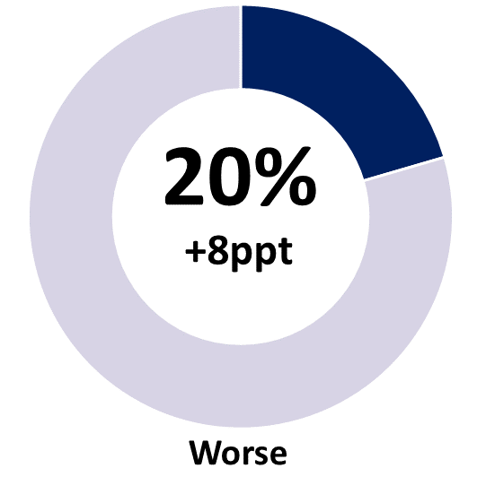
Note: Individual categories may not sum to 100 due to rounding.
Businesses stating performance this year is worse than last year increased by 8 ppt to 20% in the June quarter, the highest level since 2020 (Chart 3). This follows a 6 ppt increase the previous quarter (March 2023) coming off the low point in the series (7% in the December quarter 2022).
Chart 3
Business performance – comparing this year to last – by quarter (%)
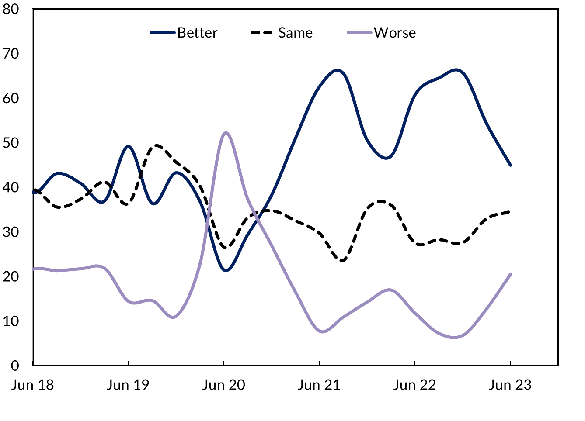

Customer relations and business opportunities drive confidence
Consistent with recent quarters, the key reasons cited for business confidence in the June quarter 2023 were ‘strong customer relations’, ‘business opportunity’ and ‘strong market position’ (Chart 4). Around 35% of businesses cited ‘business opportunity’ as a reason for confidence this quarter, in line with the historical average, but down from the high point in the series one year ago (49%). This is consistent with Territory final demand growth – still positive but moderating in 2023 after strong growth in 2022 (Chart 5).
Chart 4
Reasons for confidence cited, share of businesses (%)
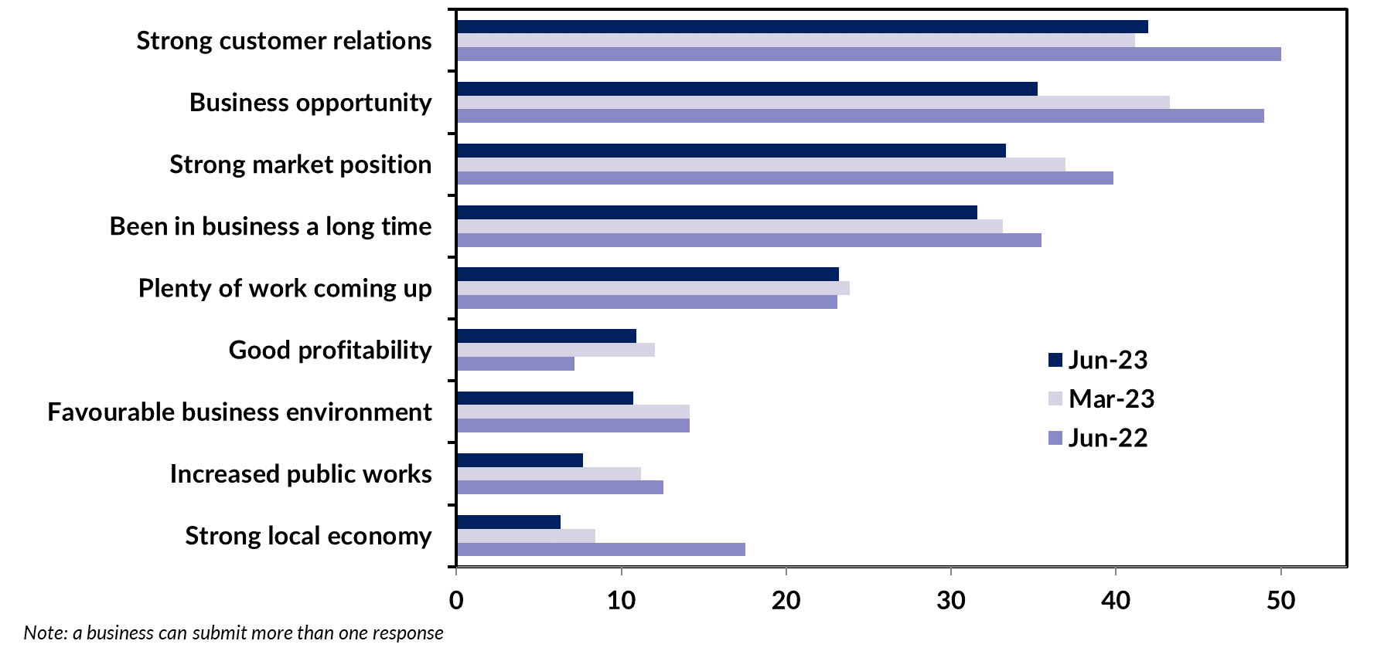

In the June quarter 2023, 23% of businesses reported ‘plenty of work coming up’ as a reason to be confident, which is consistent with the Territory’s final demand results in the year to March, including increases in private investment (7.9%) and public investment (14.3%). Further, building work yet to be done – a forward indicator of construction activity – has been trending up since 2020 and was valued at $1.14 billion in the March quarter, strongly supported by non-residential works (Chart 6).
Chart 5  Territory state final demand  Component contribution, year-on-year growth (%) | Chart 6  Value of building work yet to be done  Quarterly, current prices ($M)

Labour shortages and rising costs are concerns
A ‘lack of suitably skilled workers’ remains the most commonly cited reason for concern in the June quarter 2023, though this has eased significantly from the previous quarter and the year prior (Chart 7). These response levels are consistent with ABS reported job vacancies, which have fallen from the peak in early 2022, but are still well above the historical average (Chart 8).
Chart 7
Reasons for worry cited, share of businesses (%)
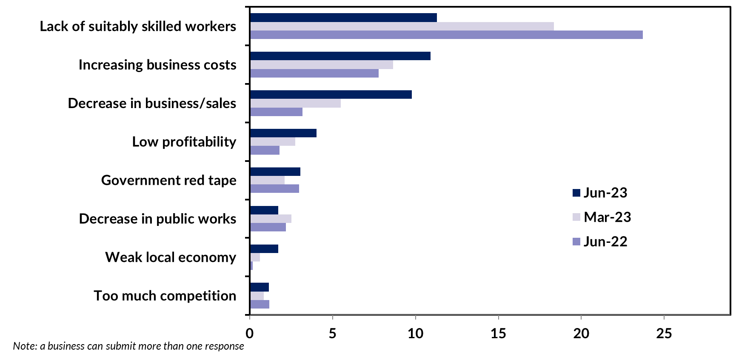
Almost 11% of businesses cited ‘increasing business costs’ as a reason for being worried, an increase in both quarterly and through the year terms, and the highest level observed in the series. Supply chain disruption and higher fuel prices resulting from the return of global demand have contributed to the increased cost of raw materials. Industries in Australia such as manufacturing have faced heightened costs for inputs to production, notably for imported materials (Chart 9), that have been passed on to consumers and businesses. However, following two years of significant growth, the World Bank expects commodity prices overall to decrease by 21% in 2023 before stabilising in 2024.
Chart 8  Job vacancies and ‘labour concerns’  Vacancies (000); share of businesses (%) | Chart 9  Input prices to manufacturing  Year-on-year growth (%)

Business confidence and performance vary among the regions
Business confidence and performance varies by region (Table 3). Business confidence was highest in the Barkly region in the June quarter with a net balance of +75%. Daly-Tiwi-East Arnhem region recorded a 7 ppt increase in business confidence to +68%, supported by 61% of businesses in the region reporting better performance on a year ago, an increase of 25 ppt from the previous quarter.
Business confidence in Greater Darwin declined by 29 ppt in the quarter to a net balance of +39%, the weakest level observed since the onset of the pandemic. 43% of Darwin businesses reported better performance compared to last year, a decrease of 11 ppt in the quarter and 18 ppt annually. Macroeconomic conditions have affected consumer sentiment and business confidence broadly across the Territory, while local factors have also had an immediate and significant impact in Darwin. The Territory Government is investigating options to address these local issues so it is unclear if the sudden decrease in confidence in the June quarter 2023 will be enduring.
Business confidence in Alice Springs declined by 6 ppt this quarter to a net balance of +66%, though this is still coming off the record high of +94% observed in the December quarter 2022.
Table 3: Business confidence and performance by region
Business Confidence |  |  |  |  | Business Performance
 | Jun qtr 2023 | Quarterly change | Annual change |  |  | Jun qtr 2023 | Quarterly change | Annual change
Territory-wide (n=522) |  |  |  |  | Territory-wide (n=522)
Confident | 57% | -19ppt | -22ppt |  | Better | 45% | -9ppt | -16ppt
Worried | 13% | +6ppt | +7ppt |  | Same | 35% | +2ppt | +7ppt
Net Balance | 43% | -25ppt | -29ppt |  | Worse | 20% | +8ppt | +9ppt
Greater Darwin (n=224) |  |  |  |  | Greater Darwin (n=224)
Confident | 53% | -22ppt | -21ppt |  | Better | 43% | -11ppt | -18ppt
Worried | 14% | +8ppt | +7ppt |  | Same | 35% | +3ppt | +9ppt
Net Balance | 39% | -29ppt | -28ppt |  | Worse | 21% | +8ppt | +9ppt
Daly-Tiwi-West Arnhem (n=41) |  |  |  |  | Daly-Tiwi-West Arnhem (n=41)
Confident | 71% | -3ppt | -14ppt |  | Better | 61% | +25ppt | +17ppt
Worried | 2% | -10ppt | -12ppt |  | Same | 24% | -24ppt | -16ppt
Net Balance | 68% | +7ppt | -2ppt |  | Worse | 15% | -1ppt | 0ppt
East Arnhem (n=37) |  |  |  |  | East Arnhem (n=37)
Confident | 62% | +2ppt | -20ppt |  | Better | 33% | -27ppt | +4ppt
Worried | 14% | 0ppt | +4ppt |  | Same | 44% | +18ppt | +15ppt
Net Balance | 49% | +2ppt | -24ppt |  | Worse | 22% | +9ppt | -19ppt
Katherine (n=16) |  |  |  |  | Katherine (n=16)
Confident | 56% | -17ppt | -24ppt |  | Better | 56% | -12ppt | +32ppt
Worried | 25% | +15ppt | +21ppt |  | Same | 6% | -8ppt | -58ppt
Net Balance | 31% | -32ppt | -45ppt |  | Worse | 38% | +20ppt | +26ppt
Barkly (n=44) |  |  |  |  | Barkly (n=44)
Confident | 80% | -20ppt | -9ppt |  | Better | 52% | +19ppt | -2ppt
Worried | 5% | +5ppt | +5ppt |  | Same | 30% | -37ppt | +2ppt
Net Balance | 75% | -25ppt | -14ppt |  | Worse | 18% | +18ppt | 0ppt
Alice Springs (n=160) |  |  |  |  | Alice Springs (n=160)
Confident | 71% | -8ppt | -12ppt |  | Better | 46% | -6ppt | -11ppt
Worried | 5% | -2ppt | -1ppt |  | Same | 44% | +8ppt | +14ppt
Net Balance | 66% | -6ppt | -11ppt |  | Worse | 10% | -2ppt | -3ppt
Note: Caution should be taken when interpreting these results as the sample size in some regions may be relatively small.

Business confidence varies across industries
Out of the 10 industries with the largest number of respondents, confidence varied from Administrative and Support Services reporting a net balance of +83%, an increase of 43 ppt on last quarter, to Retail Trade at +35% (Chart 10).
Business confidence edged down across many industries in the June quarter 2023, most notably in the customer-facing sectors including Retail Trade, Accommodation and Food Services and Other Services. The combined impact of persisting inflation, interest rate hikes and concerns around anti-social behaviour likely contributed to a decrease in the number of tourist visitations. Tourism NT reports the Territory’s hotel occupancy rate was 60% in May 2023, down by 14 ppt compared with May 2022.
The Territory’s construction industry recorded a solid net balance of +78% this quarter, with no businesses reporting as ‘worried’ (down from 6% last quarter), supported by the significant pipeline of work.
The Agriculture, Forestry and Fishing industry reported a net balance of +73% this quarter, also with no businesses reporting as ‘worried’, a significant turnaround of 44 ppt from the March quarter. The boost in confidence coincided with the release of the Territory Government’s Agribusiness 2030 Strategy, a focussed commitment to transform it into a $2 billion industry by 2030.
Chart 10
Business confidence responses by industry (%)
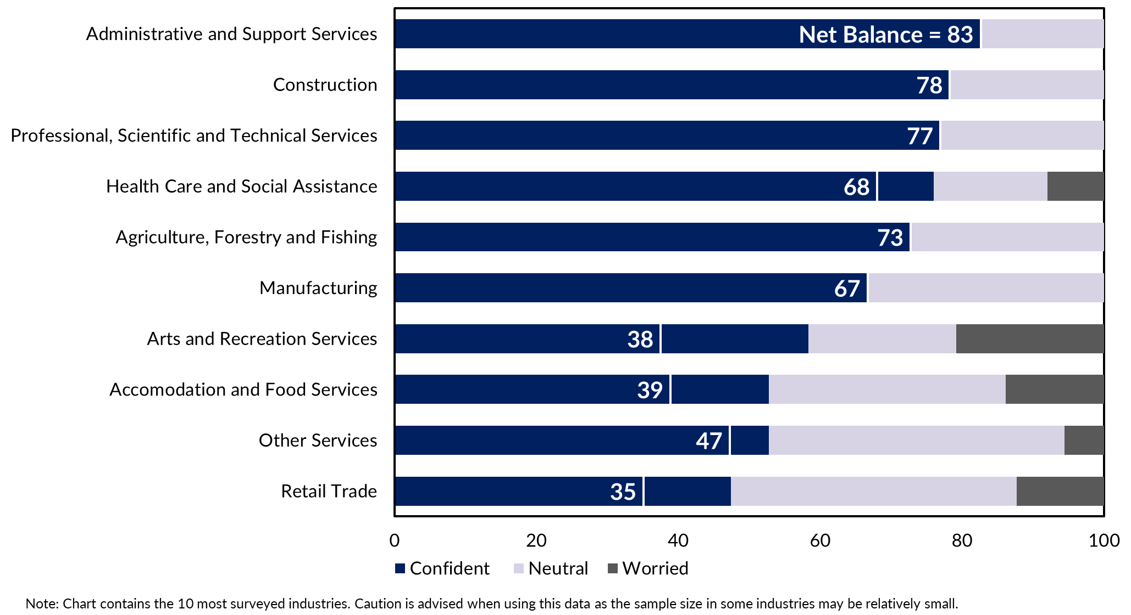

Appendix

Methodology
The Department of Industry, Tourism and Trade conducts a survey of businesses operating in the Territory on a quarterly basis. The results have been used to construct a business confidence index.
The business confidence index is calculated as the difference between the proportion of businesses that are ‘confident about their business prospects for the next 12 months' and the proportion of businesses that are ‘worried about their business prospects for the next 12 months’ (net balance approach).
The Territory-wide confidence index is weighted to account for the number of businesses in each region. The weighted result provides a more balanced reflection of overall business confidence. Business confidence results are also presented by region and industry.
522 businesses were surveyed this quarter out of 15,777 operating businesses in the Territory (Table 4). For the sample survey to achieve a 95% confidence level with a margin of error of 5%, 376 survey responses are required.
Table 4: Survey Numbers
Region | Total number of businesses | Businesses surveyed | Proportion of total
Greater Darwin | 11,577 | 224 | 1.9%
Daly-Tiwi-West Arnhem | 378 | 41 | 10.8%
East Arnhem | 241 | 37 | 15.4%
Katherine | 960 | 16 | 1.7%
Barkly | 193 | 44 | 22.8%
Alice Springs | 2,034 | 160 | 7.9%
Total | 15,777 | 522 | 3.3%

