Mineral Titles Act 2010
NOTICE OF LAND CEASING TO BE A MINERAL TITLE APPLICATION AREA
Title Type and Number: | Exploration Licence 33053
Area Ceased on: | 12 September 2022
Area: | 201 Blocks, 656.05 km²
Locality: | MONMOONA
Name of Applicant(s)/Holder(s): | 100% MAG RESOURCES PTY LTD [ACN. 655 505 730]
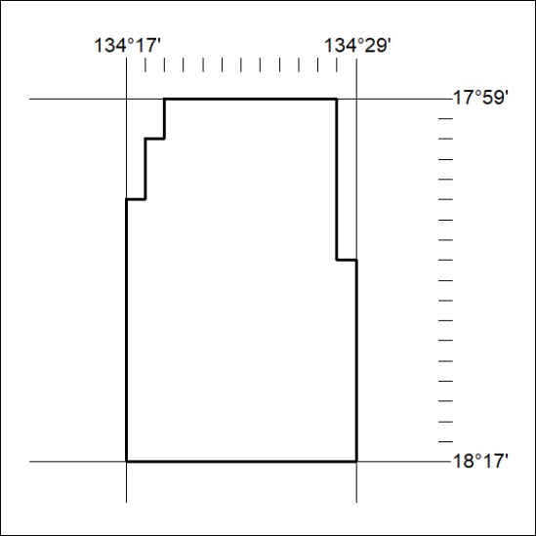

321/22

Mineral Titles Act
NOTICE OF GRANT OF A MINERAL TITLE
Title Type and Number: | Exploration Licence 33109
Granted: | 12 September 2022, for a period of 6 Years
Area: | 8 Blocks, 25.28 km²
Locality: | QUARTZ
Name of Holder/s: | 100% PROSPECT ORES PTY LTD [ACN. 645 015 818]
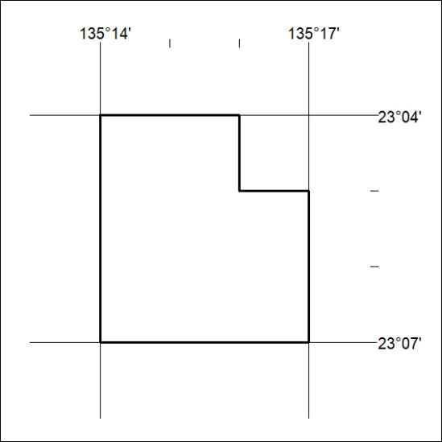
Area granted is indicated above. The titleholder is not permitted to exercise occupational rights on any land that is subject to a development title, or an application for a development title. Any land the subject of a Reserved Land gazettal under the Mineral Titles Act and all land vested in the Commonwealth of Australia is also excluded by description but not excised from the grant area.

322/22

