Mineral Titles Act
NOTICE OF GRANT OF A MINERAL TITLE
Title Type and Number: | Mineral Authority 30421
Granted: | 30 August 2022, for a period of 5 Years
Area: | 6.46 Hectares
Locality: | GOVE
Name of Holder/s: | 100% RIRRATJINGU ABORIGINAL CORPORATION
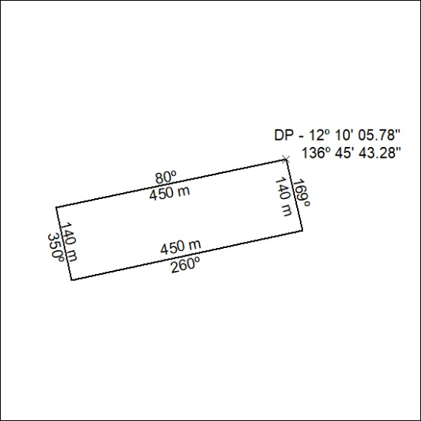

306/22

Mineral Titles Act
NOTICE OF GRANT OF A MINERAL TITLE
Title Type and Number: | Exploration Licence 32918
Granted: | 30 August 2022, for a period of 6 Years
Area: | 36 Blocks, 114.02 km²
Locality: | JERVOIS RANGE
Name of Holder/s: | 100% WRIGHT Anthony
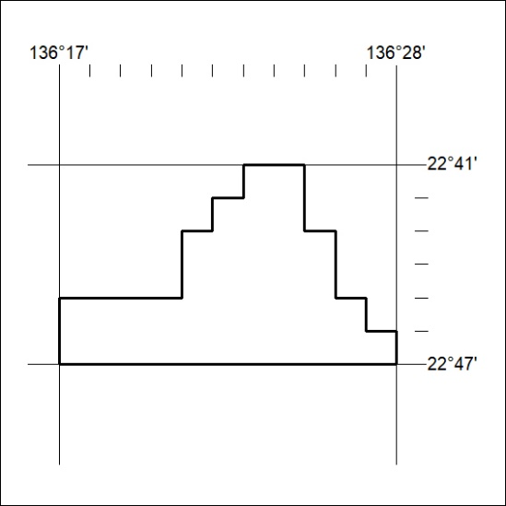
Area granted is indicated above. The titleholder is not permitted to exercise occupational rights on any land that is subject to a development title, or an application for a development title. Any land the subject of a Reserved Land gazettal under the Mineral Titles Act and all land vested in the Commonwealth of Australia is also excluded by description but not excised from the grant area.

307/22

