Mineral Titles Act 2010
NOTICE OF LAND CEASING TO BE A MINERAL TITLE AREA
Title Type and Number: | Exploration Licence 32089
Area Ceased on: | 16 November 2021
Area: | 125 Blocks, 394.59 km²
Locality: | QUARTZ
Name of Applicant(s)/Holder(s): | 100% TYPHON MINERALS PTY LTD [ACN. 614 887 464]
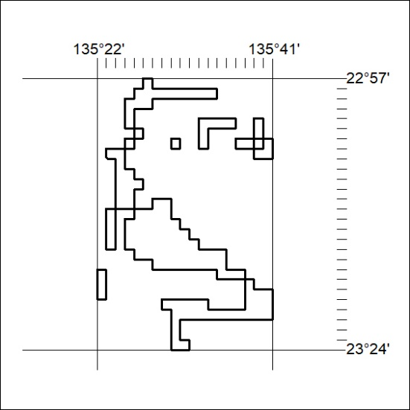

427/21

Mineral Titles Act 2010
NOTICE OF LAND CEASING TO BE A MINERAL TITLE APPLICATION AREA
Title Type and Number: | Exploration Licence 32785
Area Ceased on: | 17 November 2021
Area: | 128 Blocks, 361.07 km²
Locality: | QUARTZ
Name of Applicant(s)/Holder(s): | 100% SHREE MINERALS LIMITED [ACN. 130 618 683]
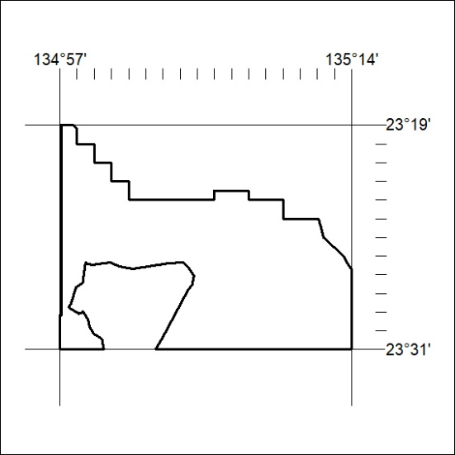

428/21

