Mineral Titles Act
NOTICE OF GRANT OF A MINERAL TITLE
Title Type and Number: | Exploration Licence 32644
Granted: | 21 September 2021, for a period of 6 Years
Area: | 242 Blocks, 751.91 km²
Locality: | ENGOORDINA
Name of Holder/s: | 100% TRI-STAR ENERGY COMPANY [ACN. 089 539 695]
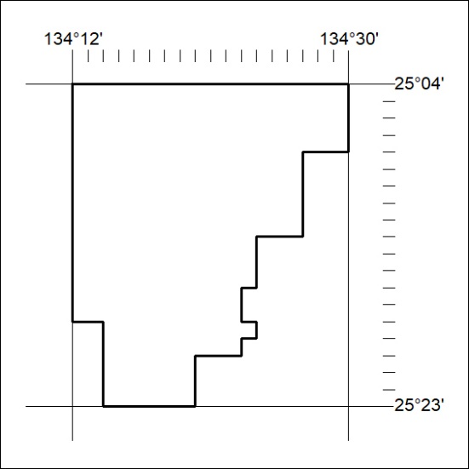
Area granted is indicated above. The titleholder is not permitted to exercise occupational rights on any land that is subject to a development title, or an application for a development title. Any land the subject of a Reserved Land gazettal under the Mineral Titles Act and all land vested in the Commonwealth of Australia is also excluded by description but not excised from the grant area.
358/21

Mineral Titles Act
NOTICE OF GRANT OF A MINERAL TITLE
Title Type and Number: | Exploration Licence 32645
Granted: | 21 September 2021, for a period of 6 Years
Area: | 250 Blocks, 775.09 km²
Locality: | ENGOORDINA
Name of Holder/s: | 100% TRI-STAR ENERGY COMPANY [ACN. 089 539 695]
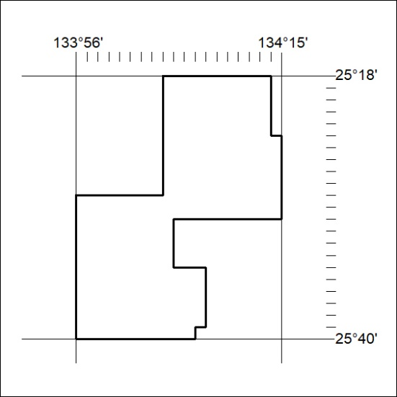
Area granted is indicated above. The titleholder is not permitted to exercise occupational rights on any land that is subject to a development title, or an application for a development title. Any land the subject of a Reserved Land gazettal under the Mineral Titles Act and all land vested in the Commonwealth of Australia is also excluded by description but not excised from the grant area.
359/21

Mineral Titles Act
NOTICE OF GRANT OF A MINERAL TITLE
Title Type and Number: | Exploration Licence 32646
Granted: | 21 September 2021, for a period of 6 Years
Area: | 220 Blocks, 673.51 km²
Locality: | UMBEARA
Name of Holder/s: | 100% TRI-STAR ENERGY COMPANY [ACN. 089 539 695]
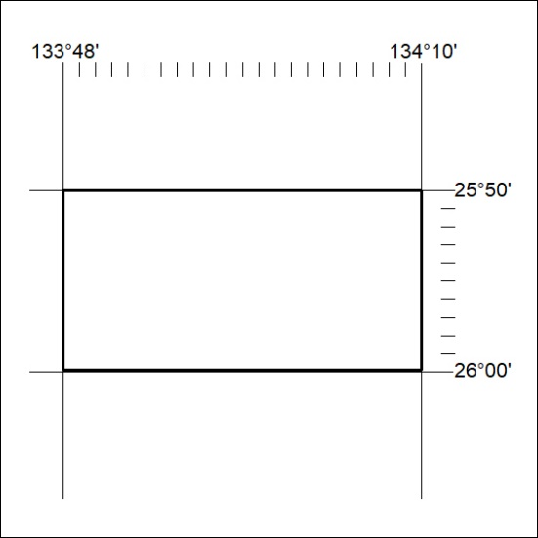
Area granted is indicated above. The titleholder is not permitted to exercise occupational rights on any land that is subject to a development title, or an application for a development title. Any land the subject of a Reserved Land gazettal under the Mineral Titles Act and all land vested in the Commonwealth of Australia is also excluded by description but not excised from the grant area.
360/21

Mineral Titles Act
NOTICE OF GRANT OF A MINERAL TITLE
Title Type and Number: | Exploration Licence 32647
Granted: | 21 September 2021, for a period of 6 Years
Area: | 249 Blocks, 770.55 km²
Locality: | BEDDOME
Name of Holder/s: | 100% TRI-STAR ENERGY COMPANY [ACN. 089 539 695]
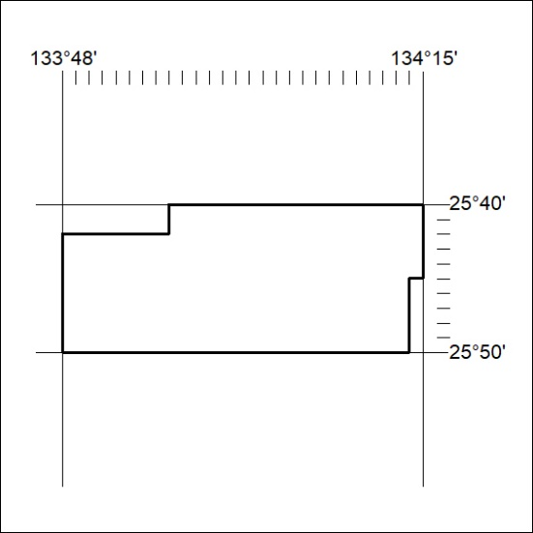
Area granted is indicated above. The titleholder is not permitted to exercise occupational rights on any land that is subject to a development title, or an application for a development title. Any land the subject of a Reserved Land gazettal under the Mineral Titles Act and all land vested in the Commonwealth of Australia is also excluded by description but not excised from the grant area.
361/21

