EconNotes

NT business count, entries and exits, 2021 – PART A
1. Introduction
- In 2021, unlike releases in previous years, the Australian Bureau of Statistics releases the annual Count of Australian Businesses, including entries and exits 2020-21 in two lots.
- The first set of data was released on 24 August 2021. This contains macro-level counts of actively trading businesses, rates of entry to and exit from the market sector of the economy, and rates of business survival at the Australia and state/territory levels. Quarterly experimental counts of Australian businesses for the five quarters ending June 2021, have also been included in this release.
- The second release is scheduled in December 2021. This will include more detailed business count data (business size, turnover, business by industry at state/territory level and regional data) and the interactive maps.
2. Business counts 2021
- There were 14 947 actively trading businesses in the Territory as at June 2021, an increase of 407 (2.8%) compared to June 2020 (Chart 1). At the national level, there were 2 402 254 actively trading businesses, an increase of 3.8% (Fig.1).
- The quarterly data for the five quarters from June 2020 to June 2021 show that the Territory business count fell in the December quarter 2020 but registered positive growth in all other quarters.
- The Territory businesses represent about 0.6% of the total Australian businesses.
- In 2020-21, there were 2257 business entries (entry rate of 15.5%), and 1792 business exits (exit rate of 12.3%). The business exit rate in the Territory was marginally lower than the exit rate in the previous year. The business entry rate, on the other hand, increased by 5 percentage points from the previous year. The Territory’s entry and exit rates are similar to the national average in 2020-21.
3. Business survival rates
- Almost two-thirds of all the Territory businesses that were operating in June 2017 are still operating in June 2021. Of all the Territory businesses operating in June 2017, 87.2% survived to June 2018, 77.6% survived to June 2019, 70.4% survived to June 2020, and 64.8% survived to June 2021 (Chart 2). Survival rate of Territory businesses were comparable to the national survival rate (Chart 3),
- Almost half of all the Territory businesses that commenced operations (new entries) in 2017-18 did not survive to June 2021, lowest of all the jurisdictions. Of the Territory businesses that started operations in 2017-18, 75.2% survived to June 2019, 58.6% survived to June 2020 and 50.6% to June 2021 (Charts 4 and 5).
Chart 1: Territory Business Count, June 2018 to June 2021 |  | Fig 1: Business Count, Australia June 2021
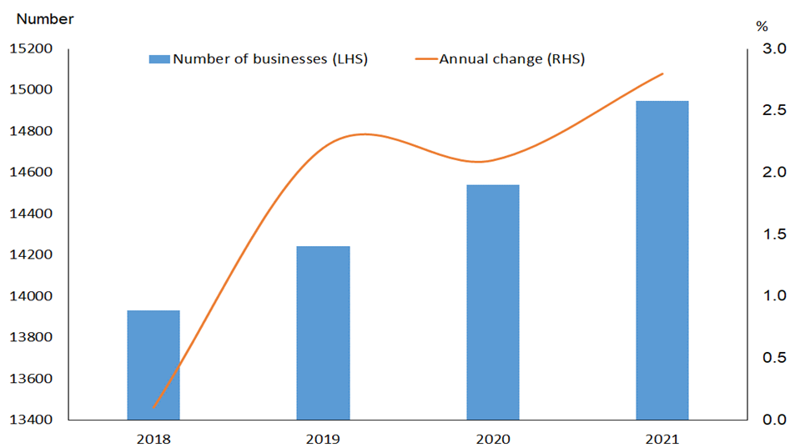 |  | 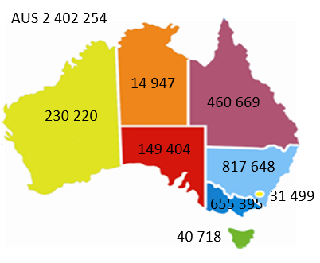
Chart 2: Survival in June 2021 of all Territory businesses operating in June 2017 |  | Chart 3: Jurisdictional comparison of survival rates in 2021 of all businesses that were operating in 2017
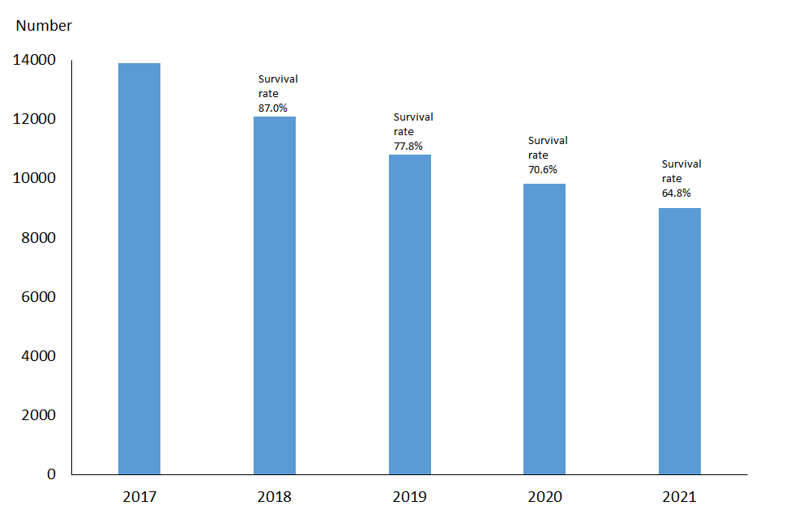 |  | 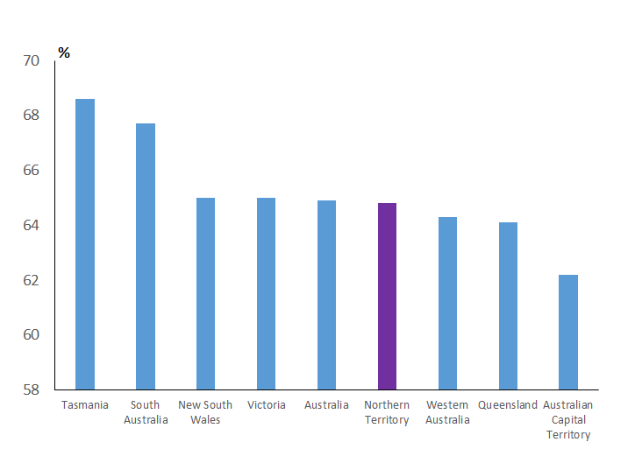
Chart 4: Survival rates of businesses that commenced operations in 2018 |  | Chart 5: Jurisdictional comparison of survival rates in 2021 of businesses that commenced operations in 2018
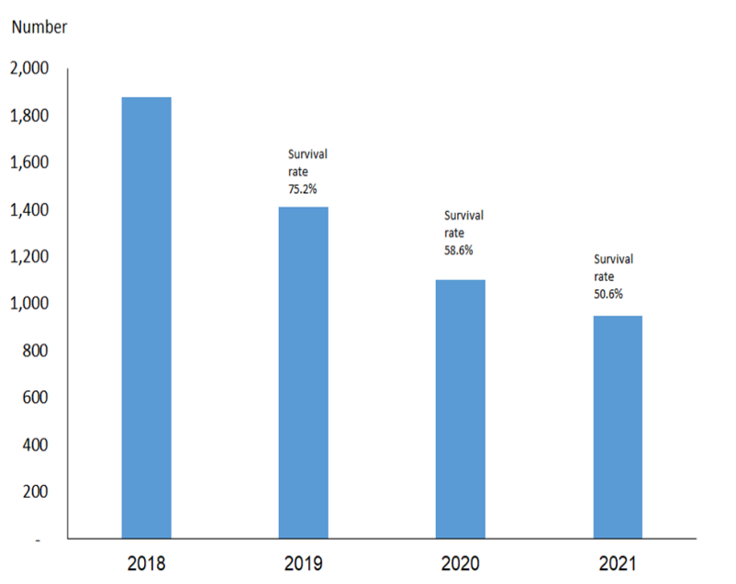 |  | 