Mineral Titles Act
NOTICE OF GRANT OF A MINERAL TITLE
Title Type and Number: | Exploration Licence 32317
Granted: | 02 June 2021, for a period of 6 Years
Area: | 235 Blocks, 738.60 km²
Locality: | BOREE
Name of Holder/s: | 100% BAUDIN RESOURCES PTY LTD [ACN. 618 455 593]
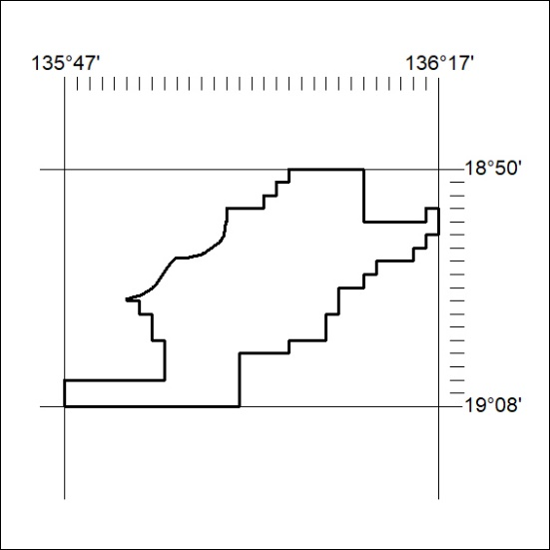
Area granted is indicated above. The titleholder is not permitted to exercise occupational rights on any land that is subject to a development title, or an application for a development title. Any land the subject of a Reserved Land gazettal under the Mineral Titles Act and all land vested in the Commonwealth of Australia is also excluded by description but not excised from the grant area.
196/21

Mineral Titles Act
NOTICE OF GRANT OF A MINERAL TITLE
Title Type and Number: | Exploration Licence 32338
Granted: | 02 June 2021, for a period of 6 Years
Area: | 250 Blocks, 783.50 km²
Locality: | MITTIEBAH
Name of Holder/s: | 100% BAUDIN RESOURCES PTY LTD [ACN. 618 455 593]
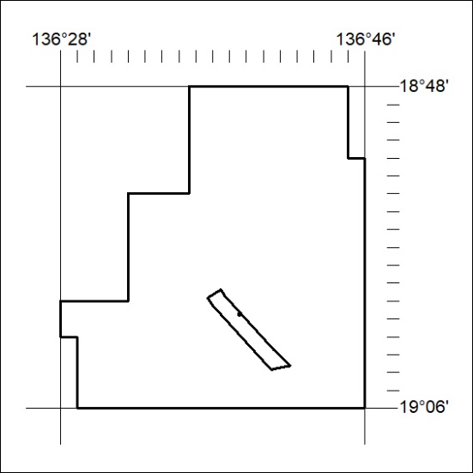
Area granted is indicated above. The titleholder is not permitted to exercise occupational rights on any land that is subject to a development title, or an application for a development title. Any land the subject of a Reserved Land gazettal under the Mineral Titles Act and all land vested in the Commonwealth of Australia is also excluded by description but not excised from the grant area.
197/21

Mineral Titles Act
NOTICE OF GRANT OF A MINERAL TITLE
Title Type and Number: | Exploration Licence 32339
Granted: | 02 June 2021, for a period of 6 Years
Area: | 250 Blocks, 791.42 km²
Locality: | BOREE
Name of Holder/s: | 100% BAUDIN RESOURCES PTY LTD [ACN. 618 455 593]
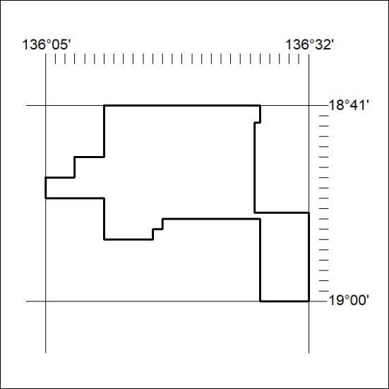
Area granted is indicated above. The titleholder is not permitted to exercise occupational rights on any land that is subject to a development title, or an application for a development title. Any land the subject of a Reserved Land gazettal under the Mineral Titles Act and all land vested in the Commonwealth of Australia is also excluded by description but not excised from the grant area.
198/21

