Mineral Titles Act
NOTICE OF LAND CEASING TO BE A MINERAL TITLE
Title Type and Number: | Mineral Lease (Central) 204
Area ceased on: | 05 June 2018
Area: | 16.00 Hectare
Locality: | TENNANT CREEK
Name of Applicants(s)Holder(s): | 100% SANTEXCO PTY LTD [ACN. 002 910 296]
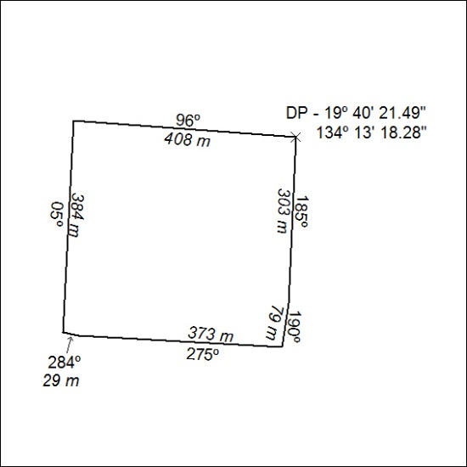

248/18

Mineral Titles Act
NOTICE OF LAND CEASING TO BE A MINERAL TITLE
Title Type and Number: | Mineral Lease (Central) 205
Area ceased on: | 05 June 2018
Area: | 16.00 Hectare
Locality: | TENNANT CREEK
Name of Applicants(s)Holder(s): | 100% SANTEXCO PTY LTD [ACN. 002 910 296]
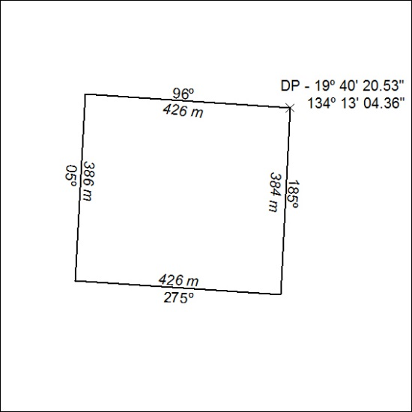

249/18

Mineral Titles Act
NOTICE OF LAND CEASING TO BE A MINERAL TITLE
Title Type and Number: | Mineral Lease (Central) 206
Area ceased on: | 05 June 2018
Area: | 17.00 Hectare
Locality: | TENNANT CREEK
Name of Applicants(s)Holder(s): | 100% SANTEXCO PTY LTD [ACN. 002 910 296]
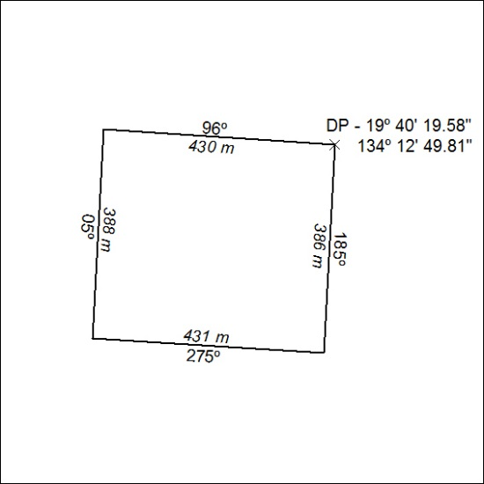

250/18

Mineral Titles Act
NOTICE OF LAND CEASING TO BE A MINERAL TITLE
Title Type and Number: | Mineral Lease (Central) 207
Area ceased on: | 05 June 2018
Area: | 14.00 Hectare
Locality: | TENNANT CREEK
Name of Applicants(s)Holder(s): | 100% SANTEXCO PTY LTD [ACN. 002 910 296]
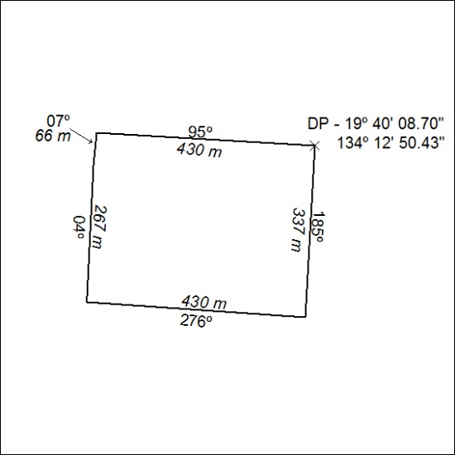

251/18

Mineral Titles Act
NOTICE OF LAND CEASING TO BE A MINERAL TITLE
Title Type and Number: | Mineral Lease (Central) 208
Area ceased on: | 05 June 2018
Area: | 16.00 Hectare
Locality: | TENNANT CREEK
Name of Applicants(s)Holder(s): | 100% SANTEXCO PTY LTD [ACN. 002 910 296]
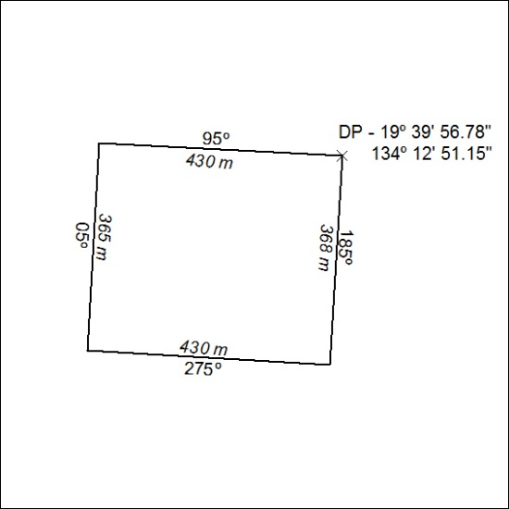

252/18

Mineral Titles Act
NOTICE OF LAND CEASING TO BE A MINERAL TITLE
Title Type and Number: | Mineral Lease (Central) 209
Area ceased on: | 05 June 2018
Area: | 16.00 Hectare
Locality: | TENNANT CREEK
Name of Applicants(s)Holder(s): | 100% SANTEXCO PTY LTD [ACN. 002 910 296]
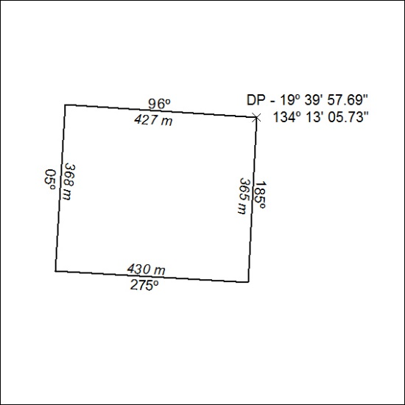

253/18

Mineral Titles Act
NOTICE OF LAND CEASING TO BE A MINERAL TITLE
Title Type and Number: | Mineral Lease (Central) 634
Area ceased on: | 05 June 2018
Area: | 8.00 Hectare
Locality: | TENNANT CREEK
Name of Applicants(s)Holder(s): | 100% GIANTS REEF EXPLORATION PTY LTD* [ACN. 009 200 346]
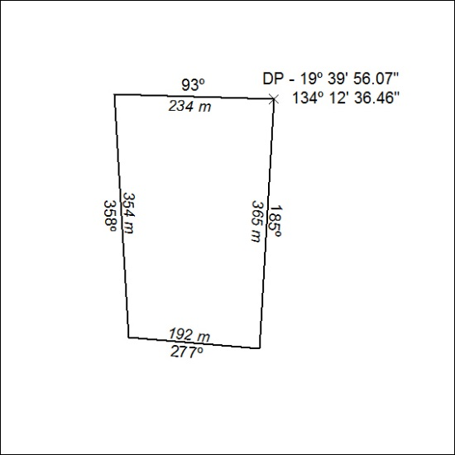

254/18

Mineral Titles Act
NOTICE OF LAND CEASING TO BE A MINERAL TITLE AREA
Title Type and Number: | Exploration Licence 31471
Area Ceased on: | 07 June 2018
Area: | 24 Blocks, 80.16 km²
Locality: | McKINLAY RIVER
Name of Applicant(s)/Holder(s): | 100% BACCHUS RESOURCES PTY LTD [ACN. 606 340 872]
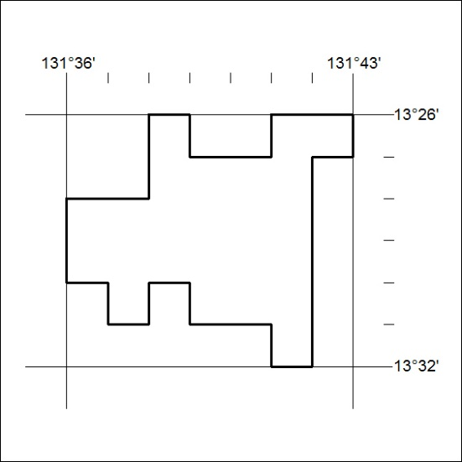
(Area now amalgamated into Exploration Licence 31471 under s102 – EL moratorium period does not apply

255/18

Mineral Titles Act
NOTICE OF LAND CEASING TO BE A MINERAL TITLE AREA
Title Type and Number: | Exploration Licence 31631
Area Ceased on: | 07 June 2018
Area: | 1 Block, 3.34 km²
Locality: | PINE CREEK
Name of Applicant(s)/Holder(s): | 100% BACCHUS RESOURCES PTY LTD [ACN. 606 340 872]
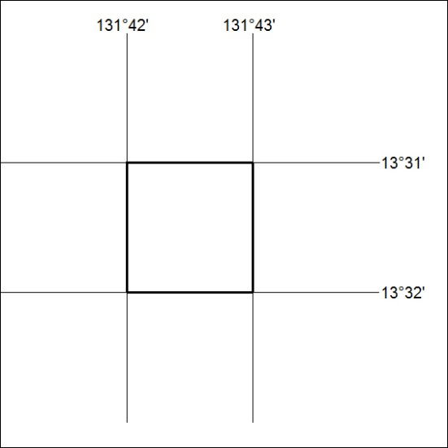
(Area now amalgamated into Exploration Licence 31899 under s102 – EL moratorium period does not apply
256/18

