Mineral Titles Act 2010
NOTICE OF LAND CEASING TO BE A MINERAL TITLE AREA
Title Type and Number: | Exploration Licence 32293
Area Ceased on: | 13 September 2022
Area: | 240 Blocks, 776.77 km²
Locality: | WONARAH
Name of Applicant(s)/Holder(s): | 90% INCA MINERALS LIMITED [ACN. 128 512 907], 5% MRG RESOURCES PTY LTD [ACN. 614 946 164], 5% WEST Jonathan
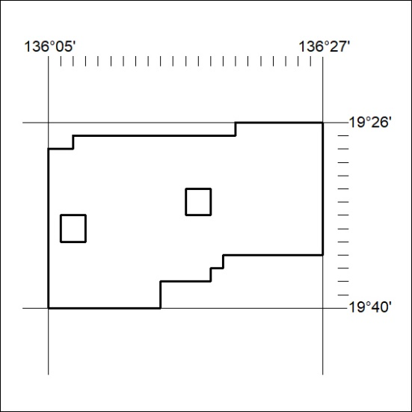
(Area now amalgamated into Exploration Licence 33282 under s102 – EL moratorium period does not apply)
323/22

Mineral Titles Act 2010
NOTICE OF LAND CEASING TO BE A MINERAL TITLE AREA
Title Type and Number: | Exploration Licence 32580
Area Ceased on: | 13 September 2022
Area: | 245 Blocks, 766.00 km²
Locality: | WONARAH
Name of Applicant(s)/Holder(s): | 90% INCA MINERALS LIMITED [ACN. 128 512 907], 5% MRG RESOURCES PTY LTD [ACN. 614 946 164], 5% WEST Jonathan
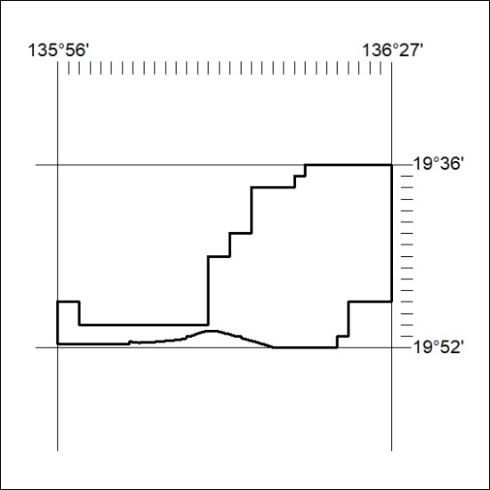
(Area now amalgamated into Exploration Licence 33258 under s102 – EL moratorium period does not apply)
324/22
Mineral Titles Act 2010
NOTICE OF LAND CEASING TO BE A MINERAL TITLE AREA
Title Type and Number: | Exploration Licence 32808
Area Ceased on: | 13 September 2022
Area: | 8 Blocks, 25.89 km²
Locality: | WONARAH
Name of Applicant(s)/Holder(s): | 90% INCA MINERALS LIMITED [ACN. 128 512 907], 5% MRG RESOURCES PTY LTD [ACN. 614 946 164], 5% WEST Jonathan
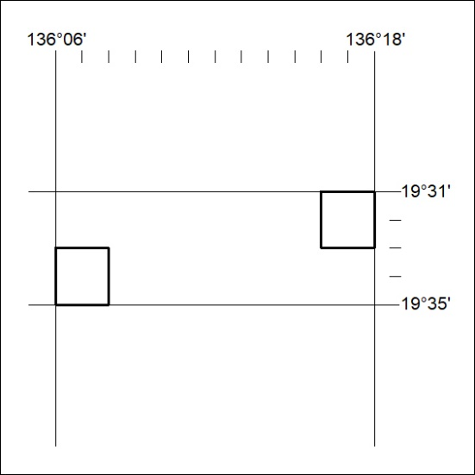
(Area now amalgamated into Exploration Licence 33282 under s102 – EL moratorium period does not apply)
325/22

Mineral Titles Act 2010
NOTICE OF LAND CEASING TO BE A MINERAL TITLE AREA
Title Type and Number: | Exploration Licence 32856
Area Ceased on: | 13 September 2022
Area: | 3 Blocks, .83 km²
Locality: | WONARAH
Name of Applicant(s)/Holder(s): | 90% INCA MINERALS LIMITED [ACN. 128 512 907], 5% MRG RESOURCES PTY LTD [ACN. 614 946 164], 5% WEST Jonathan
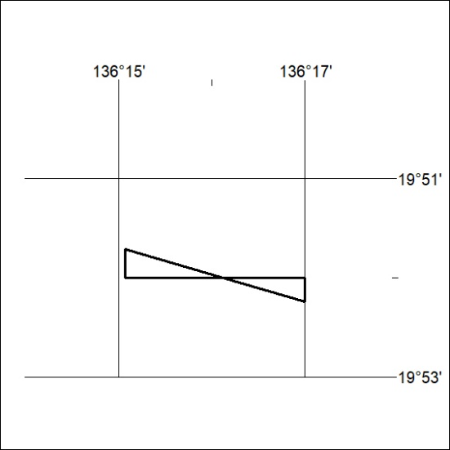
(Area now amalgamated into Exploration Licence 33258 under s102 – EL moratorium period does not apply)
326/22

