# Economic growth

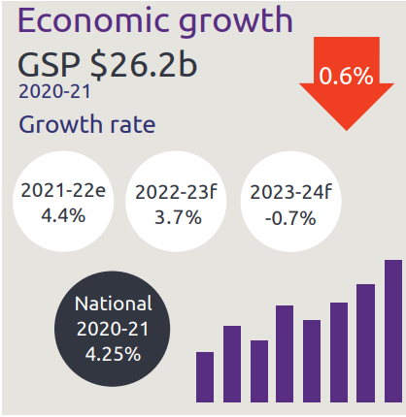

* Economic growth GSP $26.2 billion
* NT growth rate:
  + 2021-22 is 4.4%
  + 2022-23 is 3.7%
  + 2023-24 is -0.7%
* National growth rate in 2020-21 is 4.25%

# Industry share of output top 5

Industry share of output as described below

* Construction is 5.6%
* Mining is 24.6%
* Public admin is 11.9%
* Health is 8.1%
* Education is 4.9%

# State Final Demand

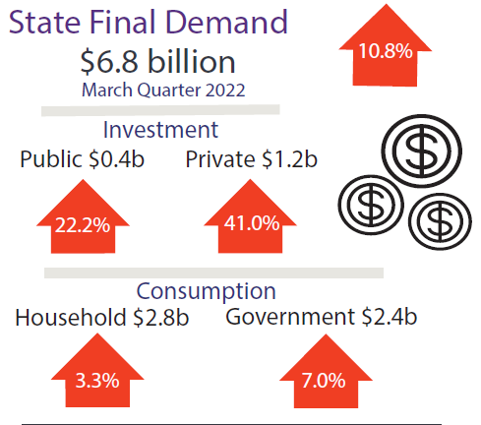

* State Final Demand, up 10.8% to $6.8 billion through the year to March 2022
  + Public investment, up 22.2% to $0.4 billion through the year to March 2022
  + Private business investment, up 41.0% to $1.2 billion through the year to March 2022
  + Household consumption, up 3.3% to $2.8 billion through the year to March 2022
  + Government consumption, up 7% to $2.4 billion through the year to March 2022

# Business confidence for the Northern Territory

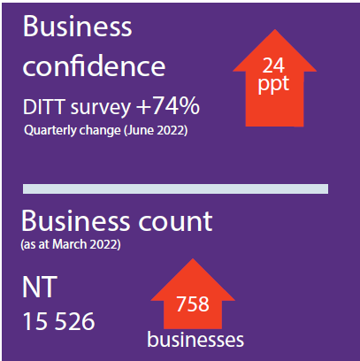

* Business confidence for the Northern Territory is +74% (360 businesses) in the June 2022 quarter, up 24 percentage points from the previous quarter
* Business count as at March 2022 for the Northern Territory was 15,526, up 758 business over the year

# Darwin inflation

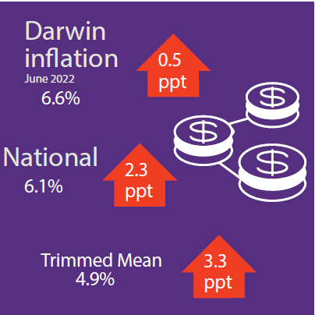

* Darwin inflation decreased 6.6% through the year to June 2022
* National inflation increased 6.1%
* Trimmed mean increased 3.3%

# Labour market

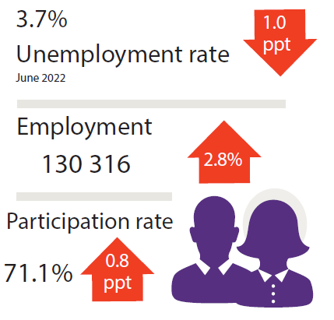

* Unemployment rate is 3.7%
* Employment is 130,316, up 2.8%
* Participation rate was 71.1%, up 0.8 percentage points

# NT population

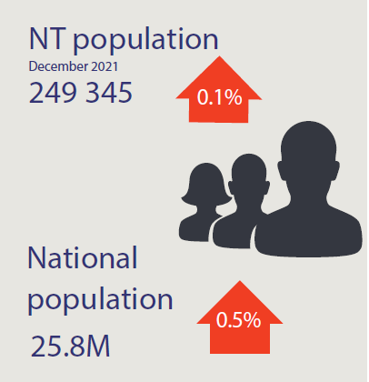

* NT population is 249,345, up 0.1% through the year
* National population is 25.8 million, up 0.5% through the year

# Population distribution

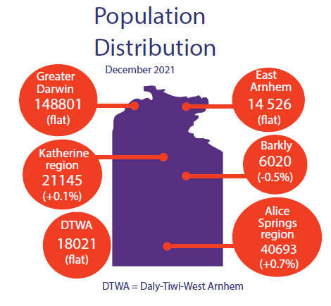

Population distribution:

* Greater Darwin was 148801
* East Arnhem was 14526
* Katherine was 21145
* Alice Springs was 40693
* Barkly was 6020
* Daly-Tiwi-West Arnhem was 18021

# Average weekly earnings

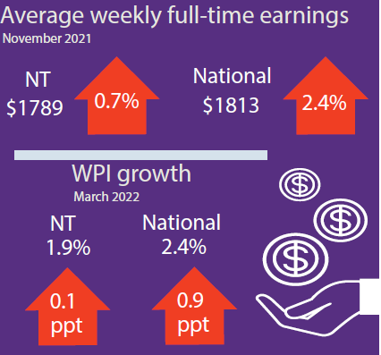

Average weekly earnings in the NT is $1789, up 0.8%, and nationally is $1813, up 2.4%

WPI in the NT increased by 1.9% through the year and 2.4% nationally

# Median house prices

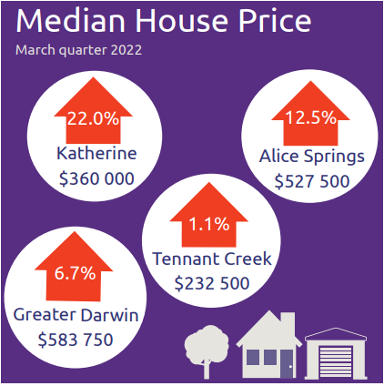

Median house prices in the March quarter 2022:

* Katherine $360,000 up 22.0%
* Alice Springs $527,500 up 12.5%
* Tennant Creek $232,500 up 1.1%
* Greater Darwin $ 583,750 up 6.7%

# Business size

Business size as described below

NT business size:

* Small is 96.7%
* Medium is 3.2%
* Large is 0.1%

# Business location

Business location as described below

Businesses by location:

* Greater Darwin has 72.9%
* Katherine has 6.4%
* Alice Springs has 13.1%
* Rest of NT has 7.6%

NT Department of Industry, Tourism and Trade  
t: 08 8999 5139  
industry.nt.gov.au