Mineral Titles Act 2010
NOTICE OF LAND CEASING TO BE A MINERAL TITLE AREA
Title Type and Number: | Exploration Licence 27979
Area Ceased on: | 03 January 2022
Area: | 24 Blocks, 77.67 km²
Locality: | BUCK
Name of Applicant(s)/Holder(s): | 100% PRODIGY GOLD NL* [ACN. 009 127 020]
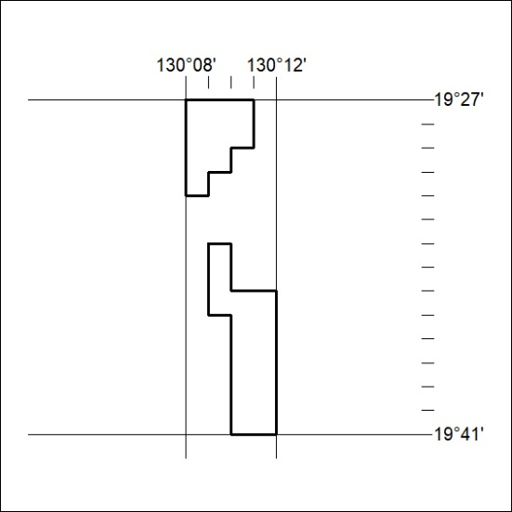

001/22

Mineral Titles Act 2010
NOTICE OF LAND CEASING TO BE A MINERAL TITLE APPLICATION AREA
Title Type and Number: | Extractive Mineral Exploration Licence 32658
Area Ceased on: | 24 December 2021
Area: | 4 Blocks, 13.25 km²
Locality: | DRY RIVER
Name of Applicant(s)/Holder(s): | 100% TERRITORY SANDS PTY LTD [ACN. 632 797 972]
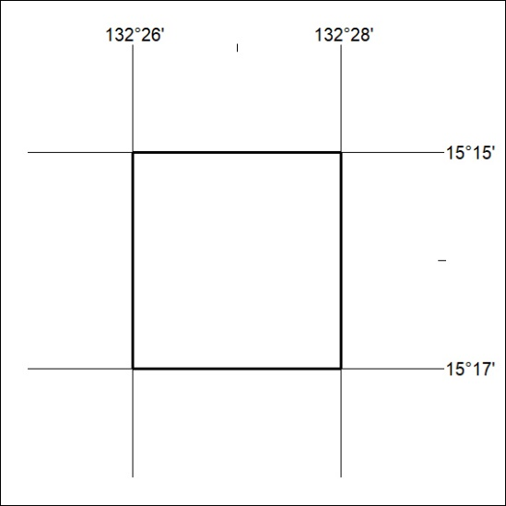

002/22
Mineral Titles Act 2010
NOTICE OF LAND CEASING TO BE A MINERAL TITLE APPLICATION AREA
Title Type and Number: | Extractive Mineral Exploration Licence 32659
Area Ceased on: | 24 December 2021
Area: | 4 Blocks, 13.25 km²
Locality: | DRY RIVER
Name of Applicant(s)/Holder(s): | 100% TERRITORY SANDS PTY LTD [ACN. 632 797 972]
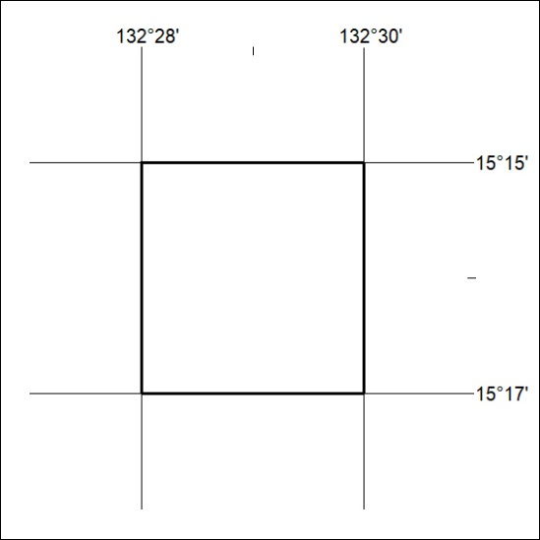

003/22

Mineral Titles Act 2010
NOTICE OF LAND CEASING TO BE A MINERAL TITLE APPLICATION AREA
Title Type and Number: | Extractive Mineral Exploration Licence 32660
Area Ceased on: | 24 December 2021
Area: | 4 Blocks, 13.25 km²
Locality: | ELSEY
Name of Applicant(s)/Holder(s): | 100% TERRITORY SANDS PTY LTD [ACN. 632 797 972]
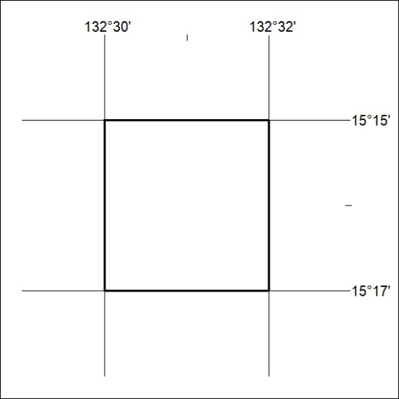

004/22

Mineral Titles Act
NOTICE OF GRANT OF A MINERAL TITLE
Title Type and Number: | Extractive Mineral Exploration Licence 32655
Granted: | 24 December 2021, for a period of 2 Years
Area: | 4 Blocks, 13.13 km²
Locality: | NEWCASTLE WATERS
Name of Holder/s: | 100% TERRITORY SANDS PTY LTD [ACN. 632 797 972]
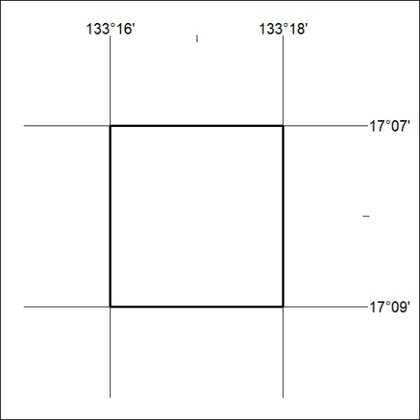
Area granted is indicated above. The titleholder is not permitted to exercise occupational rights on any land that is subject to a development title, or an application for a development title. Any land the subject of a Reserved Land gazettal under the Mineral Titles Act and all land vested in the Commonwealth of Australia is also excluded by description but not excised from the grant area.
005/22

Mineral Titles Act
NOTICE OF GRANT OF A MINERAL TITLE
Title Type and Number: | Extractive Mineral Exploration Licence 32661
Granted: | 24 December 2021, for a period of 2 Years
Area: | 4 Blocks, 13.13 km²
Locality: | NEWCASTLE WATERS
Name of Holder/s: | 100% TERRITORY SANDS PTY LTD [ACN. 632 797 972]
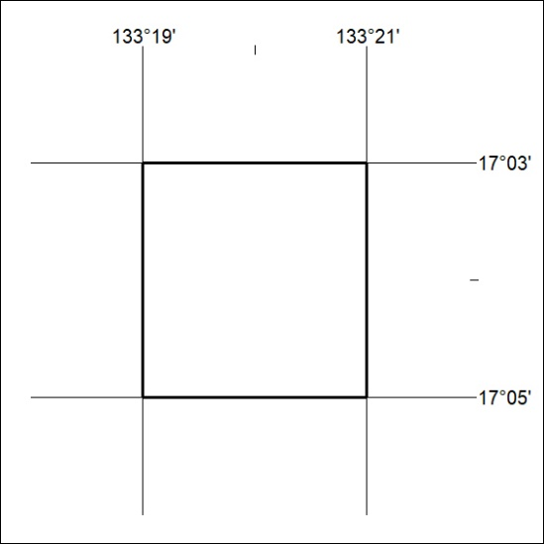
Area granted is indicated above. The titleholder is not permitted to exercise occupational rights on any land that is subject to a development title, or an application for a development title. Any land the subject of a Reserved Land gazettal under the Mineral Titles Act and all land vested in the Commonwealth of Australia is also excluded by description but not excised from the grant area.
006/22

