Mineral Titles Act 2010
NOTICE OF LAND CEASING TO BE A MINERAL TITLE AREA
Title Type and Number: | Exploration Licence 27069
Area Ceased on: | 30 August 2021
Area: | 17 Blocks, 54.27 km²
Locality: | ANNINGIE
Name of Applicant(s)/Holder(s): | 100% ENIGMA MINING LIMITED [ACN. 009 225 558]
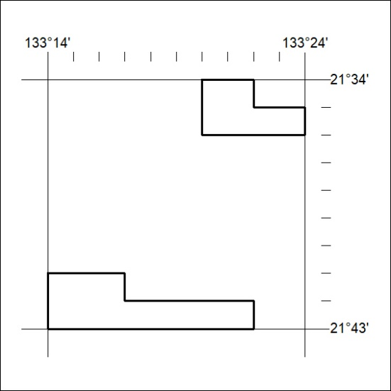

337/21

Corrigendum
Notice Number 328/21 appearing in MN79/21 on 26 August 2021 is hereby cancelled and replaced by the following:

Mineral Titles Act 2010
NOTICE OF LAND CEASING TO BE A MINERAL TITLE AREA
Title Type and Number: | Extractive Mineral Permit 30369
Area ceased on: | 25 August 2021
Area: | 75.00 Hectare
Locality: | NOONAMAH
Name of Applicants(s)Holder(s): | 100% EAST ARM CIVIL PTY LTD [ACN. 073 382 251]
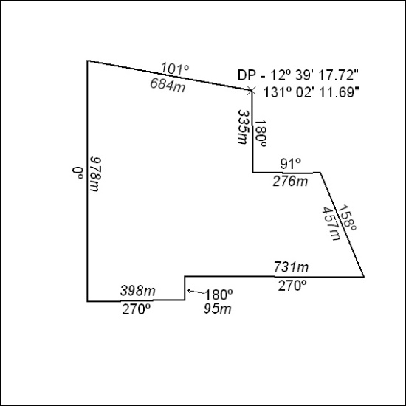

338/21

