Mineral Titles Act 2010
NOTICE OF LAND CEASING TO BE A MINERAL TITLE AREA
Title Type and Number: | Exploration Licence 23655
Area Ceased on: | 12 June 2021
Area: | 6 Blocks, 19.12 km²
Locality: | GILES
Name of Applicant(s)/Holder(s): | 60% PRODIGY GOLD NL* [ACN. 009 127 020], 40% SELECT RESOURCES PTY. LTD. [ACN. 099 956 797]
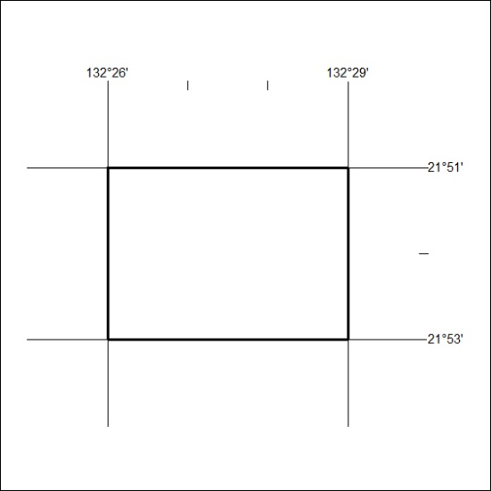

203/21

Mineral Titles Act
NOTICE OF GRANT OF A MINERAL TITLE
Title Type and Number: | Exploration Licence 32261
Granted: | 11 June 2021, for a period of 6 Years
Area: | 100 Blocks, 326.66 km²
Locality: | BOXER
Name of Holder/s: | 100% WALHALLOW CREEK NO 2 PTY LTD [ACN. 626 076 471]
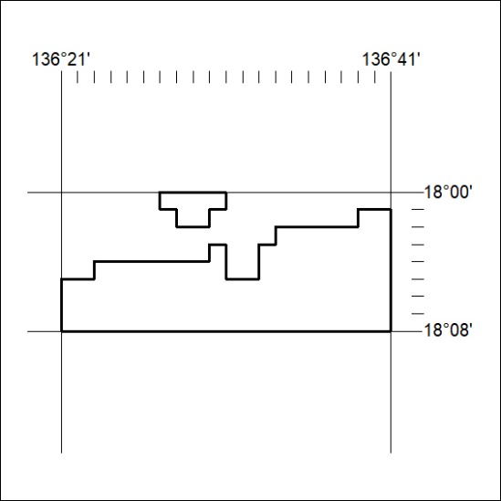
Area granted is indicated above. The titleholder is not permitted to exercise occupational rights on any land that is subject to a development title, or an application for a development title. Any land the subject of a Reserved Land gazettal under the Mineral Titles Act and all land vested in the Commonwealth of Australia is also excluded by description but not excised from the grant area.

204/21

Mineral Titles Act
NOTICE OF GRANT OF A MINERAL TITLE
Title Type and Number: | Exploration Licence 32507
Granted: | 11 June 2021, for a period of 6 Years
Area: | 249 Blocks, 823.97 km²
Locality: | WILLEROO
Name of Holder/s: | 100% MINERALS PTY LTD [ACN. 641 565 139]
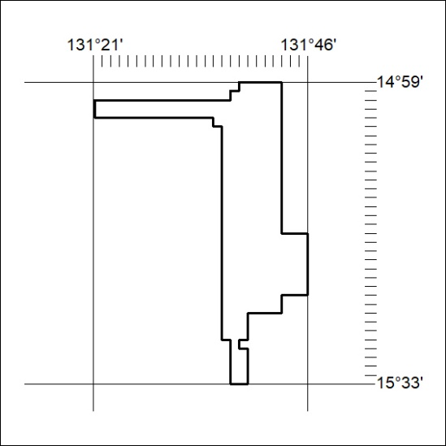
Area granted is indicated above. The titleholder is not permitted to exercise occupational rights on any land that is subject to a development title, or an application for a development title. Any land the subject of a Reserved Land gazettal under the Mineral Titles Act and all land vested in the Commonwealth of Australia is also excluded by description but not excised from the grant area.
205/21

Mineral Titles Act
NOTICE OF GRANT OF A MINERAL TITLE
Title Type and Number: | Exploration Licence 32508
Granted: | 11 June 2021, for a period of 6 Years
Area: | 249 Blocks, 789.39 km²
Locality: | FLORA
Name of Holder/s: | 100% MINERALS PTY LTD [ACN. 641 565 139]
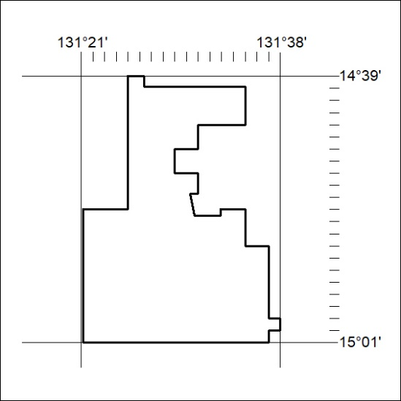
Area granted is indicated above. The titleholder is not permitted to exercise occupational rights on any land that is subject to a development title, or an application for a development title. Any land the subject of a Reserved Land gazettal under the Mineral Titles Act and all land vested in the Commonwealth of Australia is also excluded by description but not excised from the grant area.
206/21

Mineral Titles Act
NOTICE OF GRANT OF A MINERAL TITLE
Title Type and Number: | Exploration Licence 32509
Granted: | 11 June 2021, for a period of 6 Years
Area: | 245 Blocks, 766.22 km²
Locality: | FLORA
Name of Holder/s: | 100% MINERALS PTY LTD [ACN. 641 565 139]
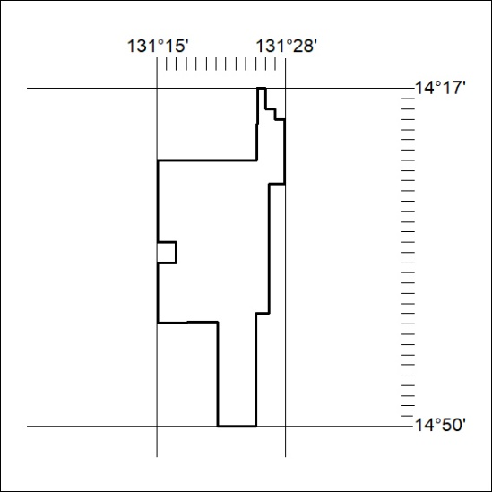
Area granted is indicated above. The titleholder is not permitted to exercise occupational rights on any land that is subject to a development title, or an application for a development title. Any land the subject of a Reserved Land gazettal under the Mineral Titles Act and all land vested in the Commonwealth of Australia is also excluded by description but not excised from the grant area.
207/21

Mineral Titles Act
NOTICE OF GRANT OF A MINERAL TITLE
Title Type and Number: | Exploration Licence 32510
Granted: | 11 June 2021, for a period of 6 Years
Area: | 249 Blocks, 793.40 km²
Locality: | BARWOLLA
Name of Holder/s: | 100% MINERALS PTY LTD [ACN. 641 565 139]
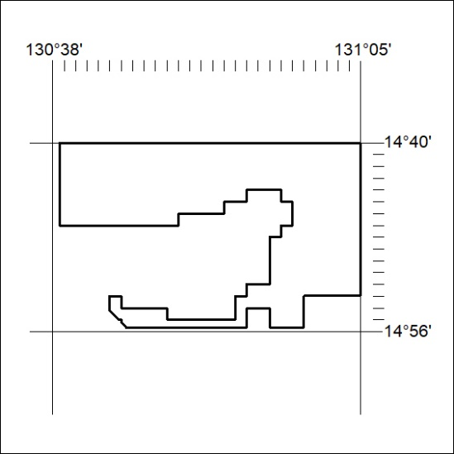
Area granted is indicated above. The titleholder is not permitted to exercise occupational rights on any land that is subject to a development title, or an application for a development title. Any land the subject of a Reserved Land gazettal under the Mineral Titles Act and all land vested in the Commonwealth of Australia is also excluded by description but not excised from the grant area.
208/21

Mineral Titles Act
NOTICE OF GRANT OF A MINERAL TITLE
Title Type and Number: | Exploration Licence 32573
Granted: | 11 June 2021, for a period of 6 Years
Area: | 247 Blocks, 770.29 km²
Locality: | ADAM
Name of Holder/s: | 100% PLUTONIC LIMITED [ACN. 632 991 167]
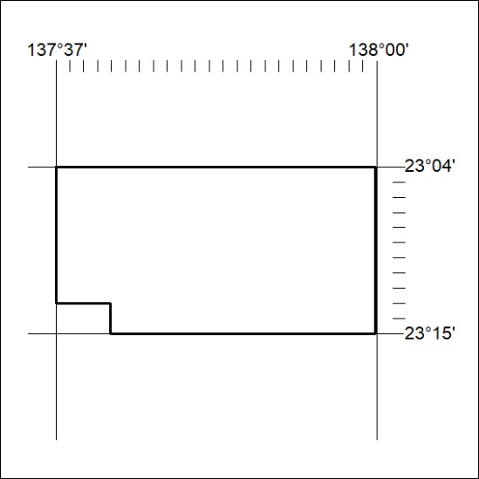
Area granted is indicated above. The titleholder is not permitted to exercise occupational rights on any land that is subject to a development title, or an application for a development title. Any land the subject of a Reserved Land gazettal under the Mineral Titles Act and all land vested in the Commonwealth of Australia is also excluded by description but not excised from the grant area.
209/21

Mineral Titles Act
NOTICE OF GRANT OF A MINERAL TITLE
Title Type and Number: | Exploration Licence 32574
Granted: | 11 June 2021, for a period of 6 Years
Area: | 240 Blocks, 718.20 km²
Locality: | ADAM
Name of Holder/s: | 100% PLUTONIC LIMITED [ACN. 632 991 167]
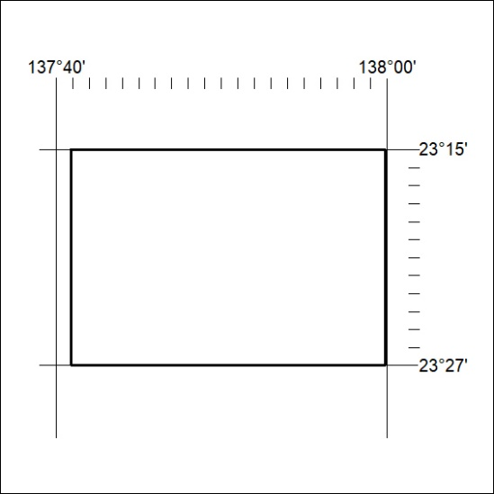
Area granted is indicated above. The titleholder is not permitted to exercise occupational rights on any land that is subject to a development title, or an application for a development title. Any land the subject of a Reserved Land gazettal under the Mineral Titles Act and all land vested in the Commonwealth of Australia is also excluded by description but not excised from the grant area.
210/21

Mineral Titles Act
NOTICE OF GRANT OF A MINERAL TITLE
Title Type and Number: | Exploration Licence 32575
Granted: | 11 June 2021, for a period of 6 Years
Area: | 240 Blocks, 722.58 km²
Locality: | FIELD RIVER
Name of Holder/s: | 100% PLUTONIC LIMITED [ACN. 632 991 167]
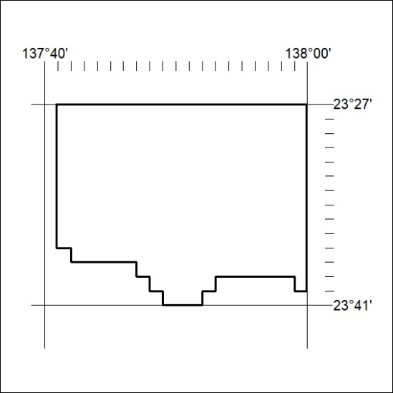
Area granted is indicated above. The titleholder is not permitted to exercise occupational rights on any land that is subject to a development title, or an application for a development title. Any land the subject of a Reserved Land gazettal under the Mineral Titles Act and all land vested in the Commonwealth of Australia is also excluded by description but not excised from the grant area.
211/21

