Mineral Titles Act 2010
NOTICE OF LAND CEASING TO BE A MINERAL TITLE AREA
Title Type and Number: | Extractive Mineral Permit 30035
Area ceased on: | 05 July 2019
Area: | 8.00 Hectare
Locality: | FOG BAY
Name of Applicants(s)Holder(s): | 100% RESOURCE BIO MANAGEMENT PTY LTD [ACN. 124 655 858]
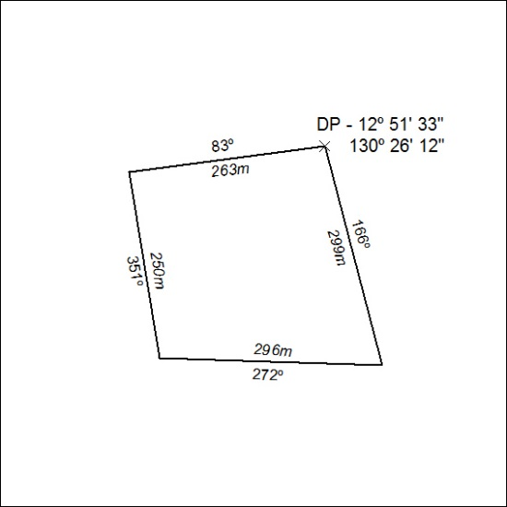

276/19

Mineral Titles Act 2010
NOTICE OF LAND CEASING TO BE A MINERAL TITLE AREA
Title Type and Number: | Mineral Lease 27438
Area ceased on: | 05 July 2019
Area: | 451.00 Hectares
Locality: | JAHLEEL
Name of Applicants(s)Holder(s): | 100% MZI RESOURCES LTD* [ACN. 077 221 722]
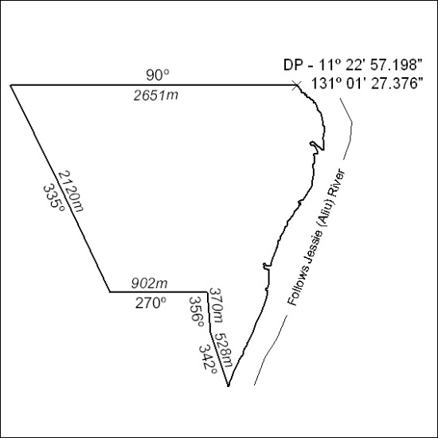

277/19

