NT Pastoral Feed Outlook - June 2016
The purpose of this quarterly outlook is to summarise information relevant to the pastoral industry such as current feed supplies, seasonal conditions, the development of drought conditions in central Australia and fire risk.
You can see the entire document and all districts by continuing to scroll through this file. If you are interested in selected sections, you can click on the links below.
Summary of current situation & trends - all districts
Northern Territory Seasonal Outlook – as at June 2016
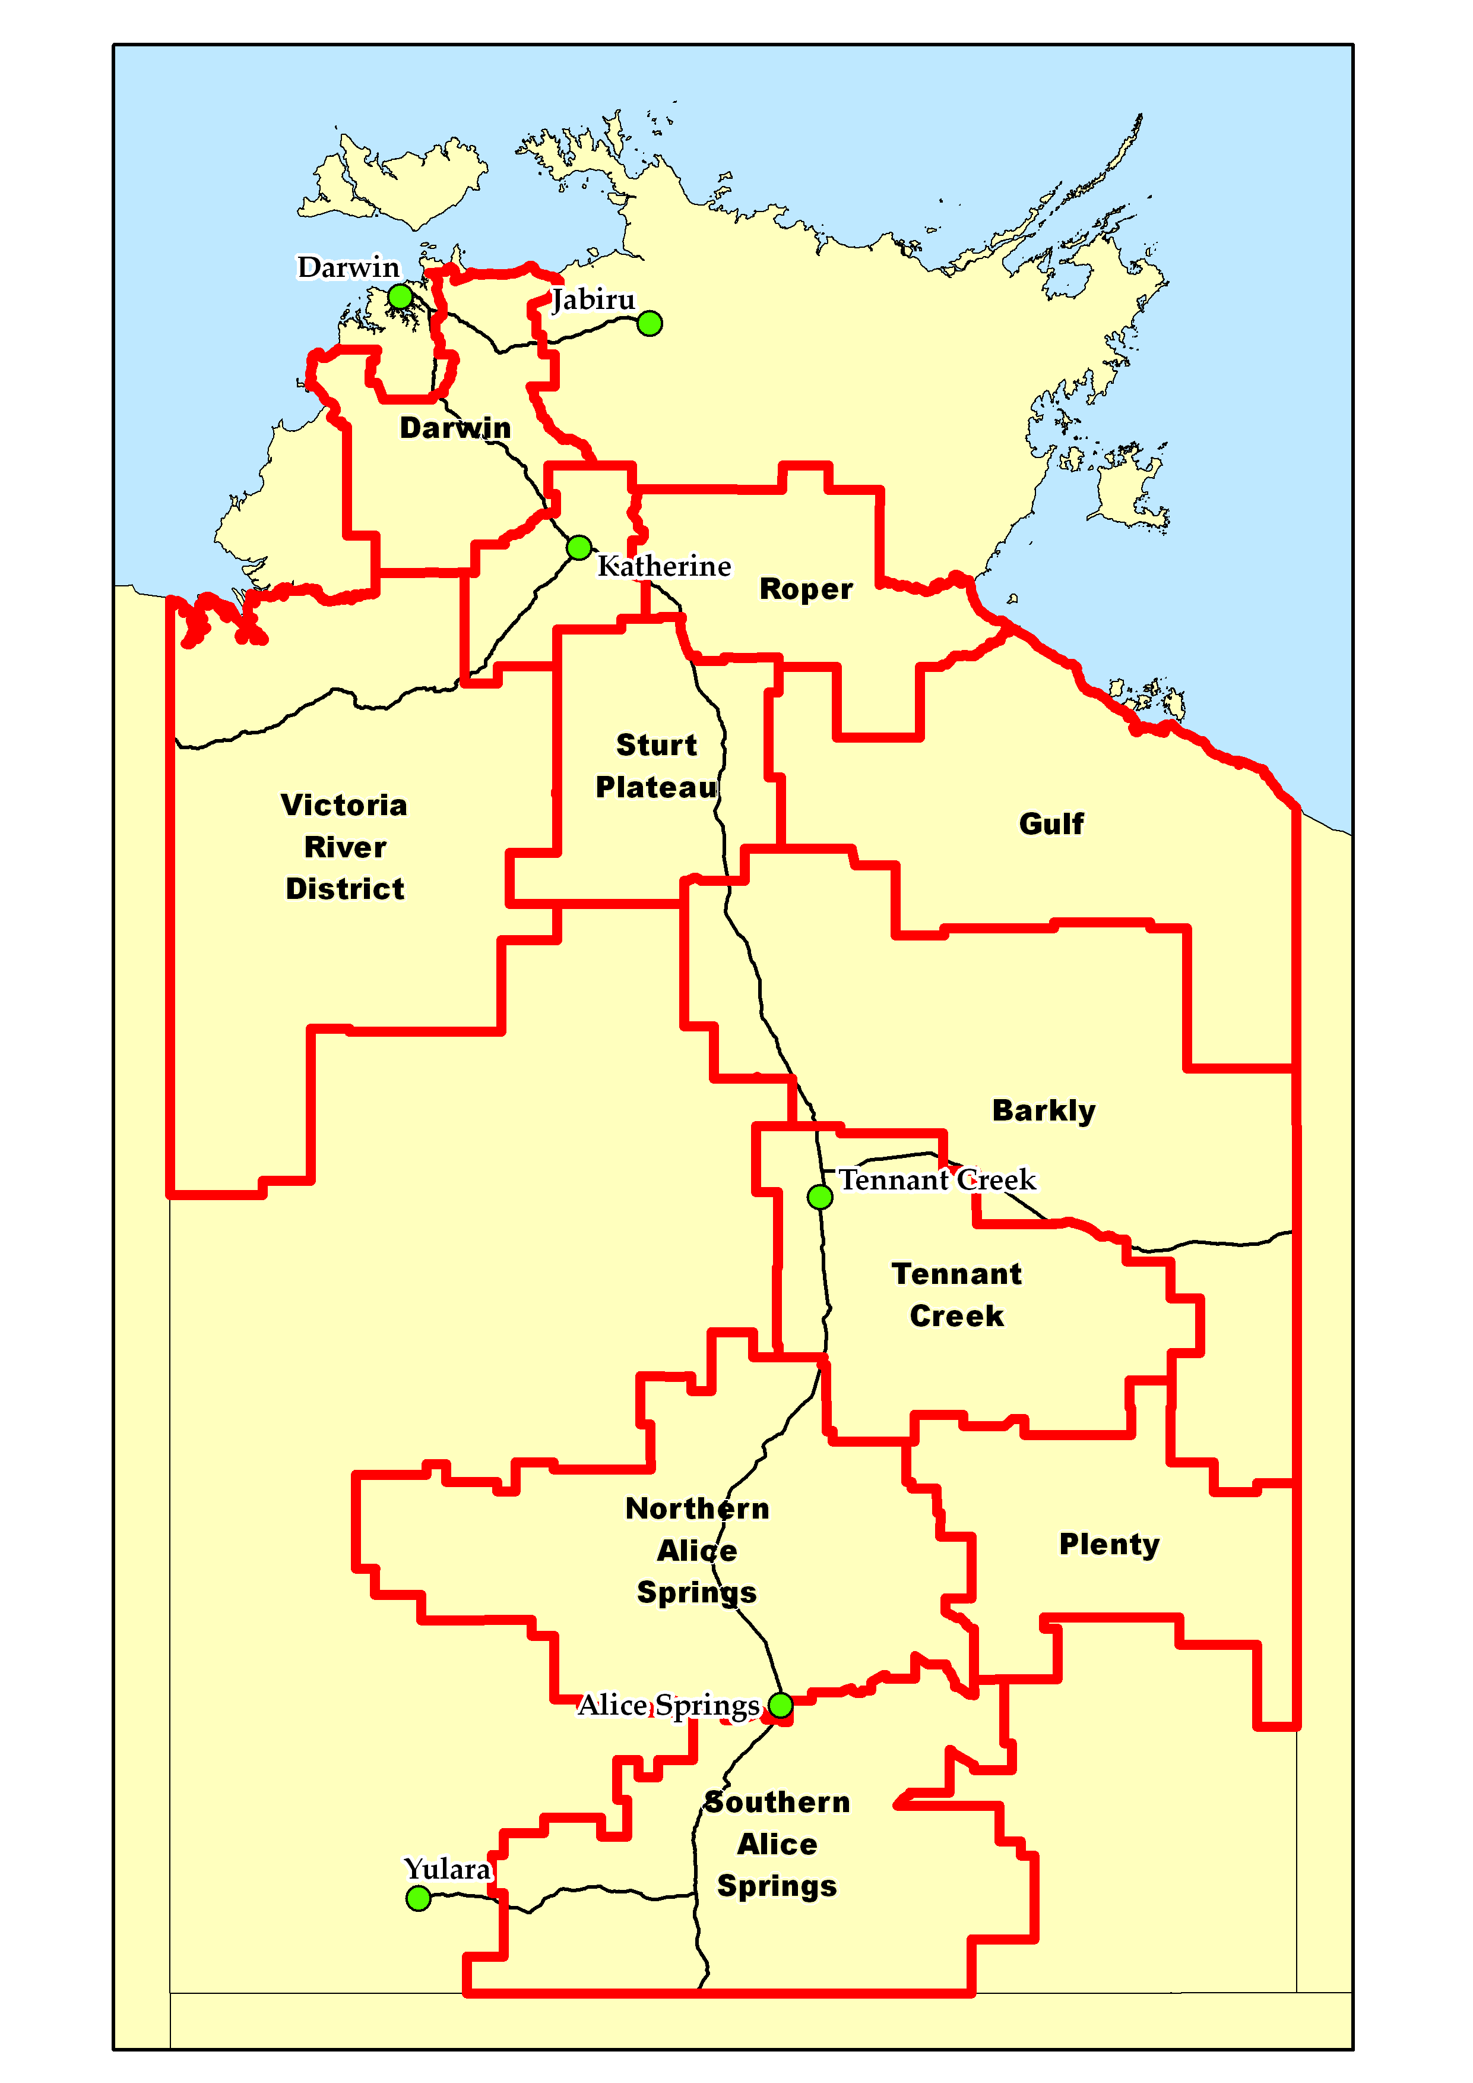
Individual District Summaries:
- Darwin District
- Katherine District
- Victoria River District
- Sturt Plateau District
- Roper District
- Gulf District
- Barkly District
- Tennant Creek District
- Northern Alice Springs District
- Plenty District
- Southern Alice Springs District

Summary of current situation & trends - all districts – June 2016

KEY | Green = low risk | Orange = watch | Red = high risk

KEY | ↑ = increasing trend | ↓ = decreasing trend | ↔ = steady

 | Northern Territory Pastoral Districts
Indicator | Darwin | Katherine | VRD | Sturt Plateau | Roper | Gulf | Barkly | Tennant Creek | Northern Alice Springs | Plenty | Southern Alice Springs | Comments
2015/16 total pasture growth | ↔ | ↔ | ↔ | ↔ | ↓ | ↓ | ↑ | ↑ | ↔ | ↑ | ↑ | Arrows indicate trend compared to the long-term median.
Current estimated standing biomass | ↑ | ↑ | ↑ | ↔ | ↑ | ↑ | ↔ | ↔ | ↑ | ↑ | ↑ | Arrows indicate trend since previous quarter.
Current seasonal outlook | ↑ | ↑ | ↑ | ↑ | ↑ | ↑ | ↑ | ↑ | ↑ | ↑ | ↑ | Arrows indicate the trend since previous quarter and taking into account the forecasted model predictions.
Current fire risk | ↑ | ↑ | ↑ | ↑ | ↑ | ↑ | ↑ | ↑ | ↓ | ↓ | ↓ | Arrows indicate the trend since previous quarter.

For further information about this Outlook, please contact Chris Materne on 8951 8135 or Caroline Pettit on 8999 9014

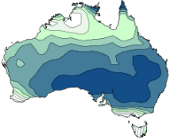
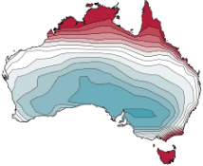
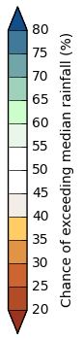
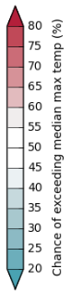
Northern Territory Seasonal Outlook
as at June 2016

Sourced from the Australian Bureau of Meteorology
http://www.bom.gov.au/climate/outlooks/
The national outlook for June to August 2016 period indicates that:
- Wetter than average across the majority of the NT, especially across the southern NT.
- Warmer than normal days and nights more likely across the northern half of the NT.
- Cooler than average days are likely over the southern half of Australia.
Chance of exceeding the median max. temp.
June-August 2016

Chance of exceeding the median rainfall
June-August 2016
The current outlook reflects a combination of a potential La Niña event in the Pacific, increasing chance of a negative Indian Ocean Dipole, and very warm sea surface temperatures surrounding northern and eastern Australia.
Seasonal Indicators | Comments (sourced from the Australian Bureau of Meteorology)
El Niño Southern Oscillation (ENSO)  http://www.bom.gov.au/climate/enso/#tabs=Overview  Current outlook:  Neutral  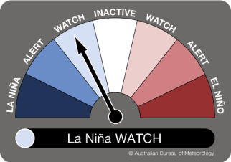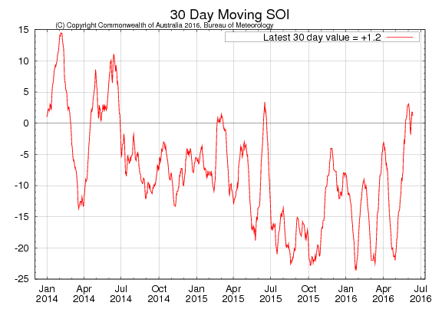  La Niña WATCH Level  (ENSO status) | 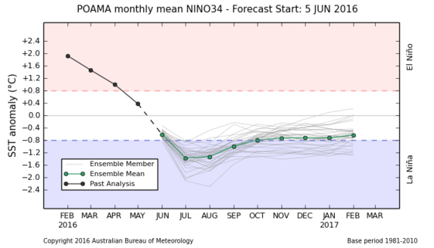  La Niño favioured for second half of 2016.  International climate models indicate further cooling in the tropical Pacific Ocean is likely, with most models suggesting sea surface temperatures will reach La Niña thresholds by August 2016.  A La Niña WATCH status means there is approximately a 50% chance of La Niña developing in 2016, which is about twice the normal likelihood.  Typically during La Niña, winter-spring rainfall is above average over northern, central and eastern Australia.
Indian Ocean Dipole (IOD)  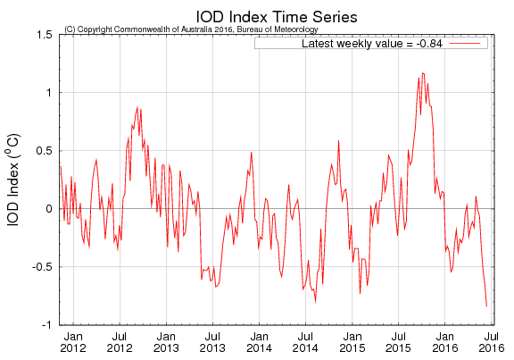  http://www.bom.gov.au/climate/enso/#tabs=Indian-Ocean  Current outlook:  Neutral | 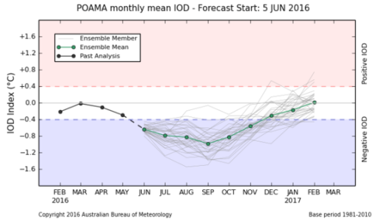  Increasing likelihood of good falls occurring across the southern NT during winter and spring.  Model outlooks suggest a negative IOD event may develop in the coming months. Negative IOD events are more likely to occur during La Niña. Hence, if La Nina does develop, this will increase the likelihood of a negative IOD event developing. More broadly, sea surface temperatures (SSTs) are significantly warmer than average across much of the Indian Ocean. This warmth will likely provide more available moisture to weather systems as they cross the Australian continent.  A negative IOD typically brings increased winter-spring rainfall to southern Australia.

Darwin District  Risks:  - As at the 1 June 2016, 52% of the district had received below average pasture growth for the 2015/16 wet season and 79 % currently with below average standing dry matter.  - In a typical wet season pasture growth in the Darwin region is limited by the available soil nitrogen, not water. Therefore a poor wet season may not generally affect the quantity of pasture growth; however it may reduce pasture growth on the flood plains by a lack of runoff. |  |  |  |  |  | 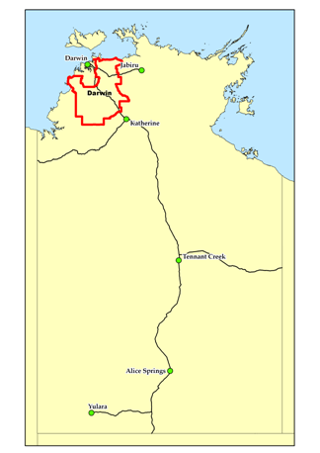
2015/16 Wet Season (as at 1 June 2016)
Pasture Growth*  (% of district) | Below Average  52% | Average  41% |  | Above Average  7%
 | <1,000kg/ha  0% | >1,000 & <2,000kg/ha  51% |  | >2,000kg/ha  49%
Currently
Total Standing Dry Matter  (% of district) | Below Average  79% | Average  20% |  | Above Average  1%
 | <1,000kg/ha  1% | >1,000 & <3,000kg/ha  93% |  | >3,000kg/ha  6%
Fire Risk  (% of district) | High  48% | Moderate  52% |  | Low  0%
Area Burnt  (% of district) | 42% (2015/16 Total Area Burnt)  21% (since 1st January 2016)
* In the Top End, pasture growth tends to be similar year to year regardless of rainfall. This is because pasture growth in the Top End is typically not water-limited and keeps growing until available soil nitrogen is exhausted. For this reason, any interpretation of growth being above or below the median should be treated cautiously because the actual difference between years is relatively small.
Median Pasture Growth (kg/ha)  (Running Total) |  |  | Chance of exceeding Median Pasture Growth  (June – August 2016)
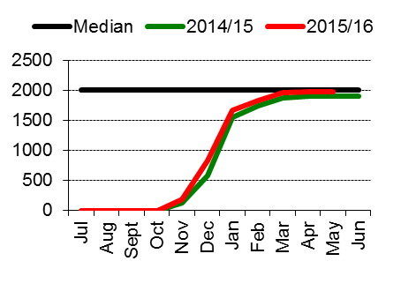 |  |  | 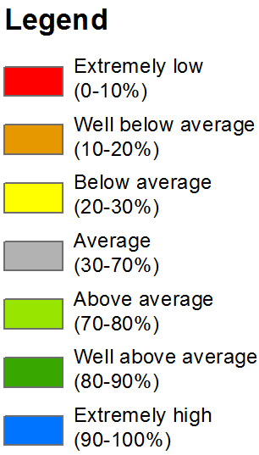 |  | 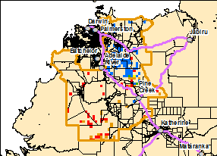  Note: Missingl data is due to seasonally low growth at this time of the year
Total 2015/16 Pasture Growth  (July 2015 – May 2016)  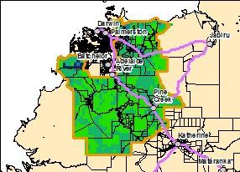 |  |  | 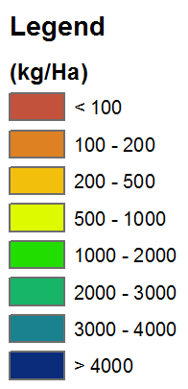 |  | Current Estimated  Total Standing Dry Matter  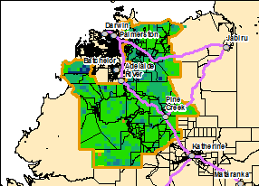

Katherine District  Risks:  - None to report |  |  |  |  |  | 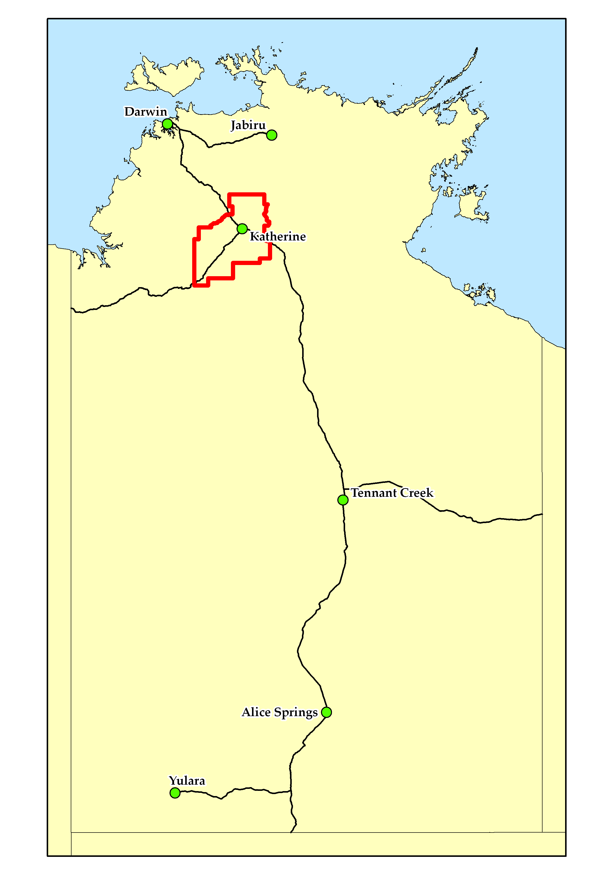
2015/16 Wet Season (as at 1 June 2016)
Pasture Growth  (% of district) | Below Average  32% | Average  49% |  | Above Average  19%
 | <1,000kg/ha  0% | >1,000 & <2,000kg/ha  33% |  | >2,000kg/ha  67%
Currently
Total Standing Dry Matter  (% of district) | Below Average  64% | Average  36% |  | Above Average  0%
 | <1,000kg/ha  <1% | >1,000 & <3,000kg/ha  95% |  | >3,000kg/ha  5%
Fire Risk  (% of district) | High  84% | Moderate  16% |  | Low  0%
Area Burnt  (% of district) | 40% (2015/16 Total Area Burnt)  13% (since 1st January 2016)
Median Pasture Growth (kg/ha)  (Running Total) |  |  | Chance of exceeding Median Pasture Growth  (June- August 2016)
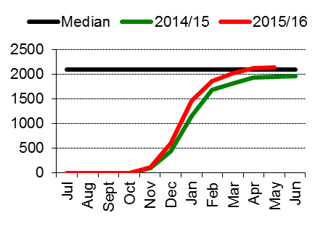 |  |  |  |  | 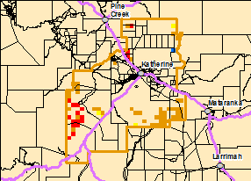  Note: Missing data is due to seasonally low growth at this time of the year
Total 2015/16 Pasture Growth  (July 2015 – May 2016)  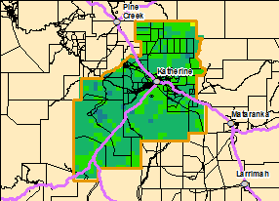 |  |  |  |  | Current Estimated  Total Standing Dry Matter  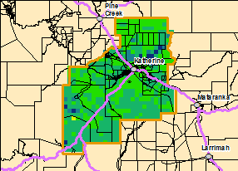

Victoria River District  Risks:  - As at the 1st June 2016, 96% of the district had a high fire risk. |  |  |  |  |  | 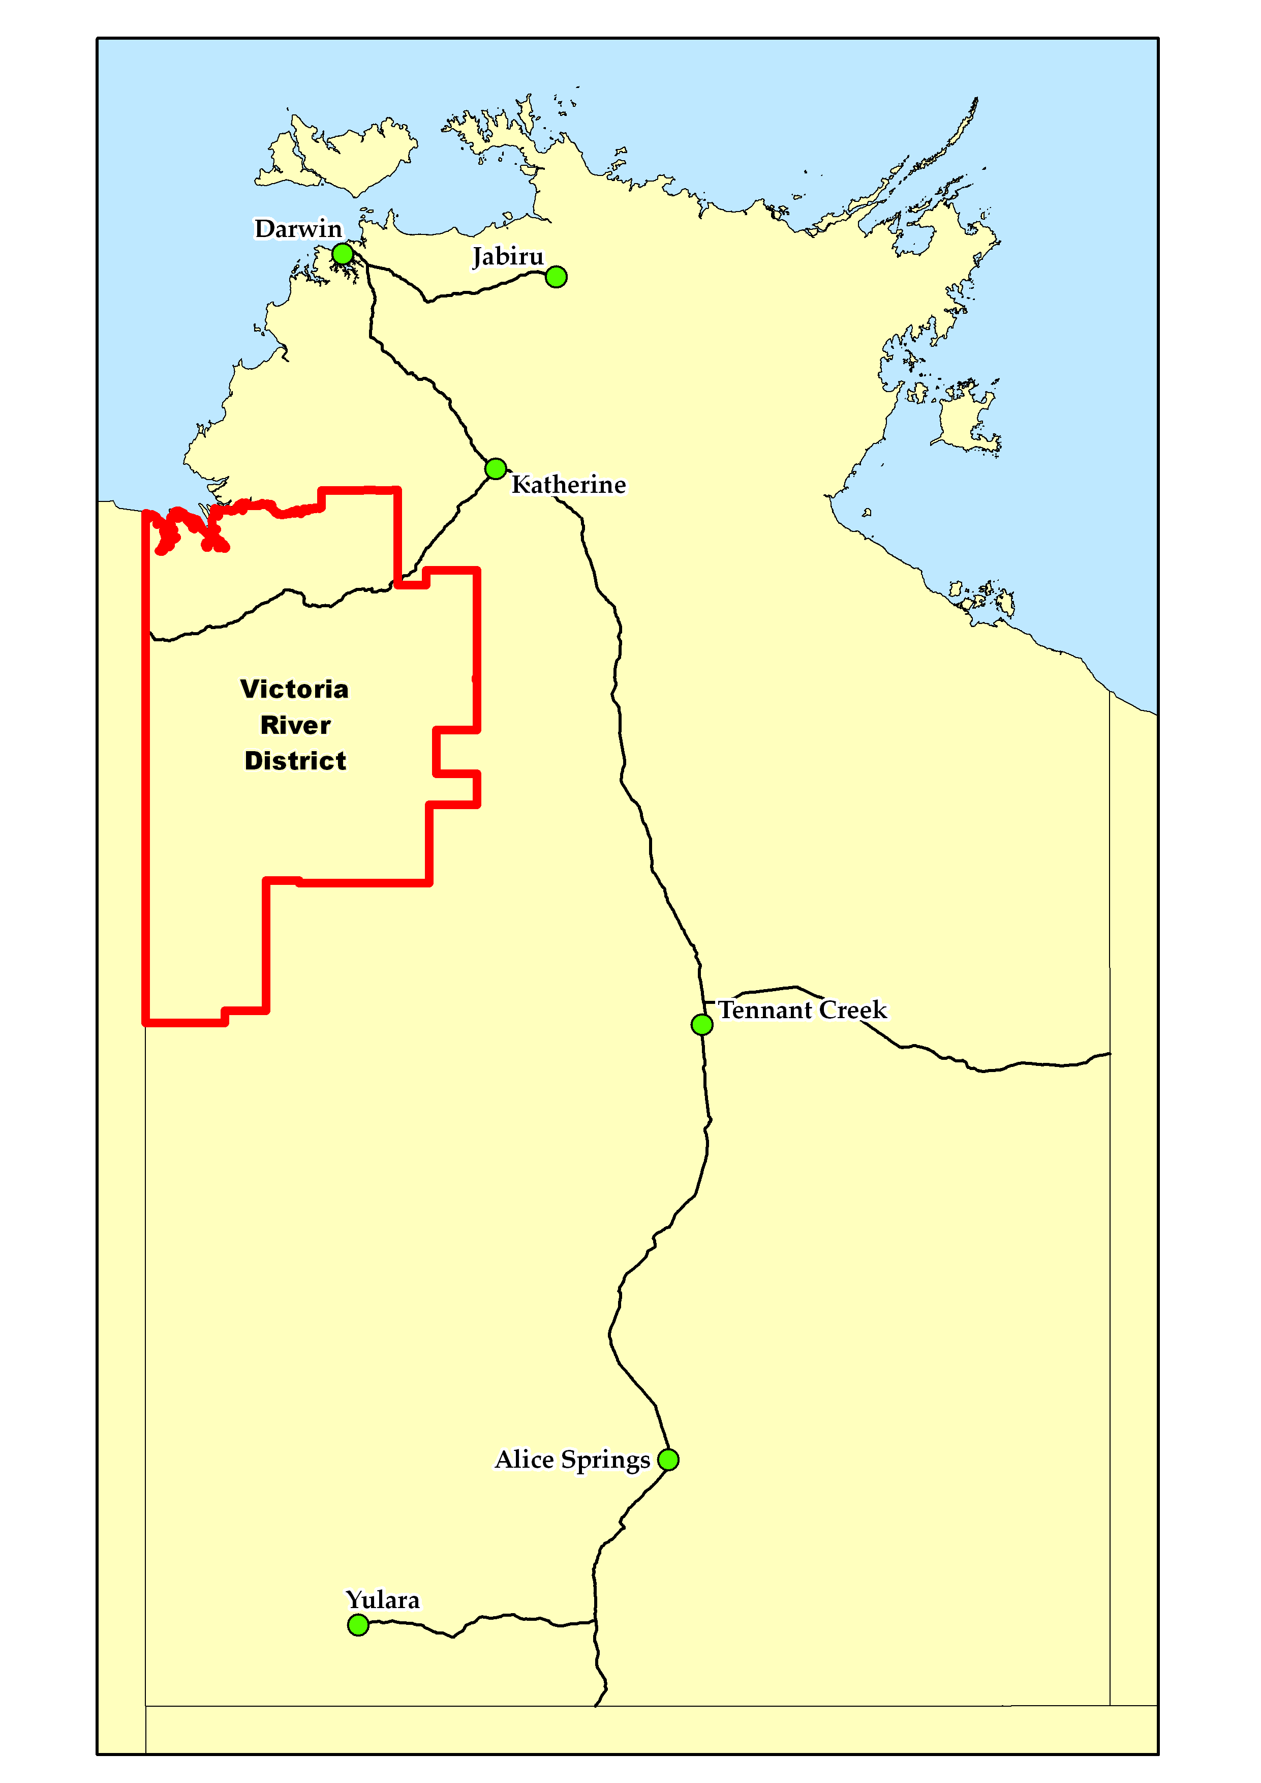
2015/16 Wet Season (as at 1 June 2016)
Pasture Growth  (% of district) | Below Average  16% | Average  75% |  | Above Average  9%
 | <1,000kg/ha  16% | >1,000 & <2,000kg/ha  41% |  | >2,000kg/ha  42%
Currently
Total Standing Dry Matter  (% of district) | Below Average  44% | Average  50% |  | Above Average  6%
 | <1,000kg/ha  5% | >1,000 & <3,000kg/ha  73% |  | >3,000kg/ha  22%
Fire Risk  (% of district) | High  96% | Moderate  4% |  | Low  0%
Area Burnt  (% of district) | 21% (2015/16 Total Area Burnt)  5% (since 1st January 2016)
Median Pasture Growth (kg/ha)  (Running Total) |  |  | Chance of exceeding Median Pasture Growth  (June – August 2016)
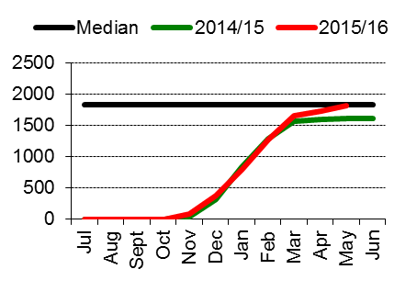 |  |  |  |  | 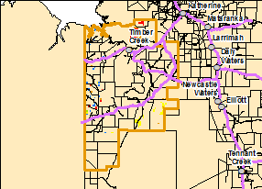  Note: Missing data is due to seasonally low growth at this time of the year
Total 2014/15 Pasture Growth  (July2015 – May 2016)  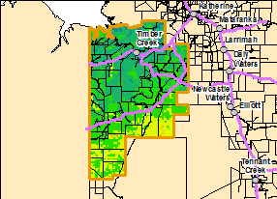 |  |  |  |  | Current Estimated  Total Standing Dry Matter  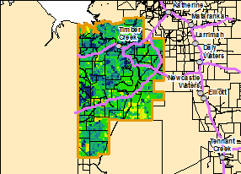

Sturt Plateau District  Risks:  - As at the 1st June 2016, 95% of the district had a high fire risk. |  |  |  |  |  | 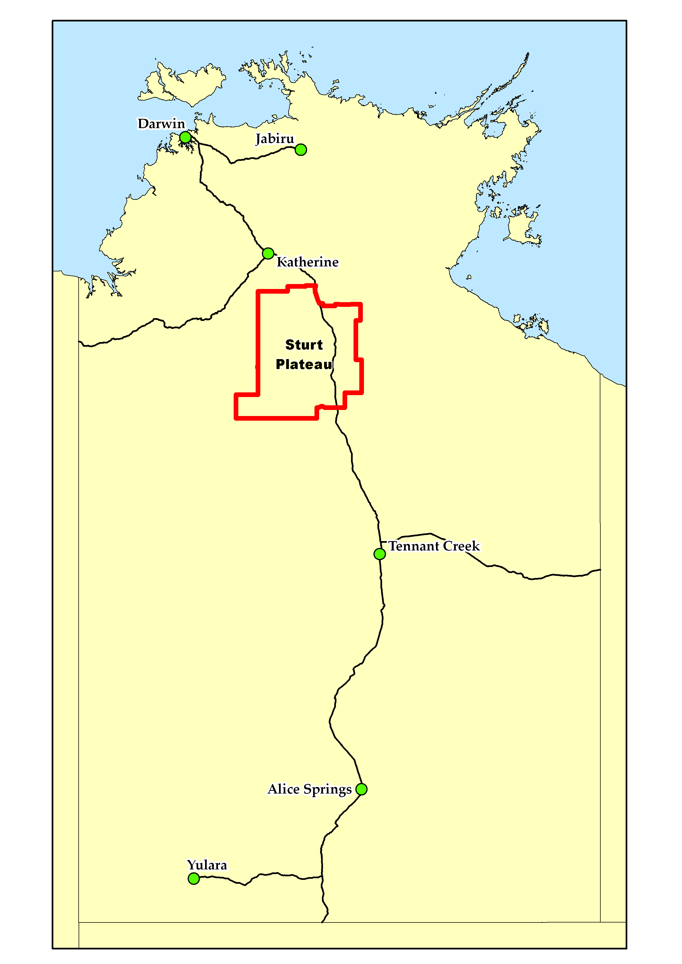
2015/16 Wet Season (as at 1 June 2016)
Pasture Growth  (% of district) | Below Average  17% | Average  56% |  | Above Average  27%
 | <1,000kg/ha  6% | >1,000 & <2,000kg/ha  37% |  | >2,000kg/ha  57%
Currently
Total Standing Dry Matter  (% of district) | Below Average  36% | Average  62% |  | Above Average  2%
 | <1,000kg/ha  8% | >1,000 & <3,000kg/ha  90% |  | >3,000kg/ha  2%
Fire Risk  (% of district) | High  95% | Moderate  5% |  | Low  0%
Area Burnt  (% of district) | 23% (2015/16 Total Area Burnt)  3% (since 1st January 2016)
Median Pasture Growth (kg/ha)  (Running Total) |  |  | Chance of exceeding Median Pasture Growth  (June - August 2016)
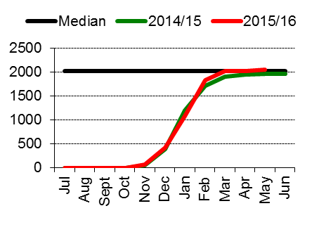 |  |  |  |  | 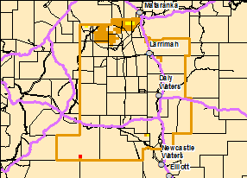  Note: Missing data is due to seasonally low growth at this time of the year
Total 2015/16 Pasture Growth  (July 2015– May2016)  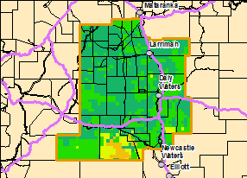 |  |  |  |  | Current Estimated  Total Standing Dry Matter  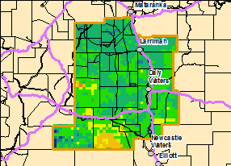

Roper District  Risks:  - As at the 1st June 2016, 85% of the region had experienced below average pasture growth for the 2015/16 Wet Season, and 86% has below average total standing dry matter. |  |  |  |  |  | 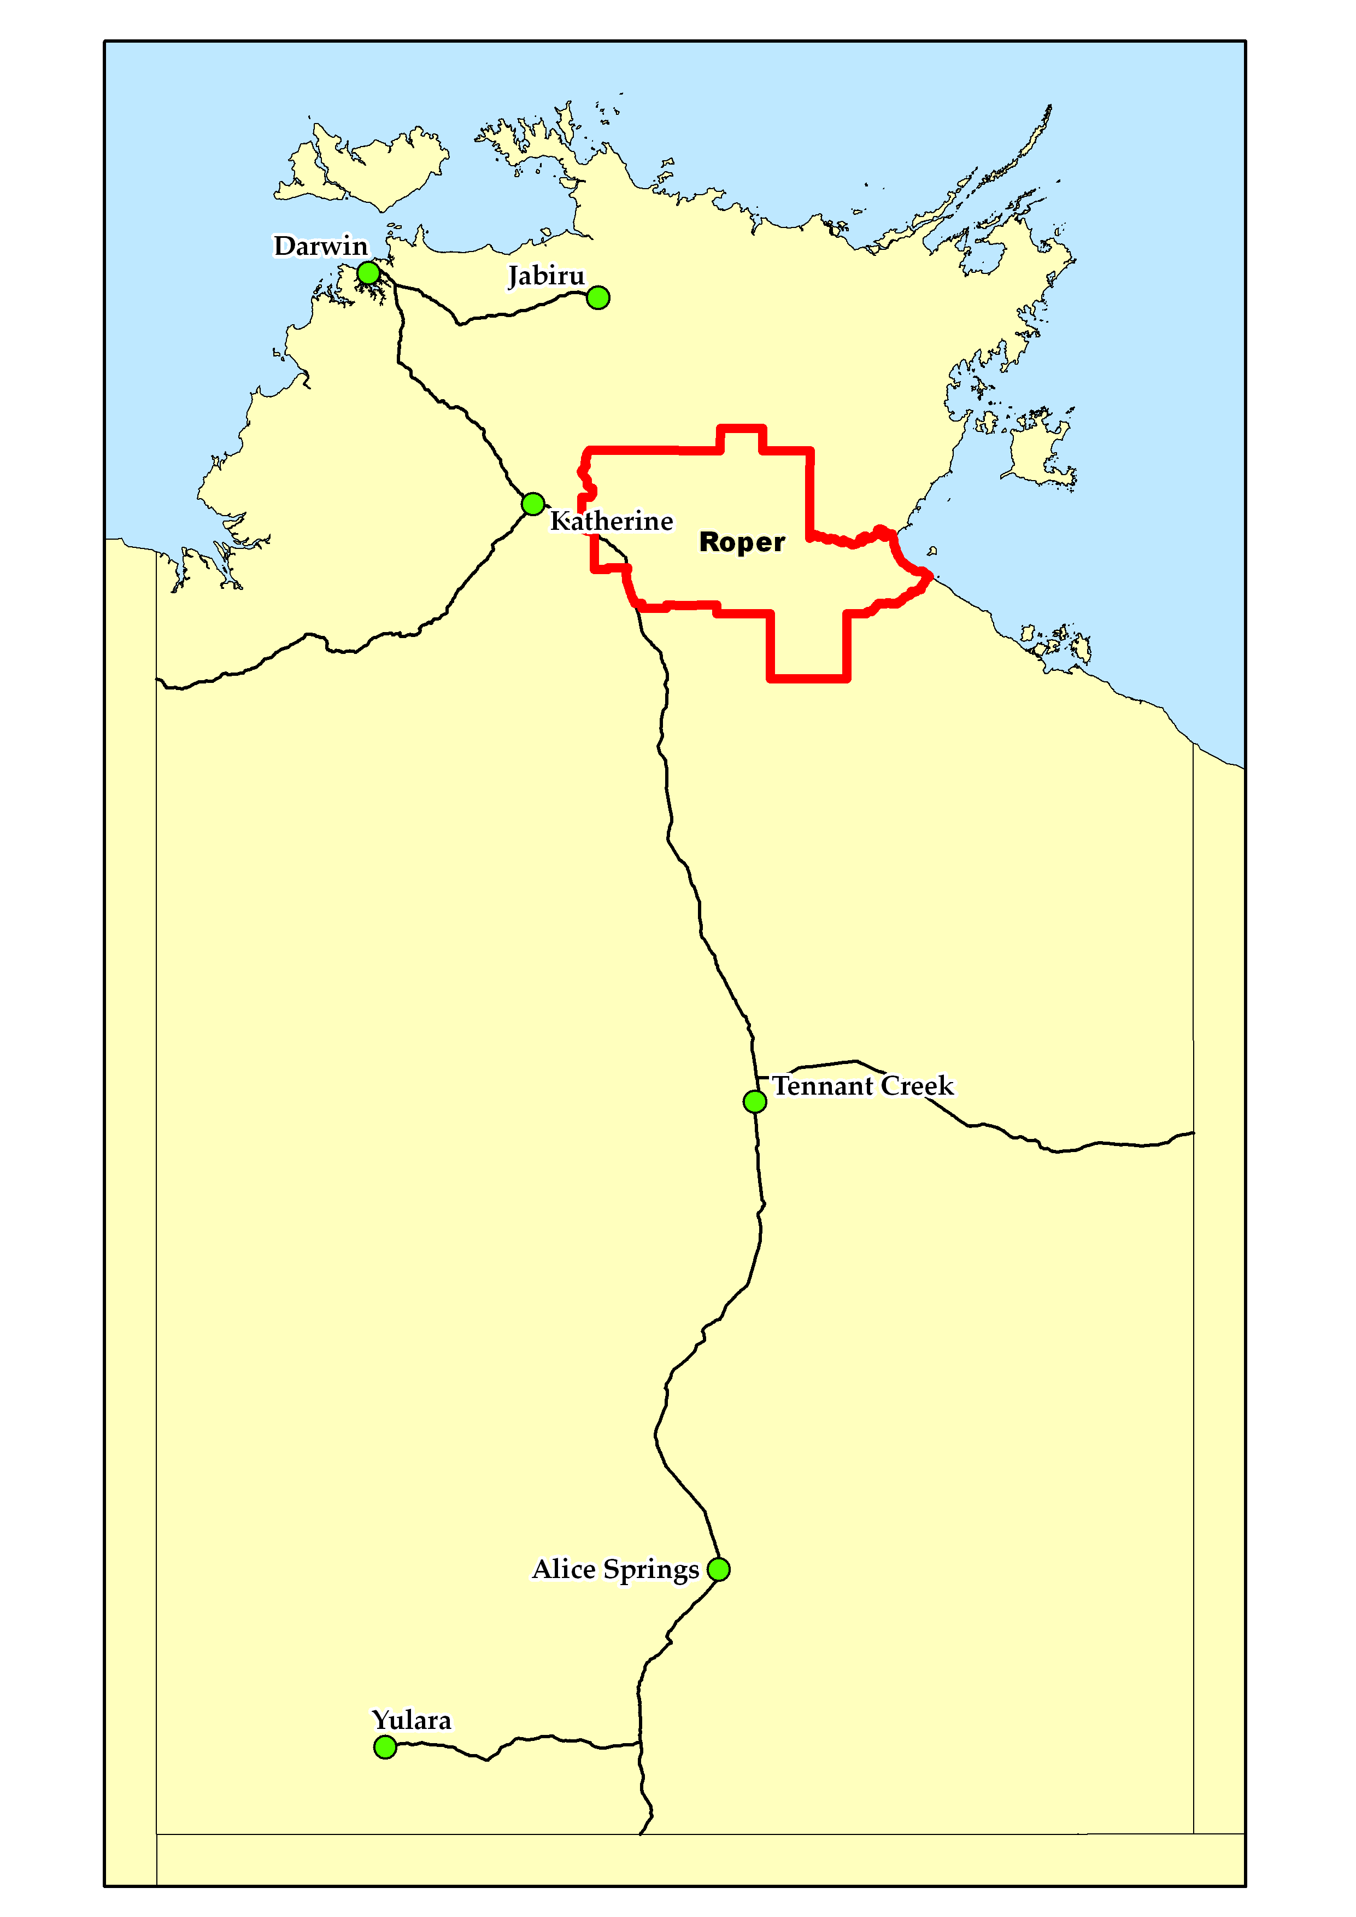
2015/16 Wet Season (as at 1 June 2016)
Pasture Growth  (% of district) | Below Average  85% | Average  13% |  | Above Average  2%
 | <1,000kg/ha  4% | >1,000 & <2,000kg/ha  67% |  | >2,000kg/ha  29%
Currently
Total Standing Dry Matter  (% of district) | Below Average  86% | Average  14% |  | Above Average  <1%
 | <1,000kg/ha  4% | >1,000 & <3,000kg/ha  83% |  | >3,000kg/ha  13%
Fire Risk  (% of district) | High  82% | Moderate  18% |  | Low  0%
Area Burnt  (% of district) | 27% (2015/16 Total Area Burnt)  4% (since 1st January 2016)
Median Pasture Growth (kg/ha)  (Running Total) |  |  | Chance of exceeding Median Pasture Growth  (June - August 2016)
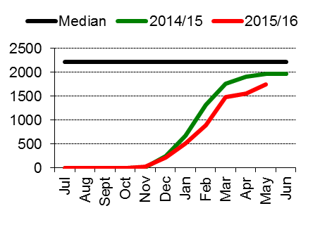 |  |  |  |  | 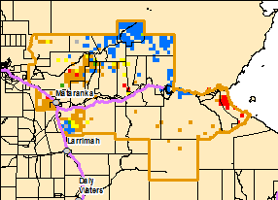  Note: Missing data is due to seasonally low growth at this time of the year
Total 2015/16 Pasture Growth  (July 2015– May 2016)  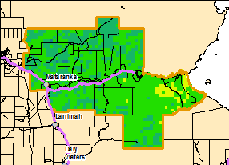 |  |  |  |  | Current Estimated  Total Standing Dry Matter  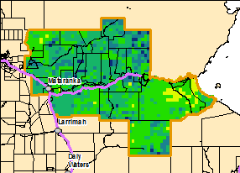

Gulf District  Risks:  - As at the 1st June 2016, 65% of the region has experienced below average pasture growth for the 2015/16 Wet Season, and 80% has below average total standing dry matter.  - As at the 1st June 2016, 99% of the district had a high fire risk. |  |  |  |  |  | 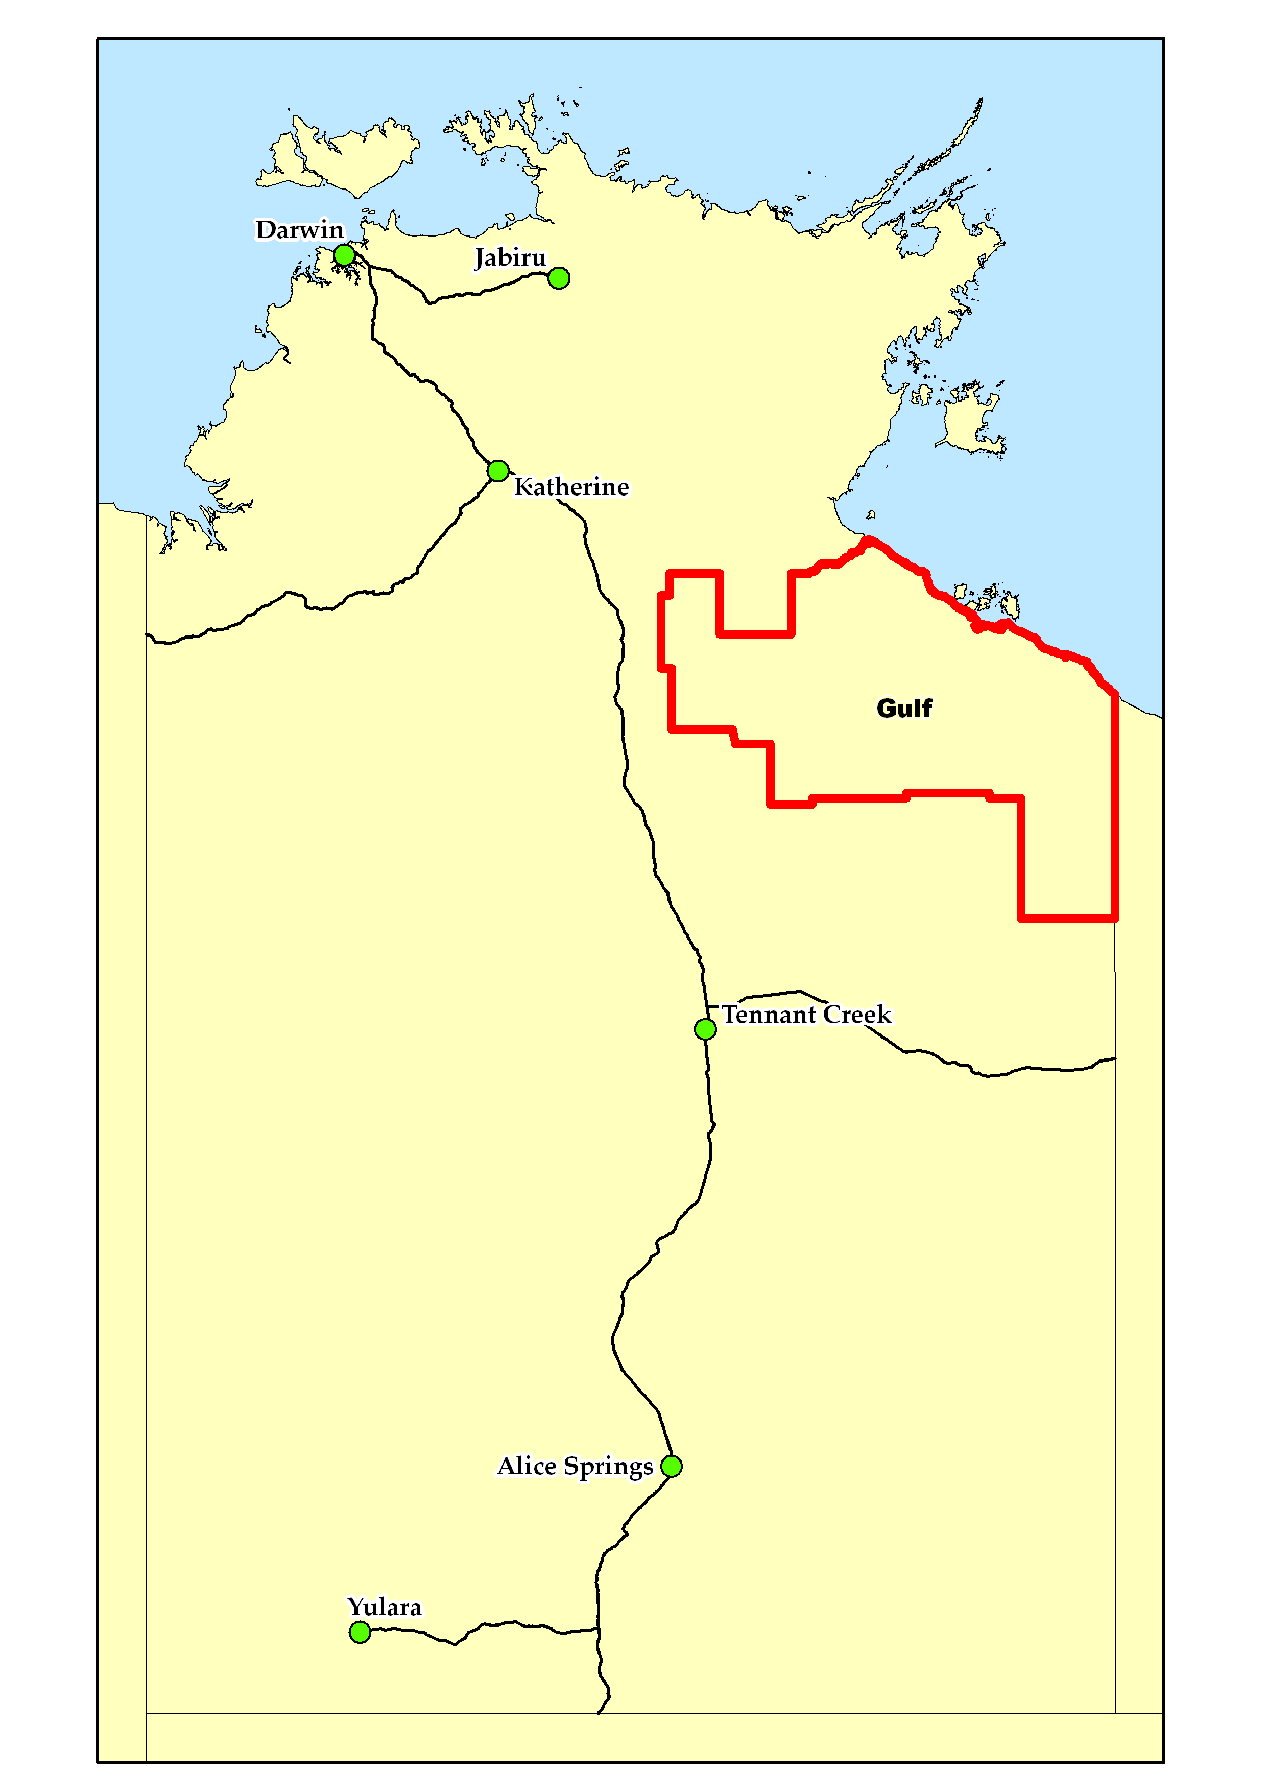
2015/16 Wet Season (as at 1 June 2016)
Pasture Growth  (% of district) | Below Average  65% | Average  30% |  | Above Average  5%
 | <1,000kg/ha  9% | >1,000 & <2,000kg/ha  62% |  | >2,000kg/ha  29%
Currently
Total Standing Dry Matter  (% of district) | Below Average  80% | Average  20% |  | Above Average  <1%
 | <1,000kg/ha  10% | >1,000 & <3,000kg/ha  76% |  | >3,000kg/ha  14%
Fire Risk  (% of district) | High  99% | Moderate  1% |  | Low  0%
Area Burnt  (% of district) | 15% (2015/16 Total Area Burnt)  <1% (since 1st January 2016)
Median Pasture Growth (kg/ha)  (Running Total) |  |  | Chance of exceeding Median Pasture Growth  (June - August 2016)
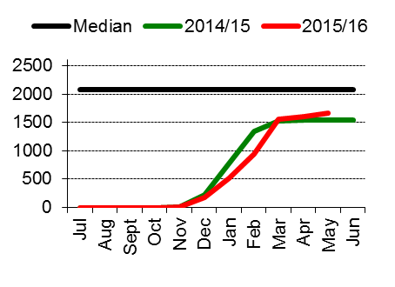 |  |  |  |  | 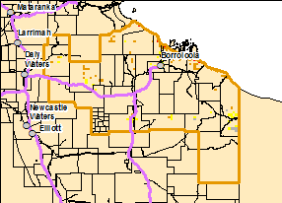  Note: Missing data is due to seasonally low growth at this time of the year
Total 2014/15 Pasture Growth  (July 2015 – May 2016)  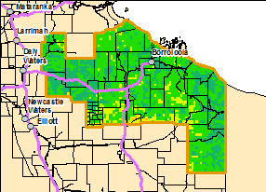 |  |  |  |  | Current Estimated  Total Standing Dry Matter  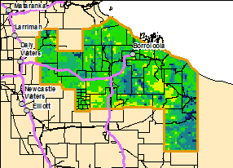

Barkly District  Risks:  - None to report |  |  |  |  |  | 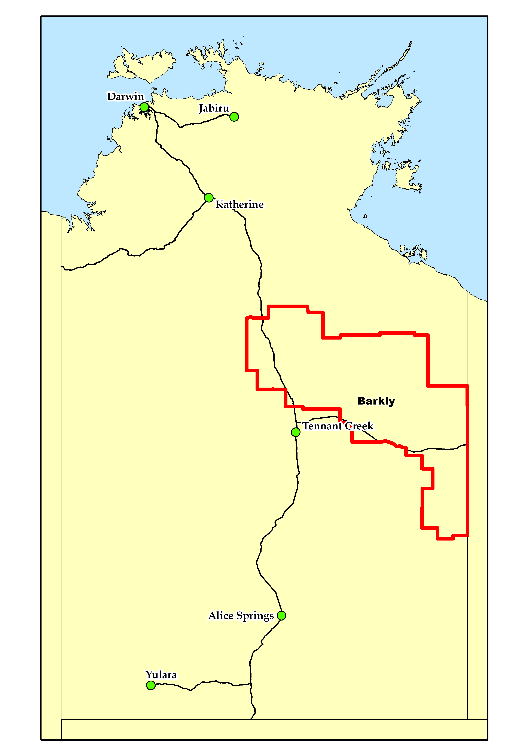
2015/16 Wet Season (as at 1 June 2016)
Pasture Growth  (% of district) | Below Average  4% | Average  65% |  | Above Average  31%
 | <500kg/ha  13% | >500 & <1,000kg/ha  43% |  | >1,000kg/ha  45%
Currently
Total Standing Dry Matter  (% of district) | Below Average  12% | Average  75% |  | Above Average  13%
 | <500kg/ha  12% | >500 & <1,000kg/ha  36% |  | >1,000kg/ha  52%
Fire Risk  (% of district) | High  86% | Moderate  14% |  | Low  0%
Area Burnt  (% of district) | 11% (2015/16 Total Area Burnt)  1% (since 1st January 2016)
Median Pasture Growth (kg/ha)  (Running Total) |  |  | Chance of exceeding Median Pasture Growth  (June - August 2016)
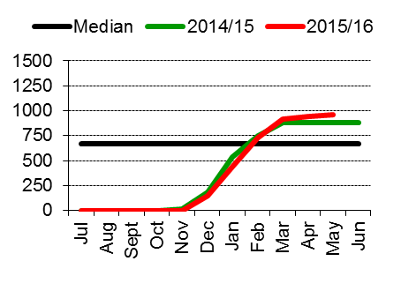 |  |  |  |  | 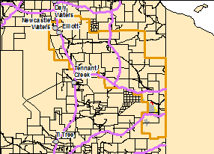  Note: Missing data is due to seasonally low growth at this time of the year
Total 2015/16 Pasture Growth  (July 2015 –May 2016)  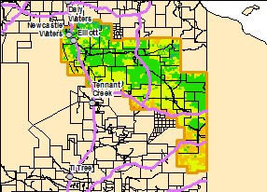 |  |  |  |  | Current Estimated  Total Standing Dry Matter  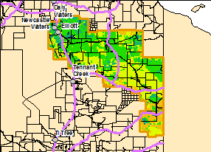

Tennant Creek District  Risks:  - None to report |  |  |  |  |  | 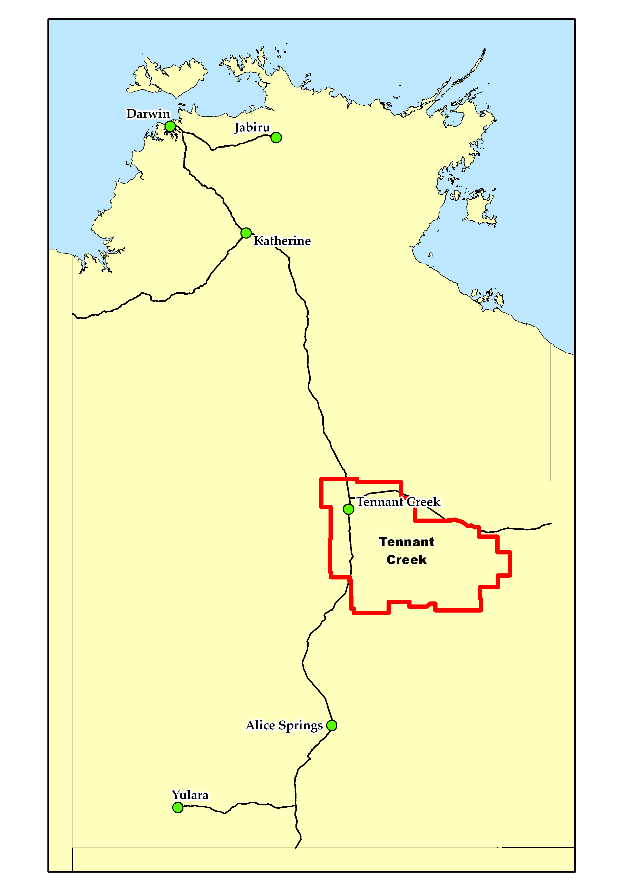
2015/16 Season (as at 1 June 2016)
Pasture Growth  (% of district) | Below Average  0% | Average  46% |  | Above Average  54%
 | <250kg/ha  6% | >250 & <500kg/ha  28% |  | >500kg/ha  67%
Currently
Total Standing Dry Matter  (% of district) | Below Average  20% | Average  64% |  | Above Average  16%
 | <500kg/ha  13% | >500 & <1,000kg/ha  24% |  | >1,000kg/ha  63%
Fire Risk  (% of district) | High  76% | Moderate  24% |  | Low  0%
Area Burnt  (% of district) | 9% (2015/16 Total Area Burnt)  1% (since 1st January 2016)
Median Pasture Growth (kg/ha)  (Running Total) |  |  | Chance of exceeding Median Pasture Growth  (June - August 2016)
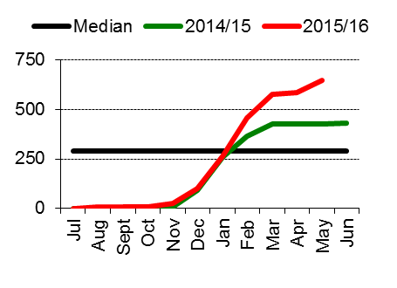 |  |  |  |  | 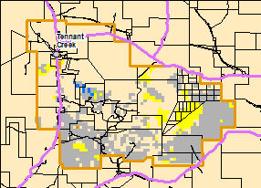  Note: Missing data is due to seasonally low growth at this time of the year
Total 2015/16 Pasture Growth  (July 2015 - May 2016)  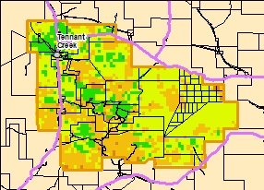 |  |  |  |  | Current Estimated  Total Standing Dry Matter  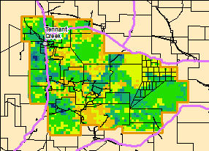

Northern Alice Springs District  Risks:  - None to report |  |  |  |  |  | 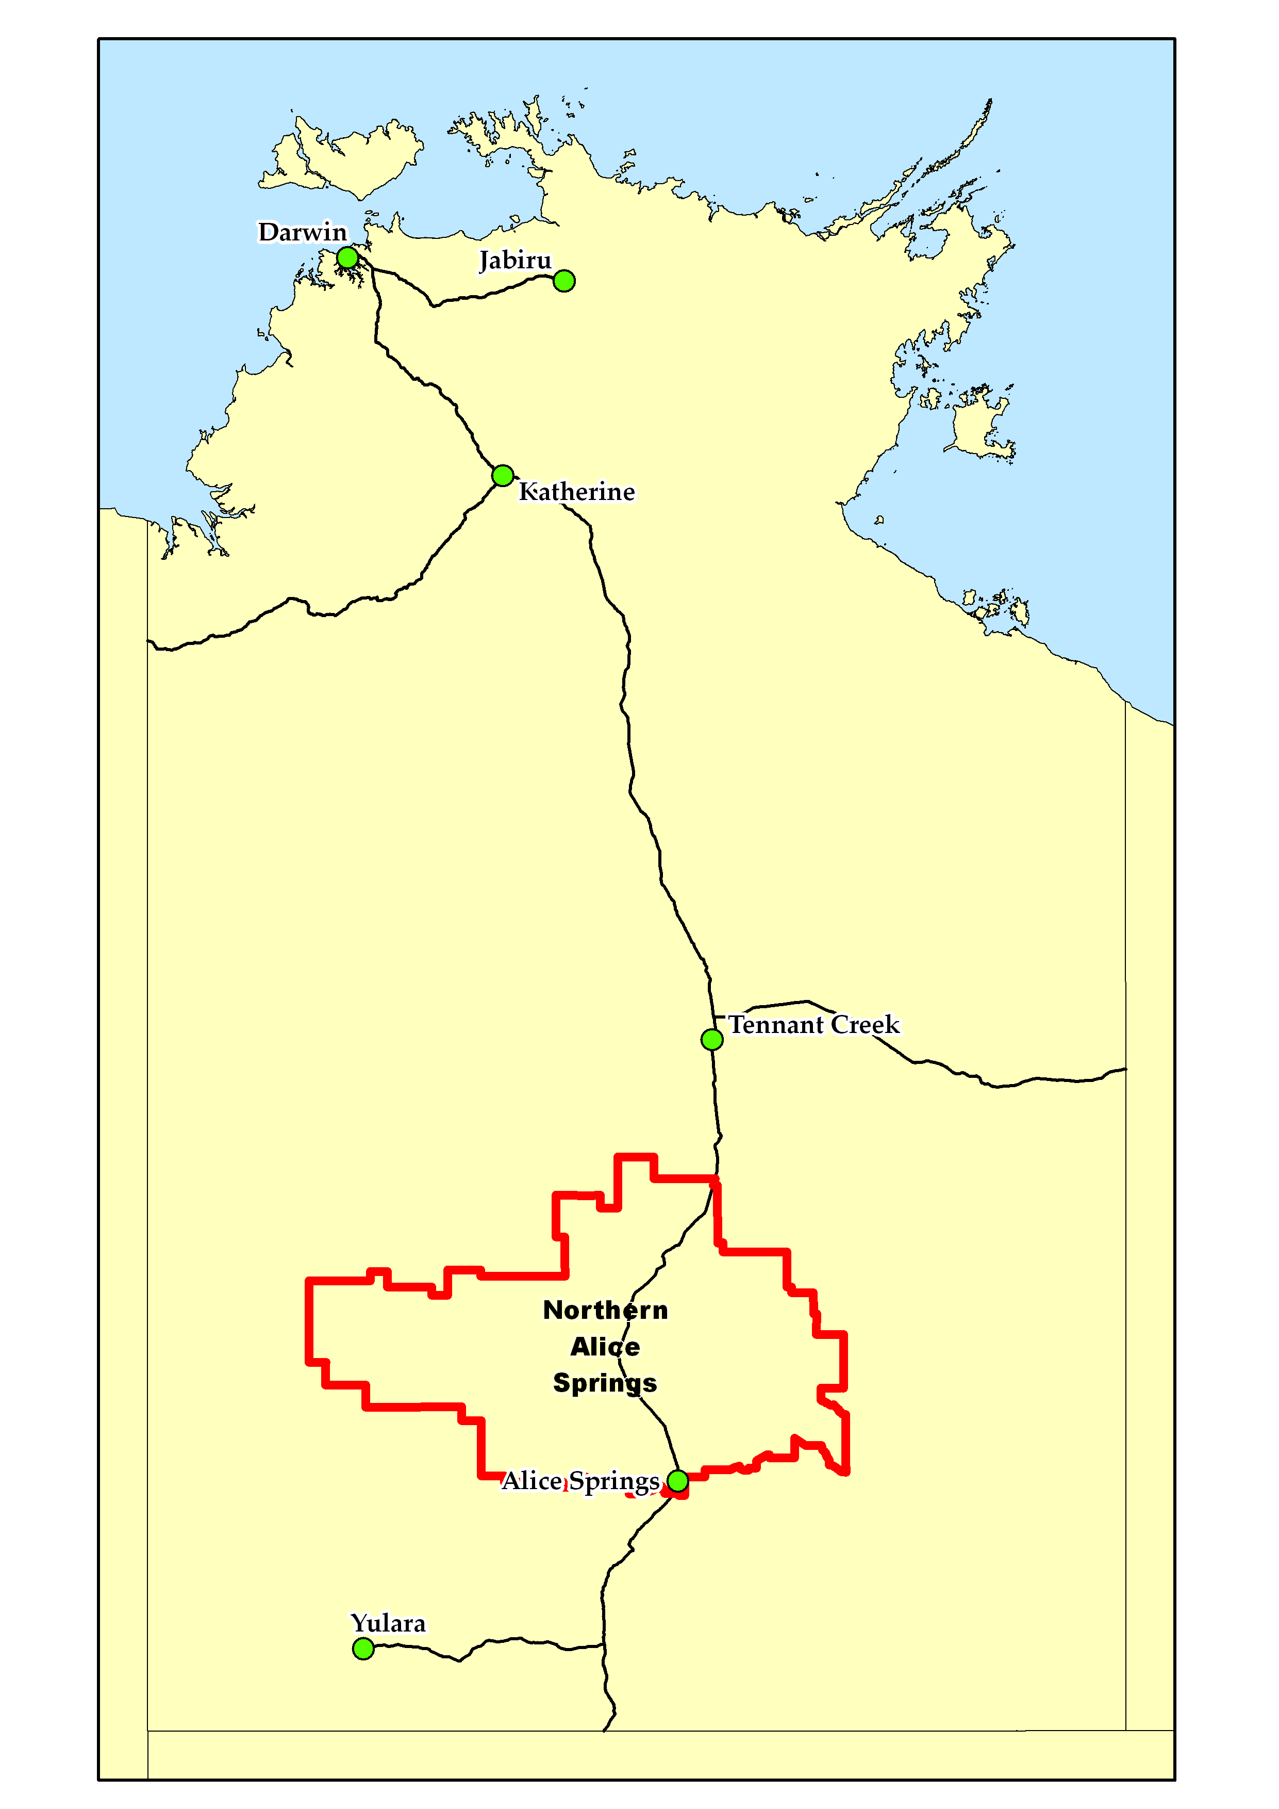
2015/16 Season (as at 1 June 2016)
Pasture Growth  (% of district) | Below Average  10% | Average  85% |  | Above Average  4%
 | <250kg/ha  22% | >250 & <500kg/ha  36% |  | >500kg/ha  42%
Currently
Total Standing Dry Matter  (% of district) | Below Average  14% | Average  80% |  | Above Average  5%
 | <250kg/ha  3% | >250 & <1,000kg/ha  41% |  | >1,000kg/ha  56%
Fire Risk  (% of district) | High  84% | Moderate  15% |  | Low  1%
Area Burnt  (% of district) | 2% (2015/16 Total Area Burnt)  <1% (since 1st January 2016)
Median Pasture Growth (kg/ha)  (Running Total) |  |  | Chance of exceeding Median Pasture Growth  (June August 2016)
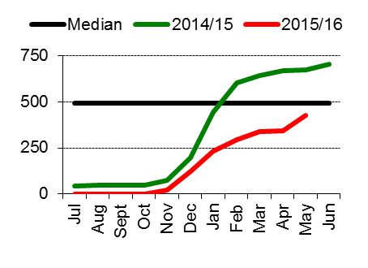 |  |  |  |  | 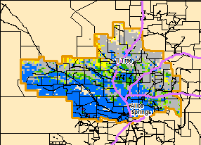
Total 2015/16 Pasture Growth  (July 2015– May 2016)  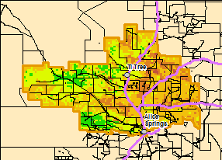 |  |  |  |  | Current Estimated  Total Standing Dry Matter  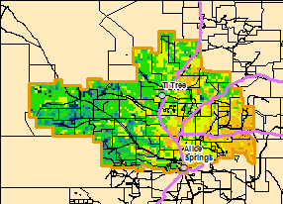

Plenty District  Risks:  - None to report |  |  |  |  |  | 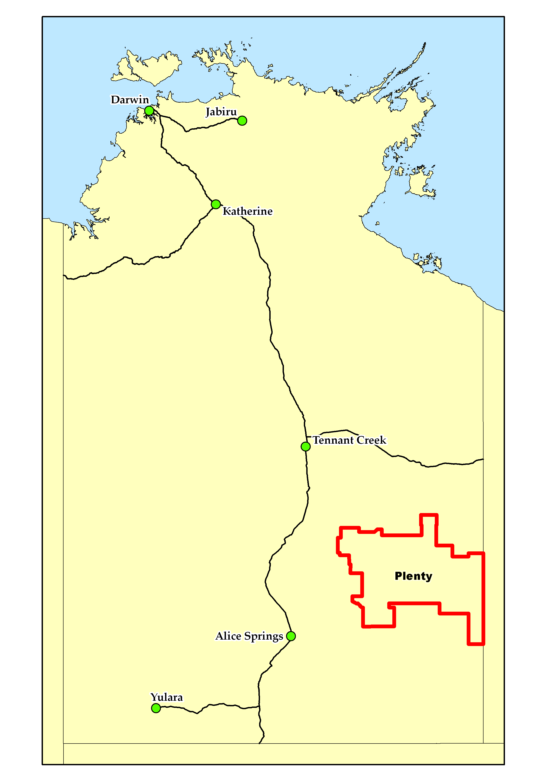
2015/16 Season (as at 1 June 2016)
Pasture Growth  (% of district) | Below Average  1% | Average  66% |  | Above Average  33%
 | <250kg/ha  31% | >250 & <500kg/ha  27% |  | >500kg/ha  43%
Currently
Total Standing Dry Matter  (% of district) | Below Average  13% | Average  83% |  | Above Average  4%
 | <250kg/ha  11% | >250 & <1,000kg/ha  58% |  | >1,000kg/ha  30%
Fire Risk  (% of district) | High  72% | Moderate  26% |  | Low  2%
Area Burnt  (% of district) | 0% (2015/16 Total Area Burnt)  0% (since 1st January 2016)
Median Pasture Growth (kg/ha)  (Running Total) |  |  | Chance of exceeding Median Pasture Growth  (June - August 2016)
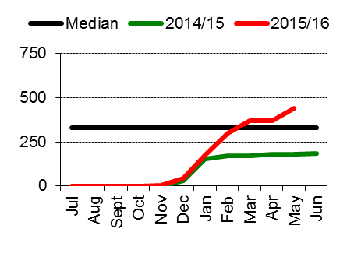 |  |  |  |  | 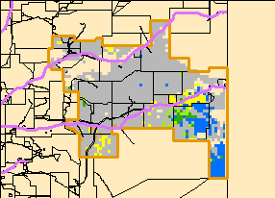
Total 2015/16 Pasture Growth  (July 2015– May 2016)  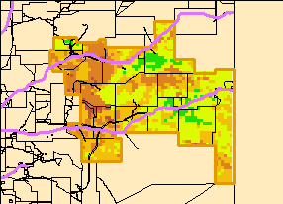 |  |  |  |  | Current Estimated  Total Standing Dry Matter  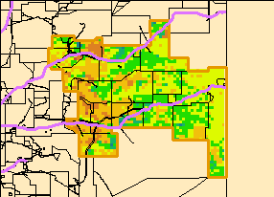

Southern Alice Springs District  Risks:  - None to report |  |  |  |  |  | 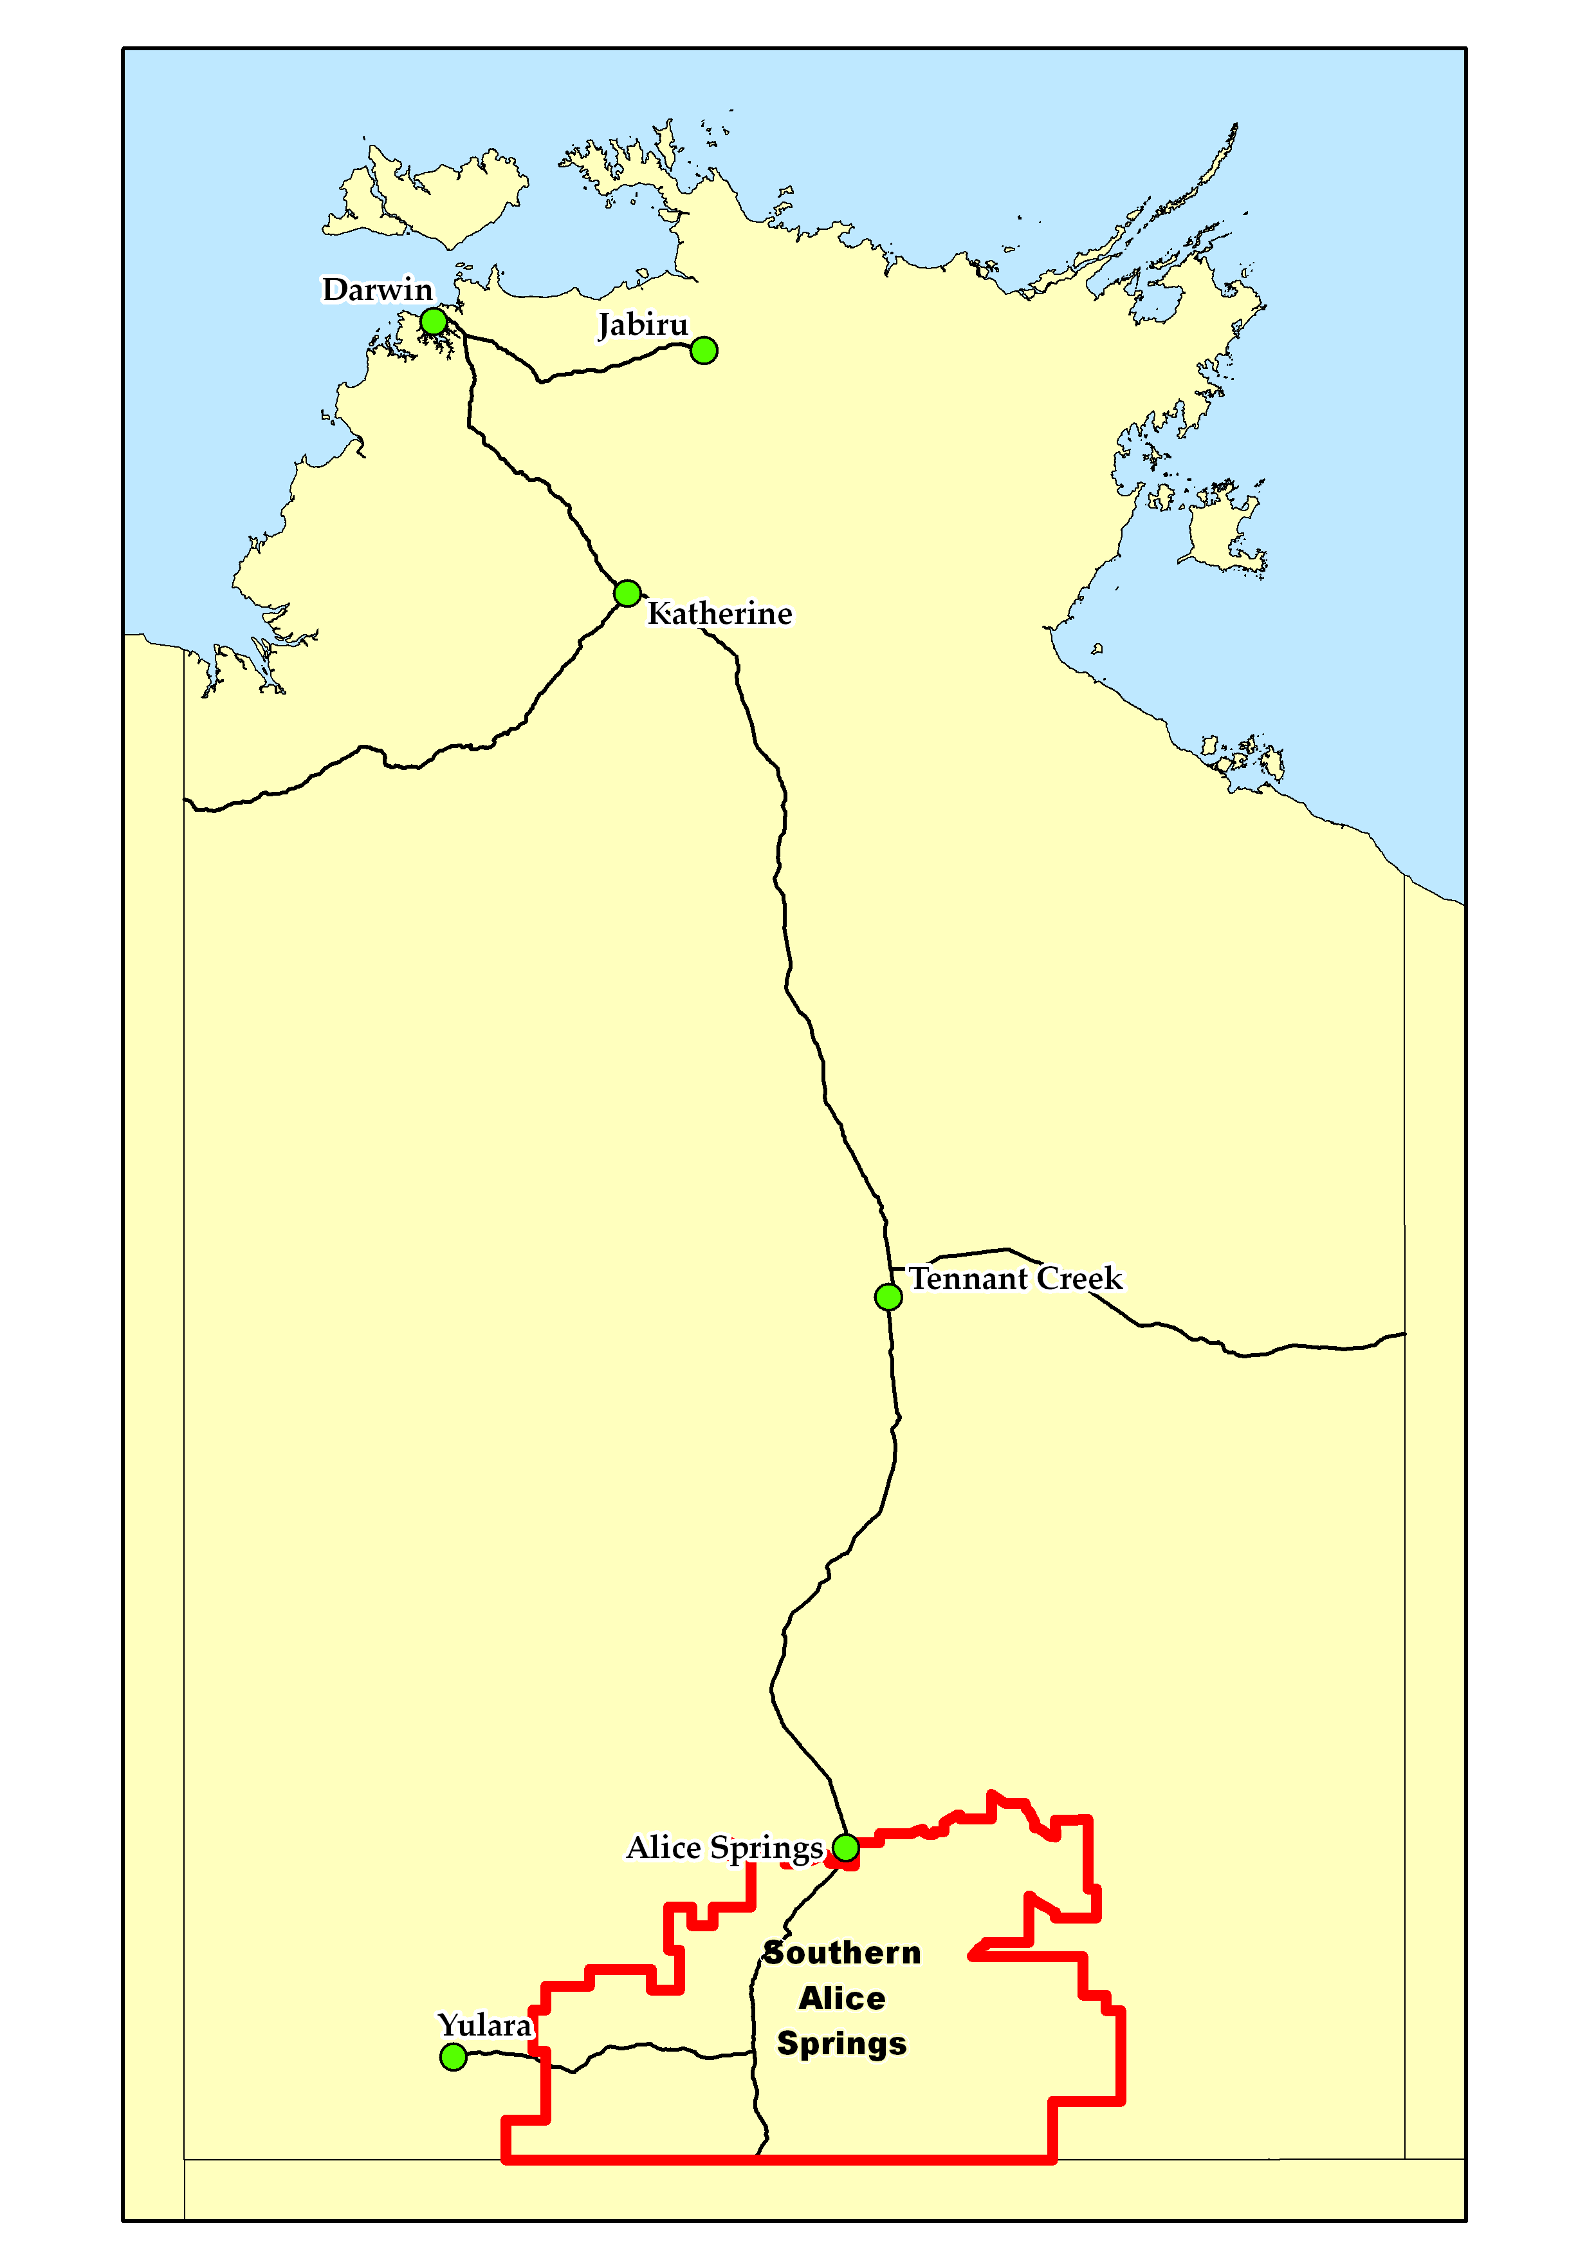
2015/16 Season (as at 1 June 2016)
Pasture Growth  (% of district) | Below Average  3% | Average  87% |  | Above Average  10%
 | <250kg/ha  24% | >250 & <500kg/ha  37% |  | >500kg/ha  39%
Currently
Total Standing Dry Matter  (% of district) | Below Average  31% | Average  67% |  | Above Average  2%
 | <250kg/ha  8% | >250 & <1,000kg/ha  68% |  | >1,000kg/ha  24%
Fire Risk  (% of district) | High  71% | Moderate  29% |  | Low  1%
Area Burnt  (% of district) | <1% (2015/16 Total Area Burnt)  <1% (since 1st January 2016)
Median Pasture Growth (kg/ha)  (Running Total) |  |  | Chance of exceeding Median Pasture Growth  (June - August 2016)
 |  |  |  |  | 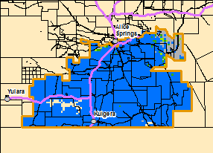
Total 2015/16 Pasture Growth  (July 2015- May 2016)  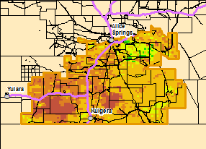 |  |  |  |  | Current Estimated  Total Standing Dry Matter  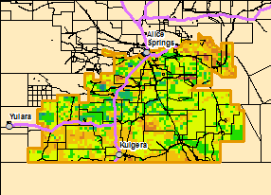

Pasture Information
The pasture and fire risk information in this document is derived from AussieGRASS. AussieGRASS is a model that simulates pasture growth and standing biomass using climate data, vegetation mapping, fire history and regional estimates of grazing pressure. The model can be used to track simulated pasture growth and total standing pasture biomass at the landscape scale.
Note that the model does not use stocking rate data for individual properties. Where stock numbers are significantly higher or lower than typical for a district, model estimates of total standing dry matter may be erroneous.

Disclaimer
While all care has been taken to ensure that information contained in this document is true and correct at the time of production, changes in circumstances after the time of distribution may impact on the accuracy of its information. The Northern Territory of Australia gives no warranty or assurance, and makes no representation as to the accuracy of any information or advice contained herein, or that it is suitable for your intended use.
You should not rely upon information in this document for the purpose of making any business or investment decisions without obtaining independent and/or professional advice in relation to your particular situation.
The Northern Territory of Australia disclaims any liability or responsibility or duty of care towards any person for loss of damage caused by any use of or reliance on this information.

