Overview
After a strong result in the September quarter, state final demand (SFD) decreased by 0.5% in the December quarter. Household consumption and business investment increased in the quarter, by 0.2% and 2.2% respectively, but this was more than offset by declines in volatile government consumption and investment and weaker housing investment. SFD increased by 3.3% in annual terms and by 4.8% in 2022 overall (see Chart 1), in line with 4.9% growth nationally. Growth in household consumption, the main contributor to growth in 2021, is moderating as rising interest rates designed to address inflationary pressures are creating uncertain macroeconomic conditions with flow through impacts to household spending.
The Territory economy is performing well above pre-pandemic levels, but the quarterly data for a number of indicators report mixed results. Retail turnover is declining in real terms at a greater rate than nationally, suggesting Territory consumers are more sensitive to the current economic uncertainty (see Chart 2). That said, business confidence remains strong across the Territory, with the major business concern being access to suitable labour. Job vacancies across the Territory are well above pre-pandemic levels and remain high, particularly in the private sector, though are starting to fall from recent all-time highs (see Chart 3). Wage growth is accelerating, notably in the private sector, reflecting the tight labour market (see Chart 4).
Indicator | Most recent | Measure | Period change¹ | Annual change² | Year on Year³ | COVID period change⁴
Economic Growth |  | $B
State final demand (NT) (sa) | Dec-22 | 7.067 | -0.5% | 3.3% | 4.8% | 17.7%
Consumption |  | 5.369 | -0.3% | 2.1% | 2.3% | 10.8%
Investment |  | 1.699 | -1.2% | 7.2% | 13.8% | 40.9%
Domestic final demand (Aus) (sa) | Dec-22 | 536.867 | 0.0% | 3.3% | 4.9% | 9.0%
Consumption |  | 414.037 | 0.4% | 4.5% | 6.1% | 9.4%
Investment |  | 122.829 | -1.4% | -0.4% | 0.9% | 7.6%
Gross state product (NT) | 2021-22 | 26.058 | na | na | 4.7% | na
Gross domestic product (Aus) | 2021-22 | 2,156.844 | na | na | 3.7% | na
Partial Indicators |  | $B
Nominal retail sales (NT) (sa) | Jan-23 | 0.310 | 0.2% | 0.4% | 2.9% | 18.8%
Nominal retail sales (Aus) (sa) | Jan-23 | 35.091 | 1.9% | 7.5% | 11.4% | 26.4%
Construction work done (NT) (sa) | Dec-22 | 0.635 | -6.5% | -18.9% | 5.6% | 32.3%
Construction work done (Aus) (sa) | Dec-22 | 55.272 | -0.4% | 1.0% | 0.7% | 3.8%
Residential building activity (NT) | Sep-22 | 0.092 | 7.0% | 3.0% | -8.3% | 12.0%
Residential building activity (Aus) | Sep-22 | 18.538 | 1.1% | -6.0% | -3.0% | -0.7%
Nominal goods exports (NT) | Jan-23 | 1.101 | -32.3% | -6.7% | 13.2% | 0.3%
Nominal goods exports (Aus) (sa) | Jan-23 | 51.014 | 1.1% | 12.5% | 28.0% | 58.4%
Prices |  | Annual ↕²
Inflation (Darwin) | Dec-22 | 7.1% | 0.1 ppt | 1.1 ppt | na | 6.7 ppt
Inflation (8 Capitals) | Dec-22 | 7.8% | 0.6 ppt | 4.3 ppt | na | 6.0 ppt
WPI growth (NT) | Dec-22 | 2.6% | 0.1 ppt | 0.5 ppt | na | 0.1 ppt
WPI growth (Aus) | Dec-22 | 3.4% | 0.2 ppt | 1.1 ppt | na | 1.2 ppt
Employment |  | #M
Employment (NT) (sa) | Feb-23 | 0.142 | 1.2% | 4.9% | 3.6% | 4.4%
Employment (Aus) (sa) | Feb-23 | 13.826 | 0.5% | 3.0% | 4.2% | 6.7%
Unemployment |  | Rate
Unemployment rate (NT) (sa) | Feb-23 | 4.6% | 0.6 ppt | 1.0 ppt | na | -0.5 ppt
Unemployment rate (Aus) (sa) | Feb-23 | 3.5% | -0.1 ppt | -0.5 ppt | na | -1.5 ppt
Population |  | #M
Population (NT) | Sep-22 | 0.251 | 0.0% | 0.4% | na | 1.2%
Population (Aus) | Sep-22 | 26.125 | 0.5% | 1.6% | na | 2.3%
1. Monthly change for retail sales, goods exports, employment and unemployment; quarterly change for all other variables.
2. Compares the latest period with the same period last year.
3. Compares the 12 months up to and including the latest period with the previous 12-month period using original data.
4. Percentage change from December 2019 to most recent data.
Chart 1: SFD declined by 0.5% in the December quarter and increased by 4.8% in 2022. Private investment and public consumption were the main contributors to growth in the past year, while household consumption’s contribution was close to flat. Private investment is being supported by investment for the Barossa gas project and the Core Lithium’s Finniss mine, as well as a number of major building and engineering projects. | Chart 2: Nominal retail turnover is being propped-up by broad-based price increases, with real turnover trending down as discretionary household spending is being dampened by interest rate hikes. In the Territory, turnover is trending down at a greater rate than nationally. As the chart shows, real retail turnover has been largely static over the past nine years, despite population growth of more than 3%.
State Final Demand – NT  Components, moving annual total | Retail Turnover  Real, quarterly, seasonally adjusted
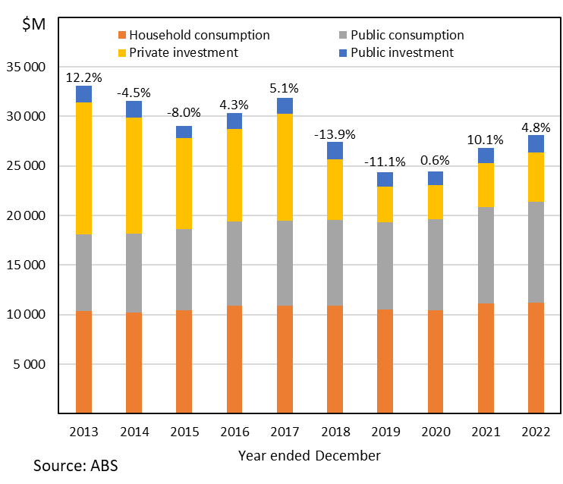 | 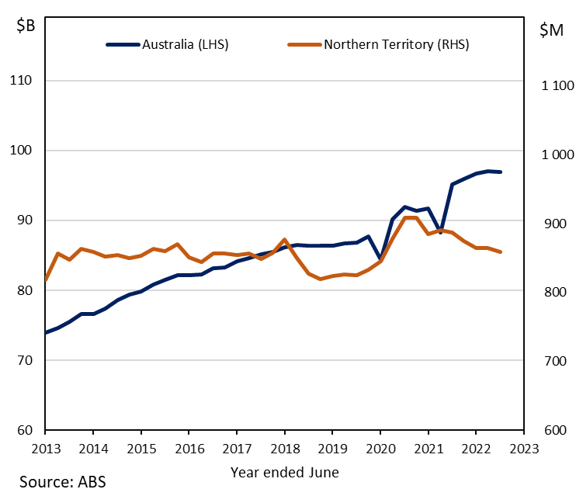
Chart 3: Over the past year job vacancies have been at record high levels as the unemployment rate was anchored at around 4%. Annual growth in vacancies is starting to moderate but broad-based labour shortages remain prevalent, particularly in the private sector. Recent analysis by Jobs and Skills Australia reports there are greater challenges recruiting in regional labour markets compared with capital cities, with fewer applicants per vacancy and lower ‘fill rates’. | Chart 4: Private sector wages increased by 3.9% annually to December 2022, demonstrating how the private sector is more responsive to changing economic conditions. The Fair Work Commission’s decision to increase the minimum wage is also a factor, with increases to award minimum wages in aviation, tourism and hospitality (4.6%) effective from 1 October 2022, and all other awards (also 4.6%) and the national minimum wage (5.2%) effective from 1 July 2022.
Job vacancies by Sector – NT  Annual percentage change | Wage Price Index by Sector – NT  Year-on-year percentage change
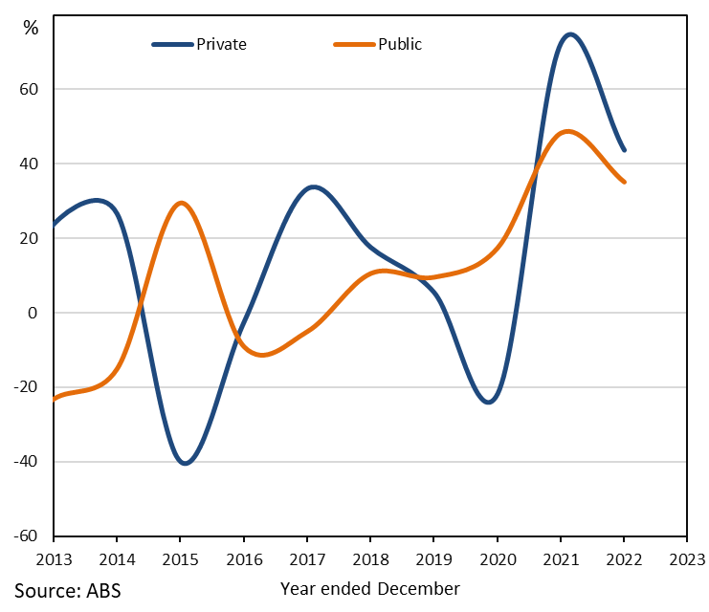 | 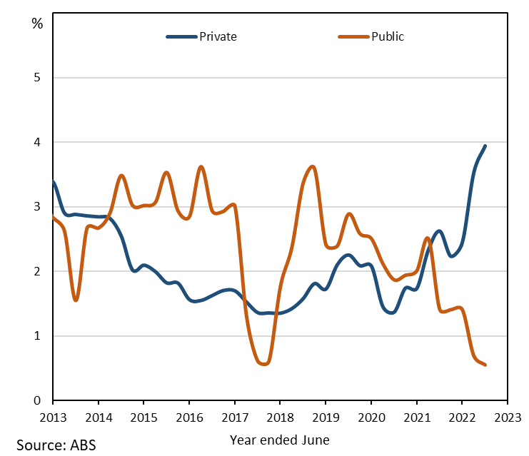
The Northern Territory of Australia exercised due care and skill to ensure that at the time of publication the information contained in this publication is true and correct. However, it is not intended to be relied on as professional advice or used for commercial purposes. The Territory gives no warranty or assurances as to the accuracy of the information contained in the publication and to the maximum extent permitted by law accepts no direct or indirect liability for reliance on its content.

