# Economic growth

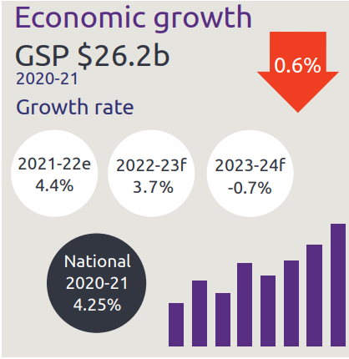

* Economic growth GSP $26.2 billion
* NT growth rate:
  + 2021-22 is 4.4%
  + 2022-23 is 3.7%
  + 2023-24 is -0.7%
* National growth rate in 2020-21 is 4.25%

# Industry share of output top 5

Industry share of output as described below

* Construction is 5.6%
* Mining is 24.6%
* Public admin is 11.9%
* Health is 8.1%
* Education is 4.9%

# State Final Demand

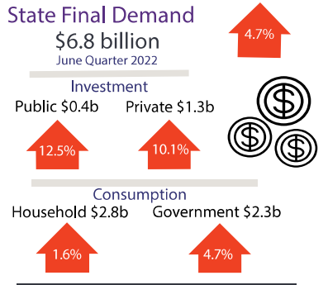

* State Final Demand, up 4.7% to $6.8 billion through the year to June 2022
  + Public investment, up 12.4% to $0.4 billion through the year to June 2022
  + Private business investment, up 10.1% to $10.1 billion through the year to June 2022
  + Household consumption, up 1.6% to $2.8 billion through the year to June 2022
  + Government consumption, up 4.7% to $2.3 billion through the year to June 2022

# Business confidence for the Northern Territory

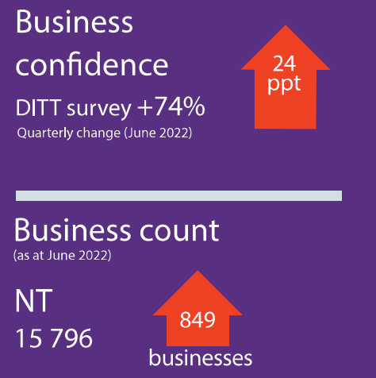

* Business confidence for the Northern Territory is +74% (360 businesses) in the June 2022 quarter, up 24 percentage points from the previous quarter
* Business count as at June 2022 for the Northern Territory was 15 796 up 849 businesses over the year to June 2022

# Darwin inflation

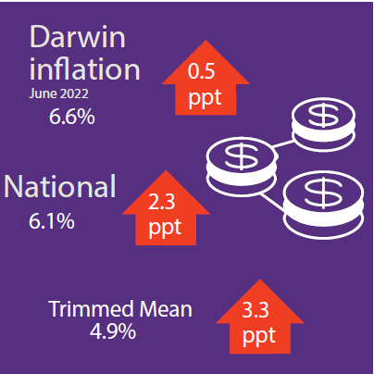

* Darwin inflation decreased 6.6% through the year to June 2022
* National inflation increased 6.1%
* Trimmed mean increased 3.3%

# Labour market

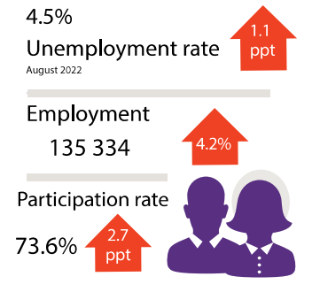

* Unemployment rate is 4.5% as of August 2022
* Employment is 135 334 up 4.2% through the year to August 2022
* Participation rate was 73.6% as of July 2022, up 2.7 percentage points through the year to July 2022

# NT population

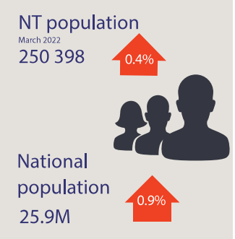

* NT population is 250 398, up 0.4% through the year
* National population is 25.9 million, up 0.9% through the year

# Population distribution

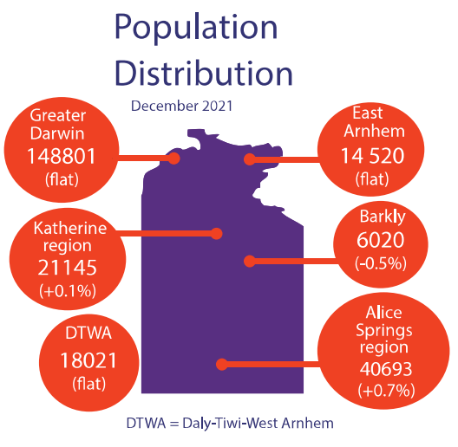

Population distribution:

* Greater Darwin was 148801
* East Arnhem was 14520
* Katherine was 21145
* Alice Springs was 40693
* Barkly was 6020
* Daly-Tiwi-West Arnhem was 18021

# Average weekly earnings

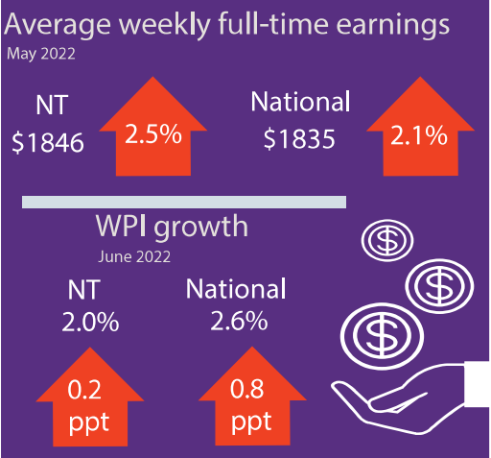

Average weekly earnings in the NT is $1846, up 2.5% through the year to May 2022

Average weekly earnings nationally is $1835, up 2.1% through the year to May 2022

WPI in the NT increased by 2.0% through the year to May 2022 and 2.6% nationally

# Median house prices

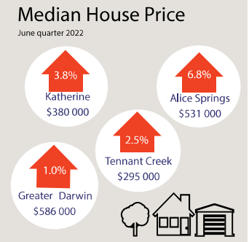

Median house prices in the June quarter 2022:

* Katherine $380 000 up 3.8%
* Alice Springs $531 000 up 6.8%
* Tennant Creek $295 000 up 2.5%
* Greater Darwin $ 586 000 up 1.0%

# Business size

Business size as described below

NT business size:

* Small is 96.7%
* Medium is 3.2%
* Large is 0.1%

# Business location

Business location as described below

Businesses by location:

* Greater Darwin has 72.9%
* Katherine has 6.4%
* Alice Springs has 13.1%
* Rest of NT has 7.6%

NT Department of Industry, Tourism and Trade  
t: 08 8999 5139  
industry.nt.gov.au