Mineral Titles Act 2010
NOTICE OF LAND CEASING TO BE A MINERAL TITLE APPLICATION AREA
Title Type and Number: | Extractive Mineral Exploration Licence 32588
Area Ceased on: | 06 June 2022
Area: | 4 Blocks, 13.13 km²
Locality: | NEWCASTLE WATERS
Name of Applicant(s)/Holder(s): | 100% TERRITORY SANDS PTY LTD [ACN. 632 797 972]
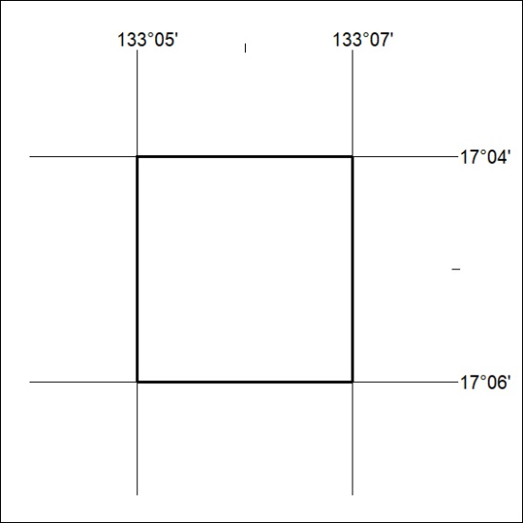

187/22

Mineral Titles Act 2010
NOTICE OF LAND CEASING TO BE A MINERAL TITLE APPLICATION AREA
Title Type and Number: | Extractive Mineral Exploration Licence 32600
Area Ceased on: | 06 June 2022
Area: | 4 Blocks, 13.13 km²
Locality: | NEWCASTLE WATERS
Name of Applicant(s)/Holder(s): | 100% TERRITORY SANDS PTY LTD [ACN. 632 797 972]
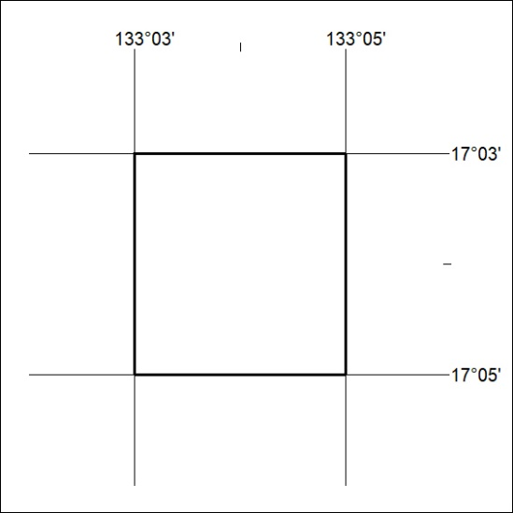

188/22
Mineral Titles Act 2010
NOTICE OF LAND CEASING TO BE A MINERAL TITLE APPLICATION AREA
Title Type and Number: | Extractive Mineral Exploration Licence 32603
Area Ceased on: | 06 June 2022
Area: | 4 Blocks, 13.13 km²
Locality: | NEWCASTLE WATERS
Name of Applicant(s)/Holder(s): | 100% TERRITORY SANDS PTY LTD [ACN. 632 797 972]
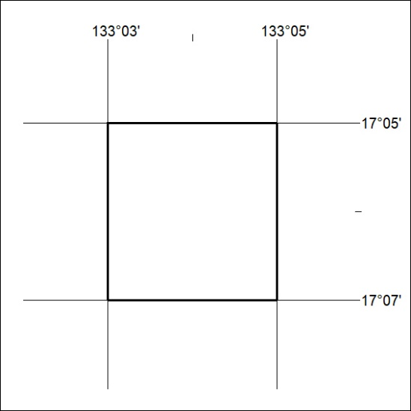

189/22

Mineral Titles Act 2010
NOTICE OF LAND CEASING TO BE A MINERAL TITLE APPLICATION AREA
Title Type and Number: | Extractive Mineral Exploration Licence 32604
Area Ceased on: | 06 June 2022
Area: | 4 Blocks, 13.13 km²
Locality: | NEWCASTLE WATERS
Name of Applicant(s)/Holder(s): | 100% TERRITORY SANDS PTY LTD [ACN. 632 797 972]
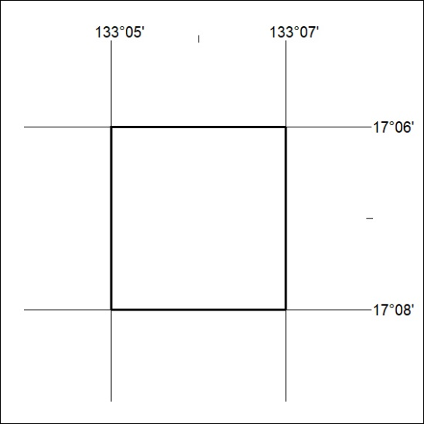

190/22

Mineral Titles Act
NOTICE OF GRANT OF A MINERAL TITLE
Title Type and Number: | Exploration Licence 32939
Granted: | 08 June 2022, for a period of 6 Years
Area: | 75 Blocks, 236.59 km²
Locality: | DOREEN
Name of Holder/s: | 100% KURSK ENERGY PTY LTD [ACN. 654 105 414]
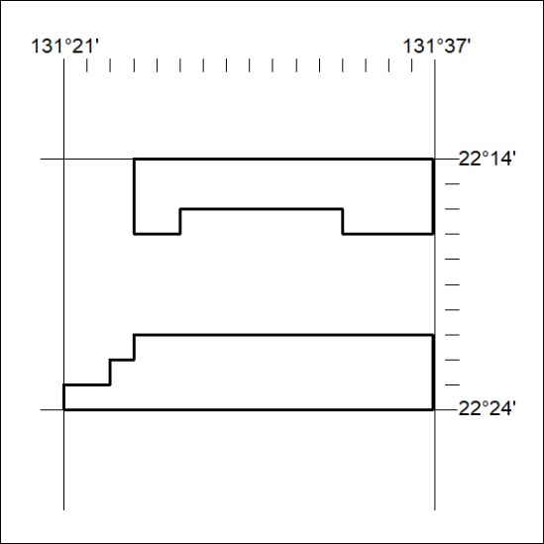
Area granted is indicated above. The titleholder is not permitted to exercise occupational rights on any land that is subject to a development title, or an application for a development title. Any land the subject of a Reserved Land gazettal under the Mineral Titles Act and all land vested in the Commonwealth of Australia is also excluded by description but not excised from the grant area.
191/22

Mineral Titles Act
NOTICE OF GRANT OF A MINERAL TITLE
Title Type and Number: | Exploration Licence 32940
Granted: | 08 June 2022, for a period of 6 Years
Area: | 25 Blocks, 79.47 km²
Locality: | VAUGHAN
Name of Holder/s: | 100% KURSK ENERGY PTY LTD [ACN. 654 105 414]
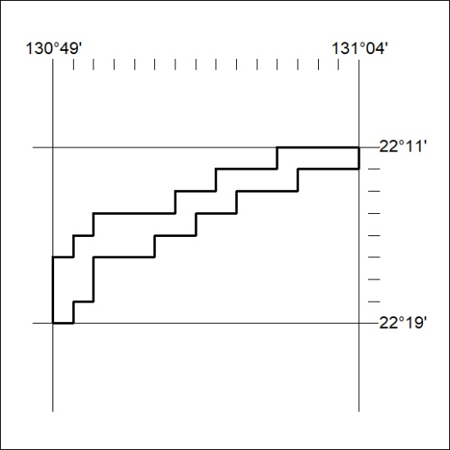
Area granted is indicated above. The titleholder is not permitted to exercise occupational rights on any land that is subject to a development title, or an application for a development title. Any land the subject of a Reserved Land gazettal under the Mineral Titles Act and all land vested in the Commonwealth of Australia is also excluded by description but not excised from the grant area.
192/22

