Mineral Titles Act 2010
NOTICE OF LAND CEASING TO BE A MINERAL TITLE AREA
Title Type and Number: | Exploration Licence 31664
Area Ceased on: | 14 May 2022
Area: | 230 Blocks, 764.98 km²
Locality: | THROSBY
Name of Applicant(s)/Holder(s): | 100% MOROAK RESOURCES PTY LTD [ACN. 616 553 014]
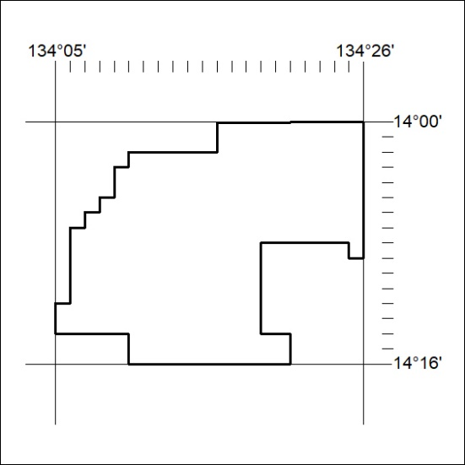

165/22

Mineral Titles Act
NOTICE OF GRANT OF A MINERAL TITLE
Title Type and Number: | Exploration Licence 32816
Granted: | 16 May 2022, for a period of 6 Years
Area: | 4 Blocks, 12.98 km²
Locality: | PLAYFORD
Name of Holder/s: | 100% BARKLY OPERATIONS PTY LTD [ACN. 641 856 706]
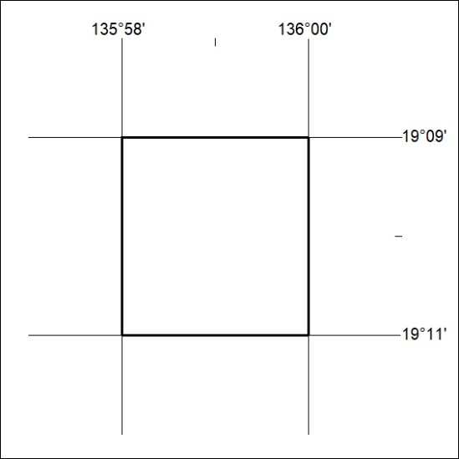
Area granted is indicated above. The titleholder is not permitted to exercise occupational rights on any land that is subject to a development title, or an application for a development title. Any land the subject of a Reserved Land gazettal under the Mineral Titles Act and all land vested in the Commonwealth of Australia is also excluded by description but not excised from the grant area.

166/22

