Mineral Titles Act 2010
NOTICE OF LAND CEASING TO BE A MINERAL TITLE AREA
Title Type and Number: | Exploration Licence 27070
Area Ceased on: | 29 July 2021
Area: | 7 Blocks, 22.37 km²
Locality: | ANNINGIE
Name of Applicant(s)/Holder(s): | 100% ENIGMA MINING LIMITED [ACN. 009 225 558]
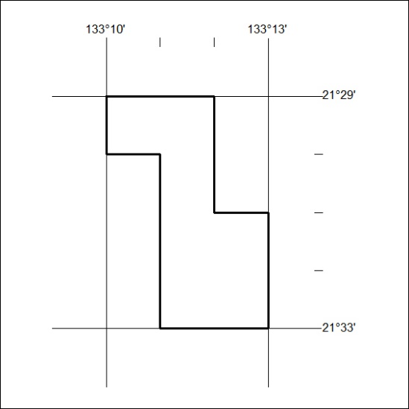

281/21

Mineral Titles Act 2010
NOTICE OF LAND CEASING TO BE A MINERAL TITLE AREA
Title Type and Number: | Extractive Mineral Permit 25200
Area ceased on: | 29 July 2021
Area: | 50.00 Hectare
Locality: | NOONAMAH
Name of Applicants(s)Holder(s): | 100% BOB KERR TRANSPORT PTY LTD [ACN. 109 115 059]
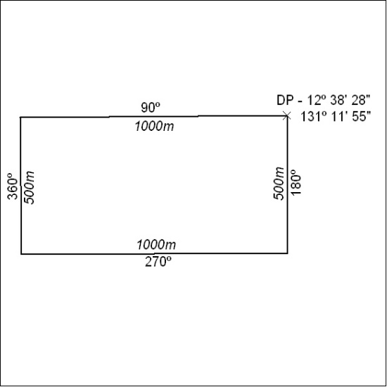

282/21

Mineral Titles Act
NOTICE OF GRANT OF A MINERAL TITLE
Title Type and Number: | Exploration Licence 32616
Granted: | 28 July 2021, for a period of 6 Years
Area: | 243 Blocks, 800.57 km²
Locality: | NEWRY
Name of Holder/s: | 50% FARNELL Geoffrey Kenneth, 50% HOKIN Geoffrey David
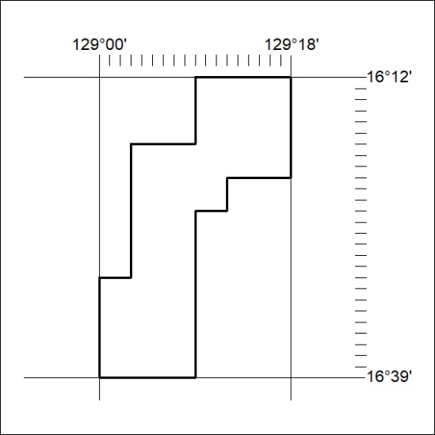
Area granted is indicated above. The titleholder is not permitted to exercise occupational rights on any land that is subject to a development title, or an application for a development title. Any land the subject of a Reserved Land gazettal under the Mineral Titles Act and all land vested in the Commonwealth of Australia is also excluded by description but not excised from the grant area.

283/21

