Mineral Titles Act 2010
NOTICE OF LAND CEASING TO BE A MINERAL TITLE APPLICATION AREA
Title Type and Number: | Extractive Mineral Permit 31669
Area ceased on: | 15 July 2021
Area: | 96.00 Hectare
Locality: | NOONAMAH
Name of Applicants(s)Holder(s): | 100% YEBNA SANDS PTY LTD [ACN. 606 114 603]
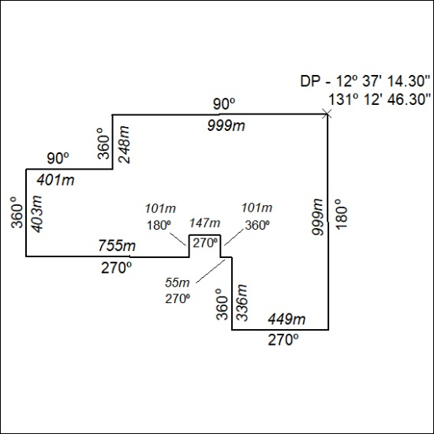

277/21

Mineral Titles Act 2010
NOTICE OF LAND CEASING TO BE A MINERAL TITLE APPLICATION AREA
Title Type and Number: | Extractive Mineral Permit 31671
Area ceased on: | 15 July 2021
Area: | 73.00 Hectare
Locality: | NOONAMAH
Name of Applicants(s)Holder(s): | 100% YEBNA SANDS PTY LTD [ACN. 606 114 603]
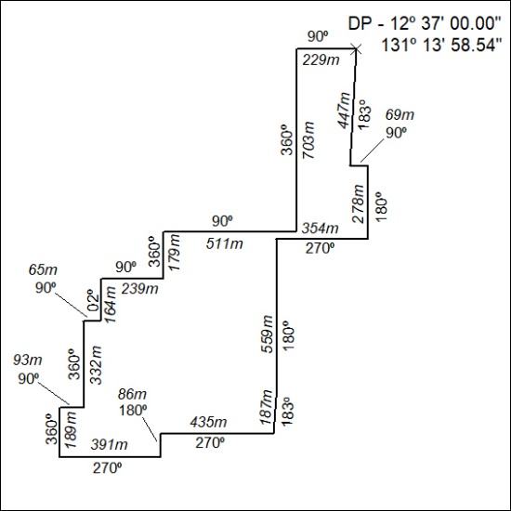

278/21

Mineral Titles Act 2010
NOTICE OF LAND CEASING TO BE A MINERAL TITLE APPLICATION AREA
Title Type and Number: | Extractive Mineral Permit 31672
Area ceased on: | 15 July 2021
Area: | 96.00 Hectare
Locality: | NOONAMAH
Name of Applicants(s)Holder(s): | 100% YEBNA SANDS PTY LTD [ACN. 606 114 603]
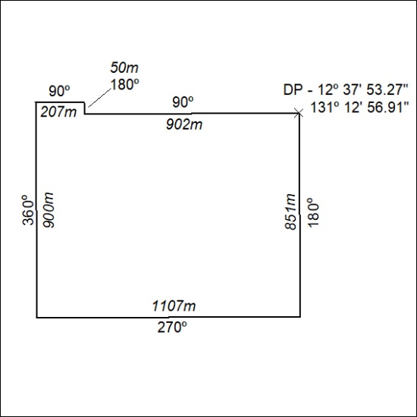

279/21

Mineral Titles Act 2010
NOTICE OF LAND CEASING TO BE A MINERAL TITLE APPLICATION AREA
Title Type and Number: | Extractive Mineral Permit 31673
Area ceased on: | 15 July 2021
Area: | 98.00 Hectare
Locality: | NOONAMAH
Name of Applicants(s)Holder(s): | 100% YEBNA SANDS PTY LTD [ACN. 606 114 603]
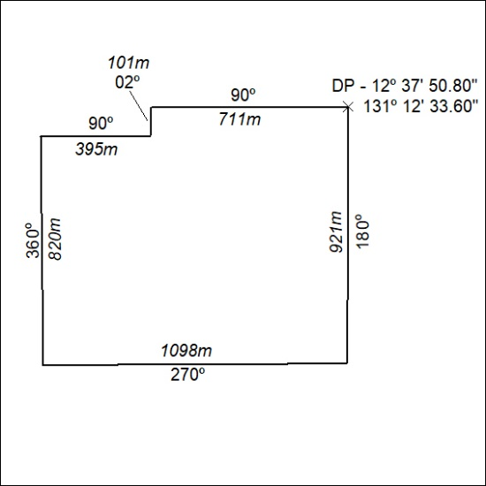

280/21

