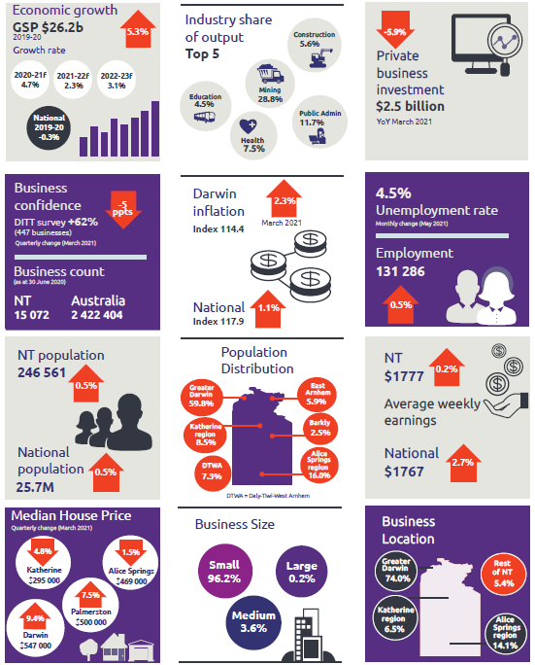
NT Department of Industry, Tourism and Trade
t: 08 8999 5139
industry.nt.gov.au

