Mineral Titles Act
NOTICE OF GRANT OF A MINERAL TITLE
Title Type and Number: | Exploration Licence 32213
Granted: | 09 March 2020, for a period of 6 Years
Area: | 4 Blocks, 12.96 km²
Locality: | FLYNN
Name of Holder/s: | 100% GIANTS REEF EXPLORATION PTY LTD* [ACN. 009 200 346]
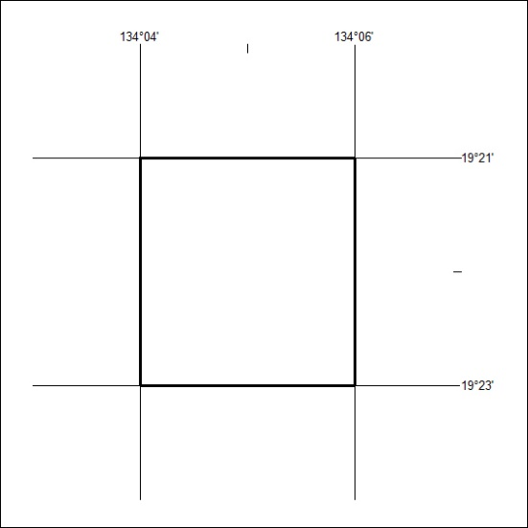
Area granted is indicated above. The titleholder is not permitted to exercise occupational rights on any land that is subject to a development title, or an application for a development title. Any land the subject of a Reserved Land gazettal under the Mineral Titles Act and all land vested in the Commonwealth of Australia is also excluded by description but not excised from the grant area.

138/20

