Mineral Titles Act
NOTICE OF LAND CEASING TO BE A MINERAL TITLE AREA
Title Type and Number: | Exploration Licence 31573
Area Ceased on: | 18 December 2018
Area: | 85 Blocks, 259.35 km²
Locality: | UMBEARA
Name of Holder(s): | 100% JOHANNSEN Lindsay Andrew
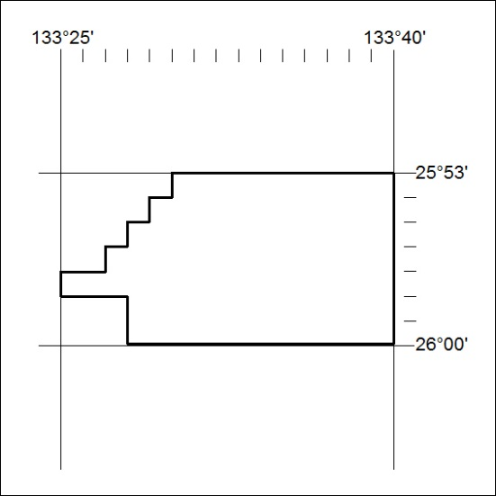

584/18

Mineral Titles Act
NOTICE OF LAND CEASING TO BE A MINERAL TITLE AREA
Title Type and Number: | Exploration Licence 31587
Area Ceased on: | 18 December 2018
Area: | 14 Blocks, 43.25 km²
Locality: | KULGERA
Name of Holder(s): | 100% JOHANNSEN Lindsay Andrew
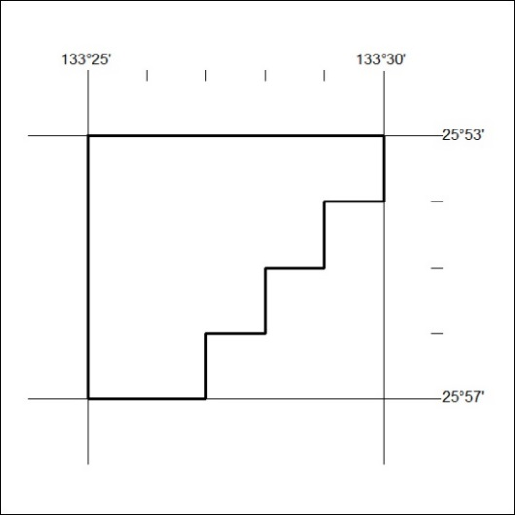

585/18

Mineral Titles Act
NOTICE OF GRANT OF A MINERAL TITLE
Title Type and Number: | Exploration Licence 31633
Granted: | 14 December 2018, for a period of 6 Years
Area: | 122 Blocks, 381.14 km²
Locality: | EPENARRA
Name of Holder(s): | 100% TREASURE CREEK PTY LTD [ACN. 619 057 644]
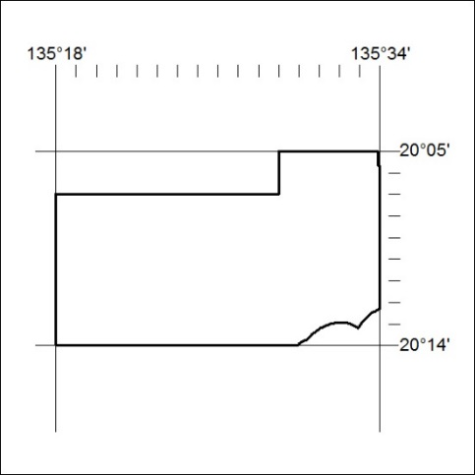
Area granted is indicated above. The titleholder is not permitted to exercise occupational rights on any land that is subject to a development title, or an application for a development title. Any land the subject of a Reserved Land gazettal under the Mineral Titles Act and all land vested in the Commonwealth of Australia is also excluded by description but not excised from the grant area.

586/18

Mineral Titles Act
NOTICE OF GRANT OF A MINERAL TITLE
Title Type and Number: | Exploration Licence 31634
Granted: | 14 December 2018, for a period of 6 Years
Area: | 168 Blocks, 525.97 km²
Locality: | EPENARRA
Name of Holder(s): | 100% TREASURE CREEK PTY LTD [ACN. 619 057 644]
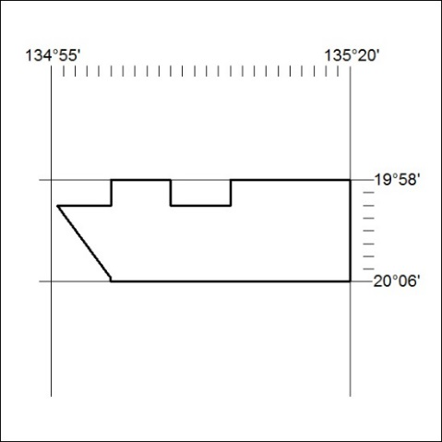
Area granted is indicated above. The titleholder is not permitted to exercise occupational rights on any land that is subject to a development title, or an application for a development title. Any land the subject of a Reserved Land gazettal under the Mineral Titles Act and all land vested in the Commonwealth of Australia is also excluded by description but not excised from the grant area.

587/18

Mineral Titles Act
NOTICE OF GRANT OF A MINERAL TITLE
Title Type and Number: | Mineral Lease 29070
Granted: | 10 December 2018, for a period of 25 Years
Area: | 7607.00 Hectares
Locality: | MAIS
Name of Holder/s: | Northern Territory Iron Ore Pty Ltd [ACN. 609 206 706]
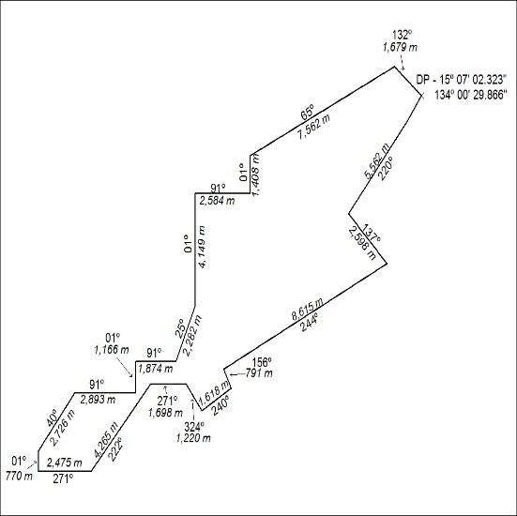

588/18

Mineral Titles Act
NOTICE OF GRANT OF A MINERAL TITLE
Title Type and Number: | Mineral Lease 29071
Granted: | 10 December 2018, for a period of 25 Years
Area: | 1316.00 Hectares
Locality: | MAIS
Name of Holder/s: | Northern Territory Iron Ore Pty Ltd [ACN. 609 206 706]
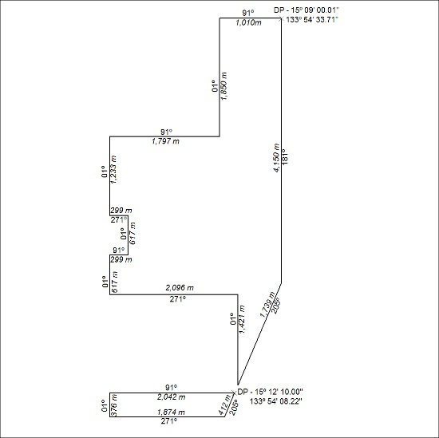

589/18

Mineral Titles Act
NOTICE OF GRANT OF A MINERAL TITLE
Title Type and Number: | Mineral Lease 29437
Granted: | 10 December 2018, for a period of 25 Years
Area: | 609.20 Hectares
Locality: | MAIS
Name of Holder/s: | Northern Territory Iron Ore Pty Ltd [ACN. 609 206 706]
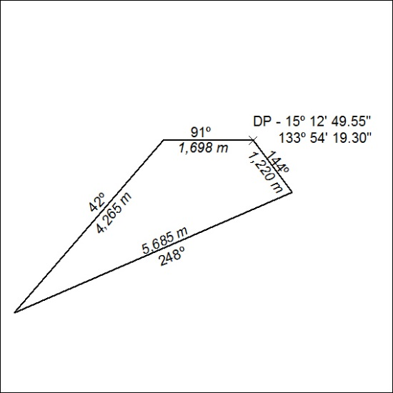

590/18

