Mineral Titles Act 2010
NOTICE OF LAND CEASING TO BE A MINERAL TITLE APPLICATION AREA
Title Type and Number: | Exploration Licence 30132
Area Ceased on: | 05 December 2022
Area: | 45 Blocks, 143.97 km²
Locality: | PARGEE
Name of Applicant(s)/Holder(s): | 100% NORTHERN MINERALS LIMITED * [ACN. 119 966 353]
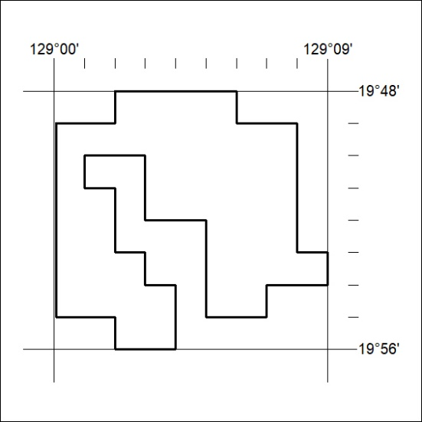

417/22

Mineral Titles Act 2010
NOTICE OF LAND CEASING TO BE A MINERAL TITLE AREA
Title Type and Number: | Extractive Mineral Exploration Licence 32252
Area Ceased on: | 03 December 2022
Area: | 4 Blocks, 11.27 km²
Locality: | KOOLPINYAH
Name of Applicant(s)/Holder(s): | 100% YEBNA QUARRIES HOLDINGS PTY LTD [ACN. 600 183 248]
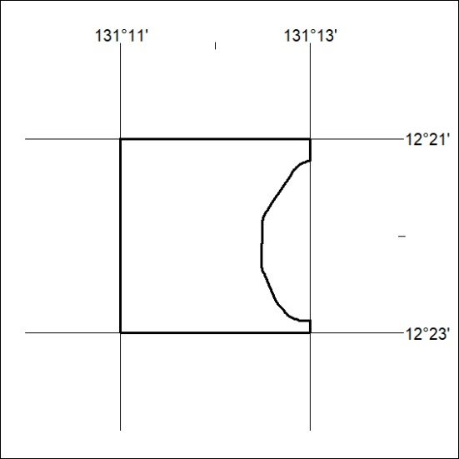

418/22
Mineral Titles Act 2010
NOTICE OF LAND CEASING TO BE A MINERAL TITLE AREA
Title Type and Number: | Extractive Mineral Exploration Licence 32253
Area Ceased on: | 03 December 2022
Area: | 4 Blocks, 8.53 km²
Locality: | KOOLPINYAH
Name of Applicant(s)/Holder(s): | 100% YEBNA QUARRIES HOLDINGS PTY LTD [ACN. 600 183 248]
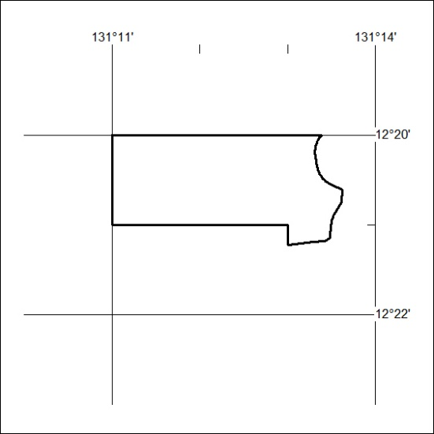

419/22

