Mineral Titles Act 2010
NOTICE OF LAND CEASING TO BE A MINERAL TITLE AREA
Title Type and Number: | Exploration Licence 23780
Area Ceased on: | 20 July 2022
Area: | 159 Blocks, 518.97 km²
Locality: | RENEHAN
Name of Applicant(s)/Holder(s): | 100% ASIAN MINERALS PTY LTD [ACN. 099 804 467]
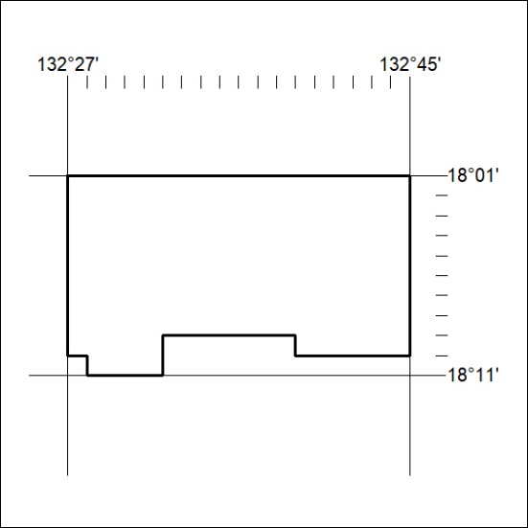

251/22

Mineral Titles Act 2010
NOTICE OF LAND CEASING TO BE A MINERAL TITLE AREA
Title Type and Number: | Exploration Licence 31757
Area Ceased on: | 20 July 2022
Area: | 51 Blocks, 166.11 km²
Locality: | KOOKABURRA
Name of Applicant(s)/Holder(s): | 100% ASIAN MINERALS PTY LTD [ACN. 099 804 467]
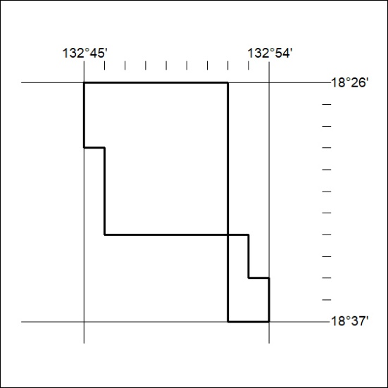

252/22
Mineral Titles Act 2010
NOTICE OF LAND CEASING TO BE A MINERAL TITLE AREA
Title Type and Number: | Exploration Licence 31758
Area Ceased on: | 20 July 2022
Area: | 37 Blocks, 120.34 km²
Locality: | KOOKABURRA
Name of Applicant(s)/Holder(s): | 100% ASIAN MINERALS PTY LTD [ACN. 099 804 467]
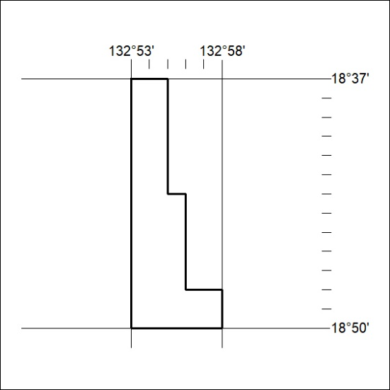

253/22

Mineral Titles Act 2010
NOTICE OF LAND CEASING TO BE A MINERAL TITLE AREA
Title Type and Number: | Exploration Licence 31759
Area Ceased on: | 20 July 2022
Area: | 66 Blocks, 215.12 km²
Locality: | RENEHAN
Name of Applicant(s)/Holder(s): | 100% ASIAN MINERALS PTY LTD [ACN. 099 804 467]
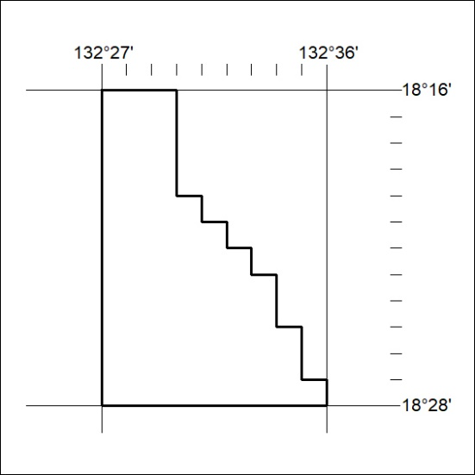

254/22

Mineral Titles Act
NOTICE OF GRANT OF A MINERAL TITLE
Title Type and Number: | Exploration Licence 32925
Granted: | 22 July 2022, for a period of 6 Years
Area: | 47 Blocks, 149.39 km²
Locality: | DOREEN
Name of Holder/s: | 100% PET FC PTY LTD [ACN. 602 050 117]
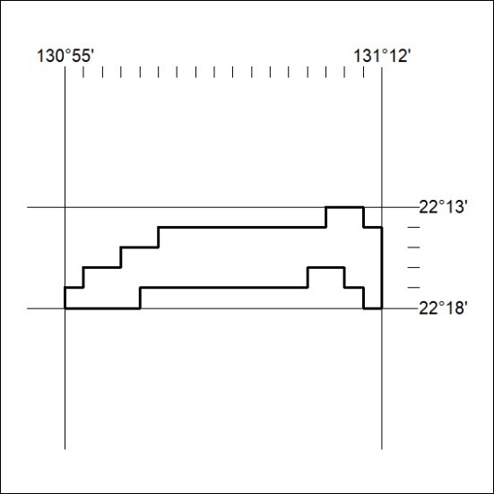
Area granted is indicated above. The titleholder is not permitted to exercise occupational rights on any land that is subject to a development title, or an application for a development title. Any land the subject of a Reserved Land gazettal under the Mineral Titles Act and all land vested in the Commonwealth of Australia is also excluded by description but not excised from the grant area.
255/22

Mineral Titles Act
NOTICE OF GRANT OF A MINERAL TITLE
Title Type and Number: | Exploration Licence 32927
Granted: | 22 July 2022, for a period of 6 Years
Area: | 24 Blocks, 76.10 km²
Locality: | NAPPERBY
Name of Holder/s: | 100% PET FC PTY LTD [ACN. 602 050 117]
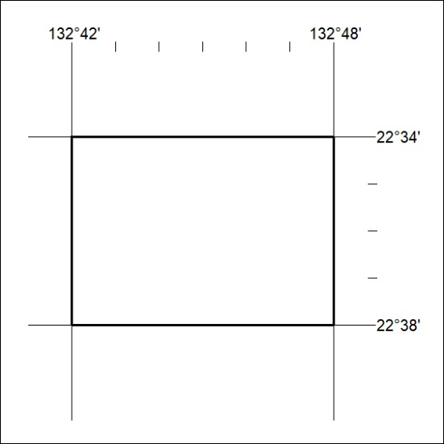
Area granted is indicated above. The titleholder is not permitted to exercise occupational rights on any land that is subject to a development title, or an application for a development title. Any land the subject of a Reserved Land gazettal under the Mineral Titles Act and all land vested in the Commonwealth of Australia is also excluded by description but not excised from the grant area.
256/22

Mineral Titles Act
NOTICE OF GRANT OF A MINERAL TITLE
Title Type and Number: | Exploration Licence 32928
Granted: | 22 July 2022, for a period of 6 Years
Area: | 44 Blocks, 139.32 km²
Locality: | NAPPERBY
Name of Holder/s: | 100% PET FC PTY LTD [ACN. 602 050 117]
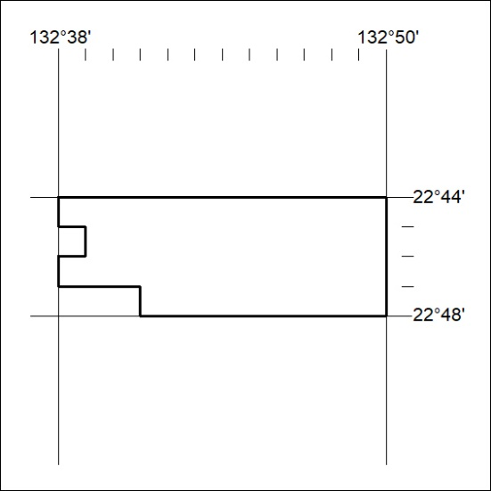
Area granted is indicated above. The titleholder is not permitted to exercise occupational rights on any land that is subject to a development title, or an application for a development title. Any land the subject of a Reserved Land gazettal under the Mineral Titles Act and all land vested in the Commonwealth of Australia is also excluded by description but not excised from the grant area.
257/22

Mineral Titles Act
NOTICE OF GRANT OF A MINERAL TITLE
Title Type and Number: | Exploration Licence 32930
Granted: | 22 July 2022, for a period of 6 Years
Area: | 36 Blocks, 108.28 km²
Locality: | DOREEN
Name of Holder/s: | 100% PET FC PTY LTD [ACN. 602 050 117]
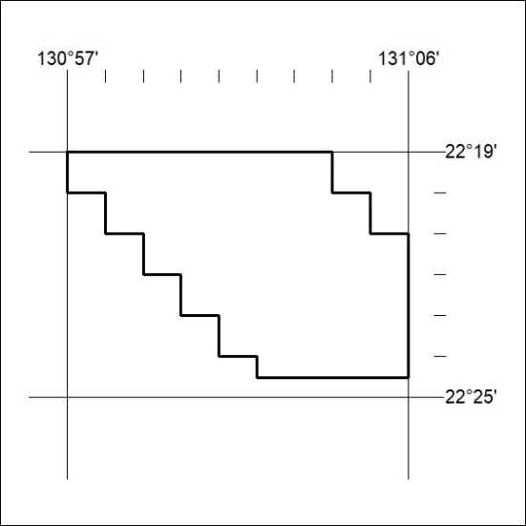
Area granted is indicated above. The titleholder is not permitted to exercise occupational rights on any land that is subject to a development title, or an application for a development title. Any land the subject of a Reserved Land gazettal under the Mineral Titles Act and all land vested in the Commonwealth of Australia is also excluded by description but not excised from the grant area.
258/22

Mineral Titles Act
NOTICE OF GRANT OF A MINERAL TITLE
Title Type and Number: | Exploration Licence 32931
Granted: | 22 July 2022, for a period of 6 Years
Area: | 16 Blocks, 40.24 km²
Locality: | DOREEN
Name of Holder/s: | 100% PET FC PTY LTD [ACN. 602 050 117]
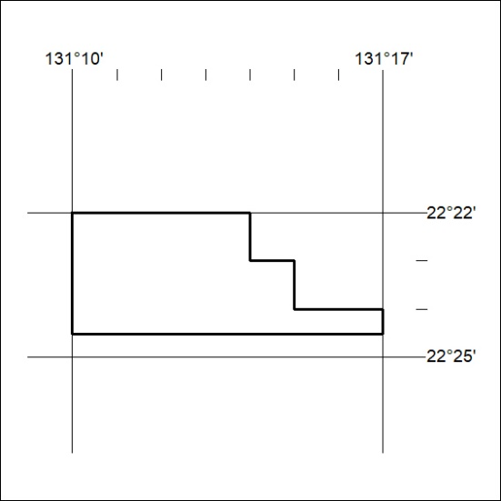
Area granted is indicated above. The titleholder is not permitted to exercise occupational rights on any land that is subject to a development title, or an application for a development title. Any land the subject of a Reserved Land gazettal under the Mineral Titles Act and all land vested in the Commonwealth of Australia is also excluded by description but not excised from the grant area.
259/22

