Mineral Titles Act
NOTICE OF GRANT OF A MINERAL TITLE
Title Type and Number: | Exploration Licence 32879
Granted: | 15 July 2022, for a period of 6 Years
Area: | 45 Blocks, 130.76 km²
Locality: | BATCHELOR
Name of Holder/s: | 100% BASE EXPLORATION PTY LTD [ACN. 647 687 652]
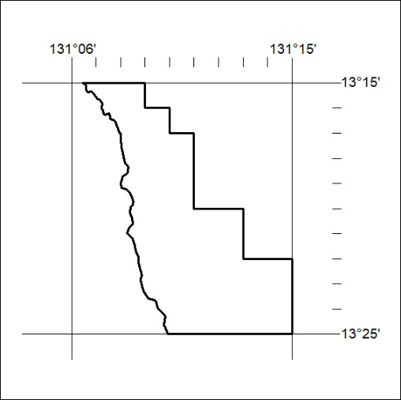
Area granted is indicated above. The titleholder is not permitted to exercise occupational rights on any land that is subject to a development title, or an application for a development title. Any land the subject of a Reserved Land gazettal under the Mineral Titles Act and all land vested in the Commonwealth of Australia is also excluded by description but not excised from the grant area.

244/22

Mineral Titles Act
NOTICE OF GRANT OF A MINERAL TITLE
Title Type and Number: | Exploration Licence 33193
Granted: | 15 July 2022, for a period of 6 Years
Area: | 144 Blocks, 461.88 km²
Locality: | JOILDUNG
Name of Holder/s: | 100% MINEMAKERS AUSTRALIA PTY LTD* [ACN. 081 911 917]
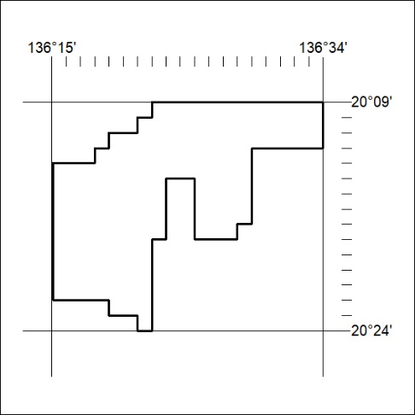
Area granted is indicated above. The titleholder is not permitted to exercise occupational rights on any land that is subject to a development title, or an application for a development title. Any land the subject of a Reserved Land gazettal under the Mineral Titles Act and all land vested in the Commonwealth of Australia is also excluded by description but not excised from the grant area.

245/22

