Mineral Titles Act 2010
NOTICE OF LAND CEASING TO BE A MINERAL TITLE AREA
Title Type and Number: | Exploration Licence 30470
Area Ceased on: | 31 July 2021
Area: | 25 Blocks, 79.98 km²
Locality: | TAYLOR
Name of Applicant(s)/Holder(s): | 100% PRODIGY GOLD NL* [ACN. 009 127 020]
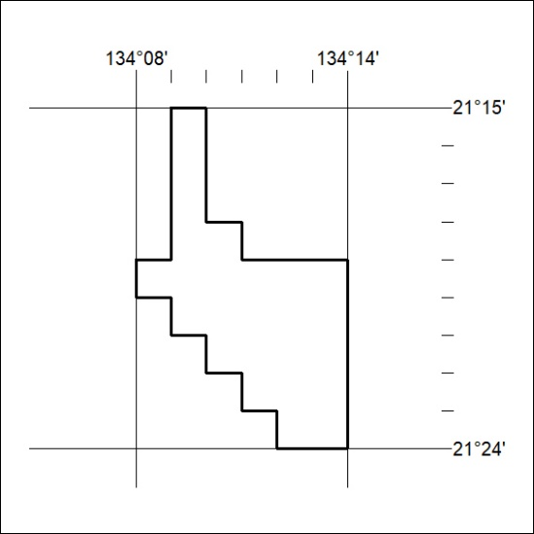

284/21

Mineral Titles Act 2010
NOTICE OF LAND CEASING TO BE A MINERAL TITLE AREA
Title Type and Number: | Exploration Licence 31665
Area Ceased on: | 02 August 2021
Area: | 36 Blocks, 114.92 km²
Locality: | BRUNCHILLY
Name of Applicant(s)/Holder(s): | 100% OM (MANGANESE) LTD [ACN. 097 091 506]
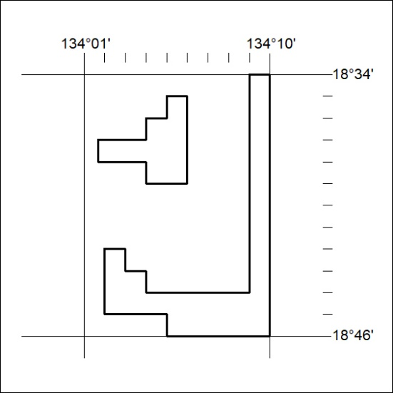

285/21

Mineral Titles Act
NOTICE OF GRANT OF A MINERAL TITLE
Title Type and Number: | Exploration Licence 32181
Granted: | 30 July 2021, for a period of 6 Years
Area: | 121 Blocks, 397.86 km²
Locality: | GLYDE
Name of Holder/s: | 100% CERBERUS RESOURCES PTY LTD [ACN. 615 192 535]
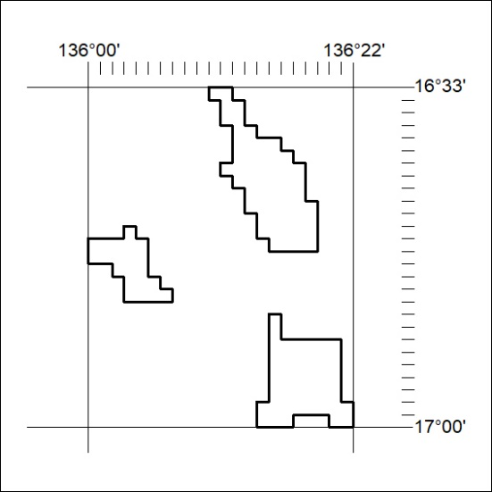
Area granted is indicated above. The titleholder is not permitted to exercise occupational rights on any land that is subject to a development title, or an application for a development title. Any land the subject of a Reserved Land gazettal under the Mineral Titles Act and all land vested in the Commonwealth of Australia is also excluded by description but not excised from the grant area.
286/21

Mineral Titles Act
NOTICE OF GRANT OF A MINERAL TITLE
Title Type and Number: | Exploration Licence 32182
Granted: | 30 July 2021, for a period of 6 Years
Area: | 235 Blocks, 771.76 km²
Locality: | LANCEWOOD
Name of Holder/s: | 100% CERBERUS RESOURCES PTY LTD [ACN. 615 192 535]
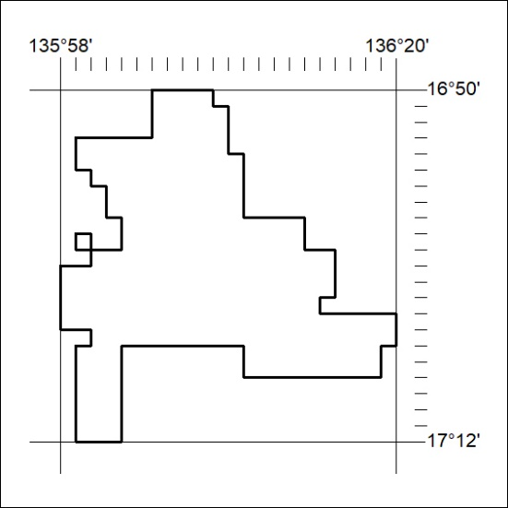
Area granted is indicated above. The titleholder is not permitted to exercise occupational rights on any land that is subject to a development title, or an application for a development title. Any land the subject of a Reserved Land gazettal under the Mineral Titles Act and all land vested in the Commonwealth of Australia is also excluded by description but not excised from the grant area.
287/21

Mineral Titles Act
NOTICE OF GRANT OF A MINERAL TITLE
Title Type and Number: | Exploration Licence 32330
Granted: | 30 July 2021, for a period of 6 Years
Area: | 146 Blocks, 482.29 km²
Locality: | BING BONG
Name of Holder/s: | 100% CERBERUS RESOURCES PTY LTD [ACN. 615 192 535]
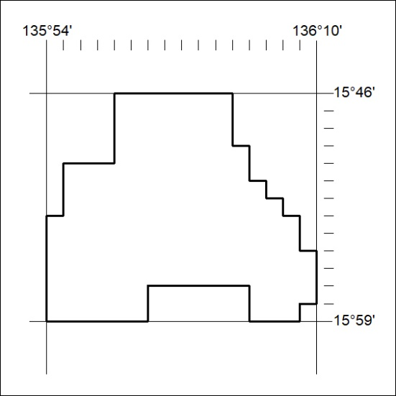
Area granted is indicated above. The titleholder is not permitted to exercise occupational rights on any land that is subject to a development title, or an application for a development title. Any land the subject of a Reserved Land gazettal under the Mineral Titles Act and all land vested in the Commonwealth of Australia is also excluded by description but not excised from the grant area.
288/21

Mineral Titles Act
NOTICE OF GRANT OF A MINERAL TITLE
Title Type and Number: | Exploration Licence 32386
Granted: | 30 July 2021, for a period of 6 Years
Area: | 250 Blocks, 814.55 km²
Locality: | CORELLA CREEK
Name of Holder/s: | 100% BAUDIN RESOURCES PTY LTD [ACN. 618 455 593]
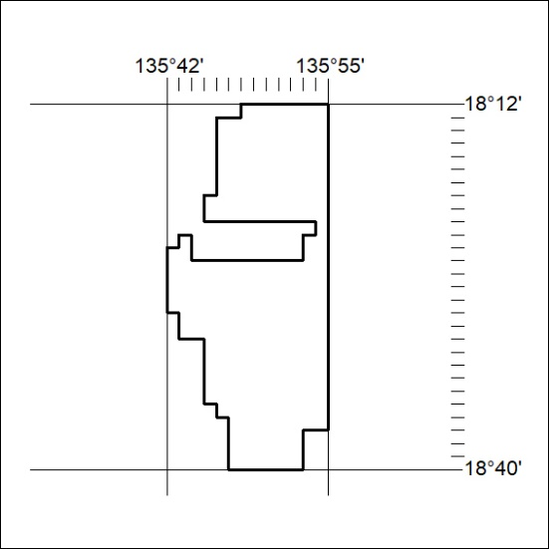
Area granted is indicated above. The titleholder is not permitted to exercise occupational rights on any land that is subject to a development title, or an application for a development title. Any land the subject of a Reserved Land gazettal under the Mineral Titles Act and all land vested in the Commonwealth of Australia is also excluded by description but not excised from the grant area.
289/21

Mineral Titles Act
NOTICE OF GRANT OF A MINERAL TITLE
Title Type and Number: | Exploration Licence 32387
Granted: | 30 July 2021, for a period of 6 Years
Area: | 250 Blocks, 814.94 km²
Locality: | PARADISE BORE
Name of Holder/s: | 100% BAUDIN RESOURCES PTY LTD [ACN. 618 455 593]
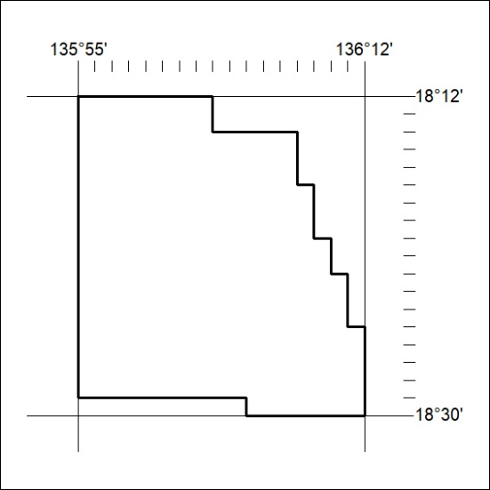
Area granted is indicated above. The titleholder is not permitted to exercise occupational rights on any land that is subject to a development title, or an application for a development title. Any land the subject of a Reserved Land gazettal under the Mineral Titles Act and all land vested in the Commonwealth of Australia is also excluded by description but not excised from the grant area.
290/21

Mineral Titles Act
NOTICE OF GRANT OF A MINERAL TITLE
Title Type and Number: | Exploration Licence 32388
Granted: | 30 July 2021, for a period of 6 Years
Area: | 250 Blocks, 813.76 km²
Locality: | BOREE
Name of Holder/s: | 100% BAUDIN RESOURCES PTY LTD [ACN. 618 455 593]
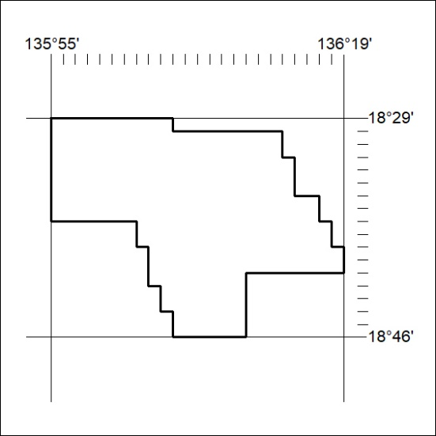
Area granted is indicated above. The titleholder is not permitted to exercise occupational rights on any land that is subject to a development title, or an application for a development title. Any land the subject of a Reserved Land gazettal under the Mineral Titles Act and all land vested in the Commonwealth of Australia is also excluded by description but not excised from the grant area.
291/21

