Key points
- Despite rising interest rates and national and global economic uncertainty, Territory-wide business confidence was +67% in the March quarter 2023, well above pre-pandemic levels and the highest ever March quarter result. Only 7% of businesses reported as being worried.
- 56% of businesses reported improved performance, the highest level recorded for any March quarter since the survey began.
- The most commonly cited reasons for confidence this quarter were ‘business opportunity’, ‘strong customer relations’ and ‘strong market position’.
- The most commonly cited reason for being worried this quarter was ‘lack of suitably skilled workers’, reflecting the Territory’s high number of job vacancies and low unemployment rate.

Territory businesses are confident about their prospects
The Territory-wide business confidence index was +67% for the March quarter 2023 in response to the question ‘How confident are you about your business prospects over the next 12 months?’ This is a 6 percentage point decrease on the previous quarter and an 8 percentage point increase annually (Table 1). The quarterly change reflects a decrease in the share of fairly confident businesses regarding the short term outlook (Figure 1), while the annual change reflects the recovery from the impacts of the Omicron outbreak in the March quarter of 2022.
Table 1: Business confidence index
 | Mar qtr 2023 | Quarterly change | Annual change*
Confident | 74% | -5ppt |  | +6ppt
Worried | 7% | +2ppt |  | -2ppt
Net Balance | 67% | -6ppt |  | +8ppt
*Current quarter compared with the same quarter in the previous year.
Figure 1: Responses to the business confidence question and change from previous quarter
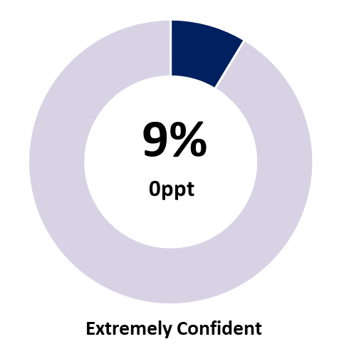 | 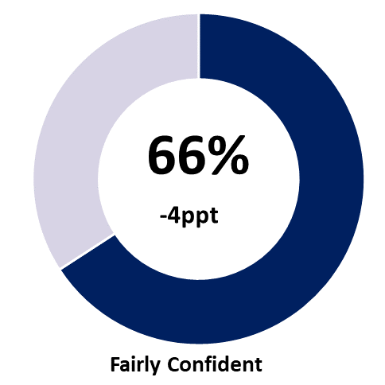 | 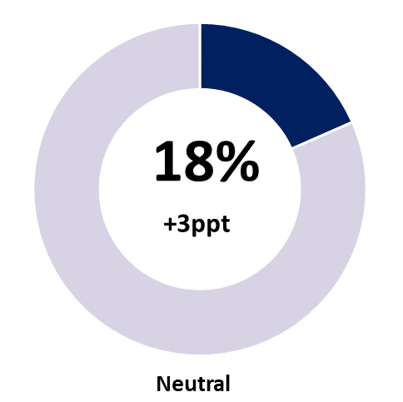
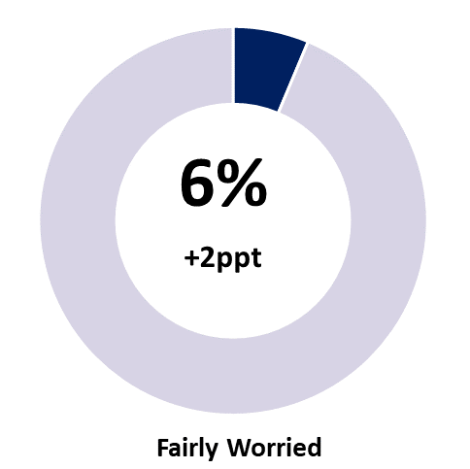 | 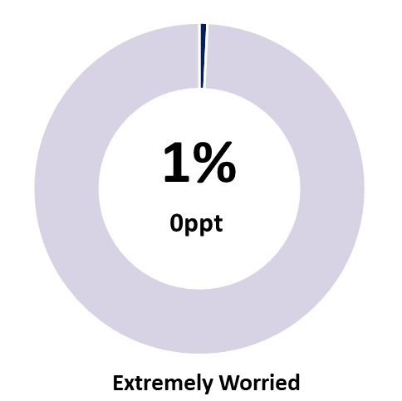 | 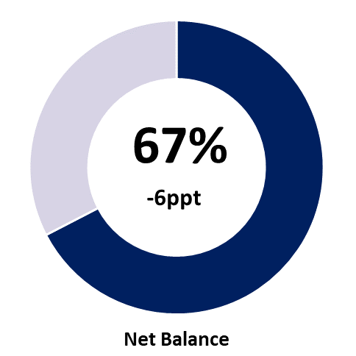
Note: Individual categories may not add to the net balance figure due to rounding.

Business confidence remains well above pre-pandemic levels
Business confidence sits well above pre-pandemic levels (Chart 1). Despite a slight decrease in the March quarter 2023, the average business confidence level in financial year 2022-23 continues its upwards trend (Chart 2). The business confidence this quarter is the highest of any March quarter on record.
Chart 1
NT business confidence
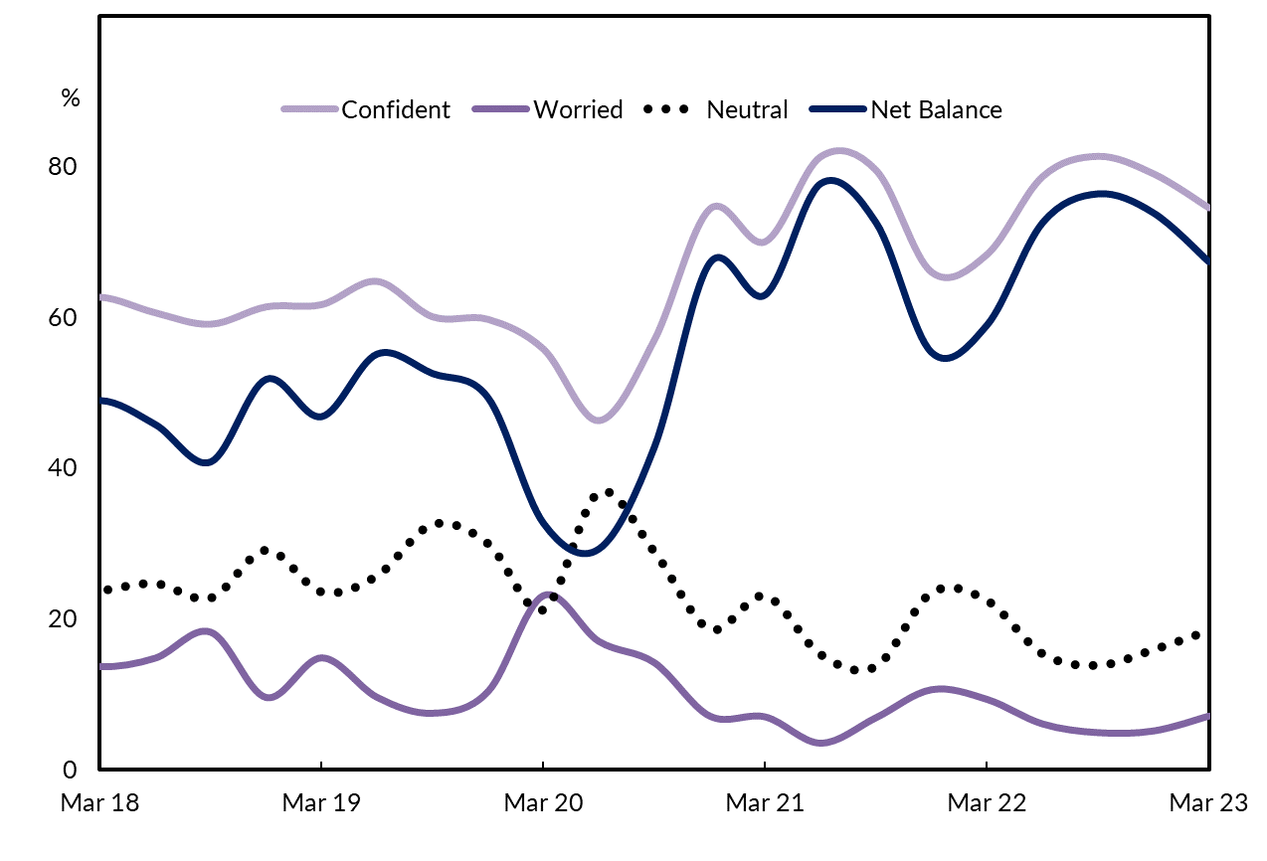

Chart 2
Business confidence by financial year
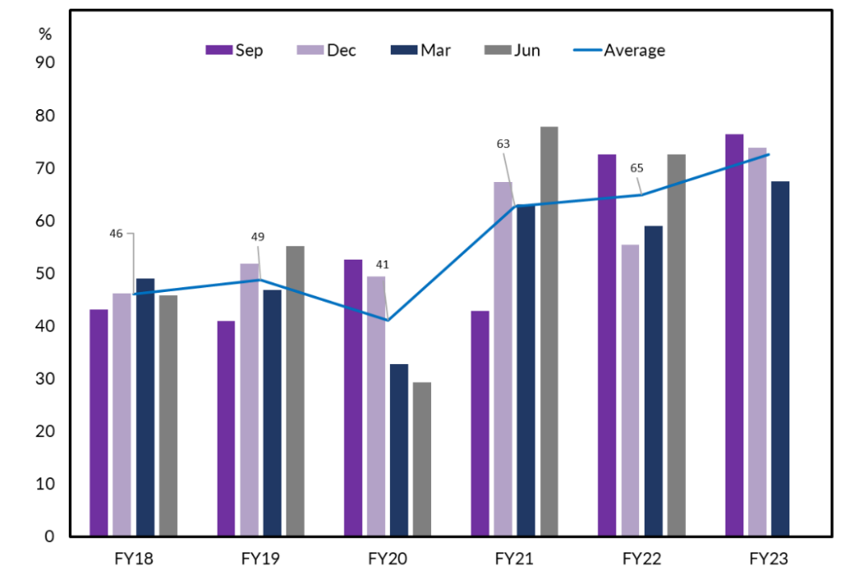

Business performance decreased this quarter
When asked ‘How’s your business performing this year compared to last year?’, 56% of businesses responded with ‘better’, representing a 10 percentage point decrease from the December quarter 2022 (Table 2). However, this is an increase of 9 percentage points annually and is the highest March quarter on record (Chart 3).
Table 2: Business performance compared to last year
 | Mar qtr 2023 | Quarterly change | Annual change*
Better | 56% | -10ppt | +9ppt
Same | 33% | +5ppt | -3ppt
Worse | 12% | +5ppt | -5ppt
*Current quarter compared with the same quarter in the previous year.
Figure 2: Responses to the business performance question and quarterly change
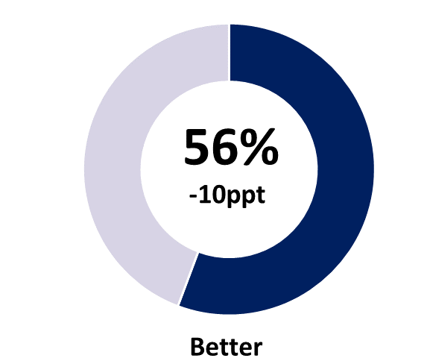 | 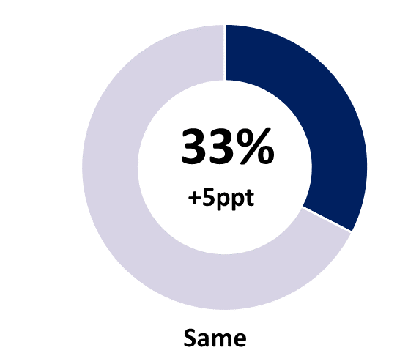 | 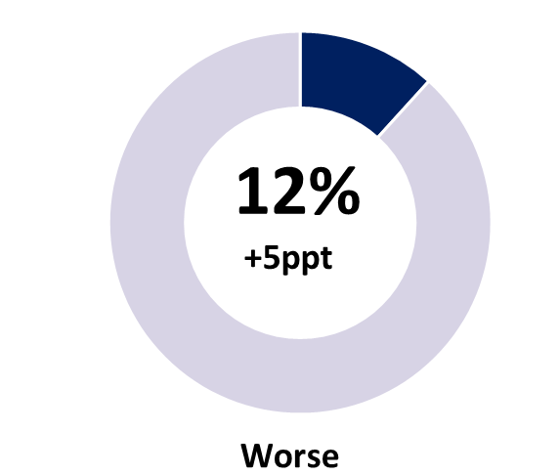
Note: Individual categories may not sum to 100 due to rounding.
Businesses stating performance this year is worse than last year increased by 5 percentage points to 12% this quarter, though this follows a record low of only 6% of businesses which reported performance had deteriorated in the December quarter 2022, and is below the historical average for the March quarter. From a regional perspective, Alice Springs was the major contributor to the fall, and this aligns with reporting of increased anti-social behaviour in the region, and its impacts on consumers and businesses.
Chart 3
Northern Territory business performance
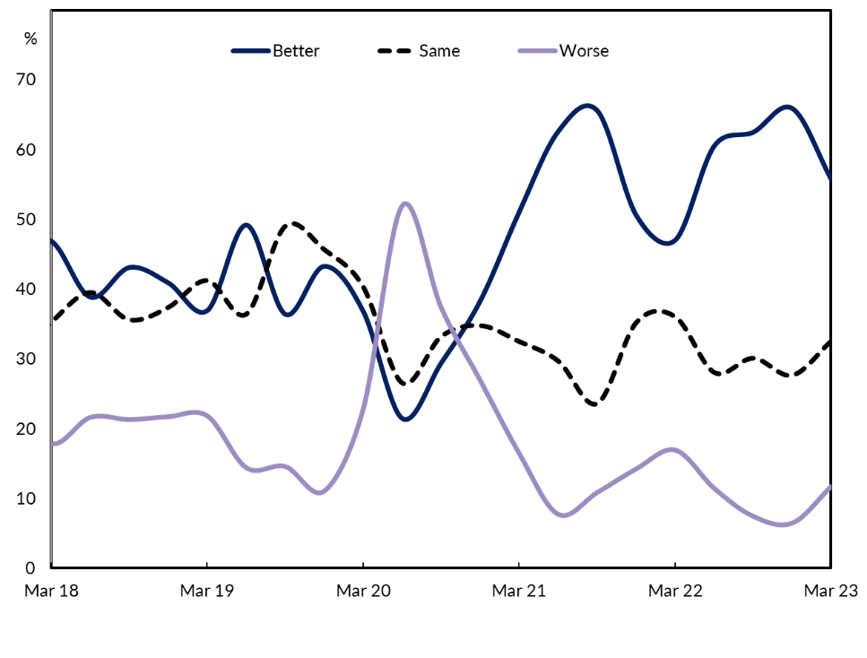

Business opportunities and customer relations drive confidence
In line with the December quarter, the key reasons cited for business confidence this quarter were ‘business opportunity’, ‘strong customer relations’ and ‘strong market position’ (Chart 4). There was an increase in the proportion of businesses reporting ‘plenty of work coming up’, ‘good profitability’ and ‘increased public works’ as the reasons for confidence, both in quarterly and annual terms.
Chart 4
Reasons for confidence
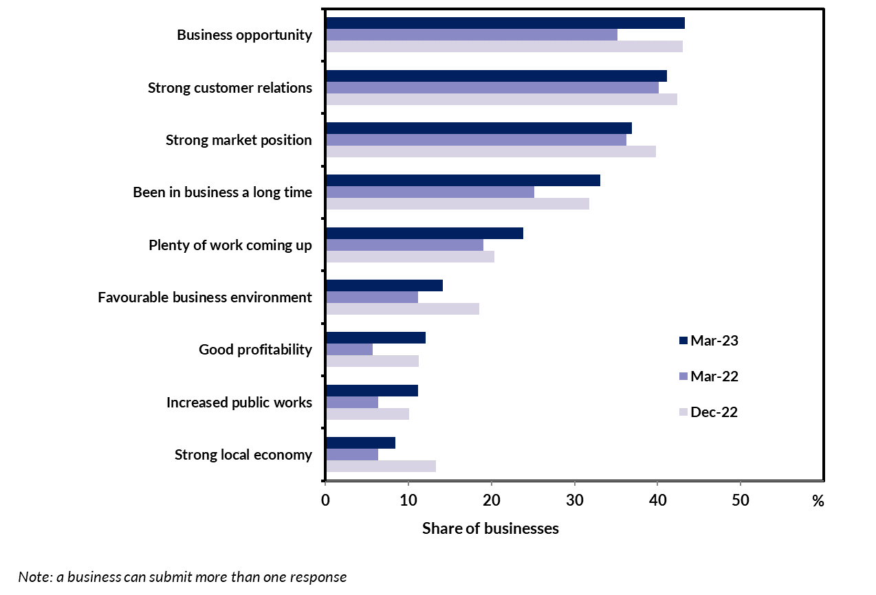
In the March quarter 2023, 8% of businesses cited ‘strong local economy’ as a reason for confidence, while only 1% of businesses cited ‘weak local economy’ as a reason for being worried. The proportion of businesses citing ‘business opportunity’ and ‘plenty of work coming up’ increased in the quarter, and this result is consistent with ABS data that reports the Territory’s overall demand increased by 4.8% in 2022, with both the private and public sectors contributing to the 13.8% increase in investment in the Territory (Chart 5).
Chart 5
Territory state final demand
Components, year-on-year moving total
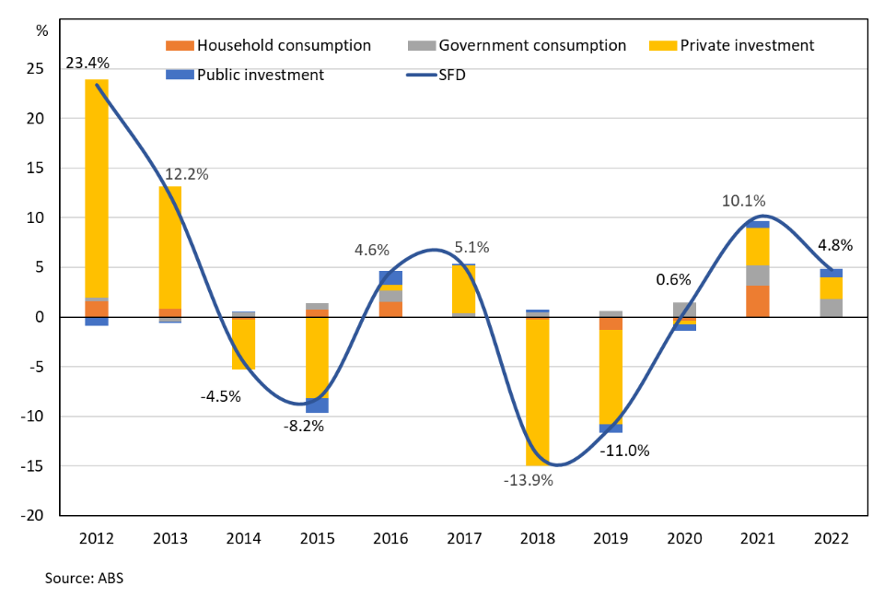

Labour shortages and rising costs are major concerns
A large proportion of businesses continue to cite ‘lack of suitably skilled workers’ as a reason for being worried (Chart 6). Consistent with recent quarters, Territory businesses are struggling with labour shortages and the unemployed to vacancy ratio is currently around 1 (i.e. there are about the same number of job vacancies as unemployed people).
Chart 6
Reasons for being worried
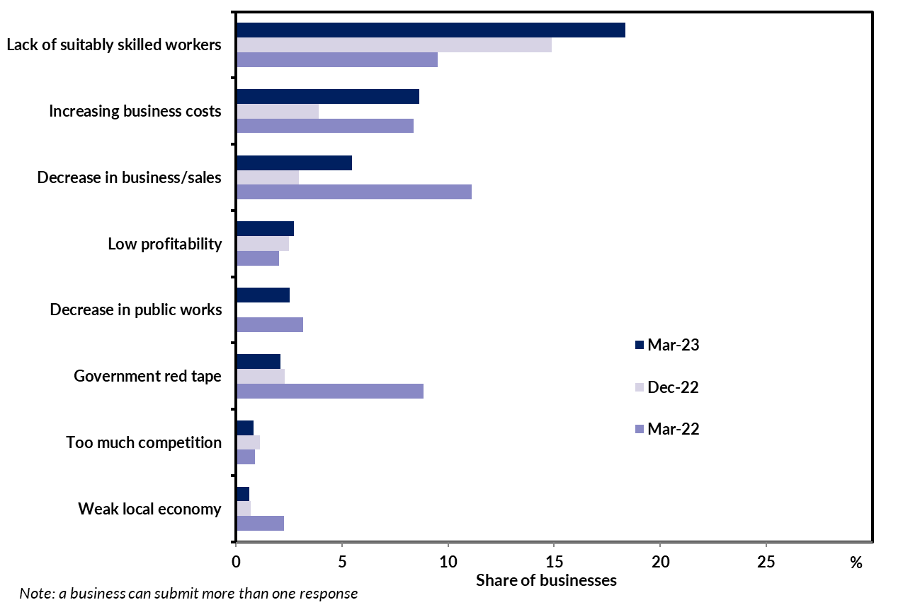
In the March quarter, there was an increase in the number of businesses citing ‘increasing business costs’ as a reason for being worried. Supply chain disruption, labour shortages and high fuel prices have contributed to increased input prices, though persistently high and broad-based rates of consumer price inflation (6.2% annually to March for Darwin) suggest that many businesses have been able to pass cost increases on to consumers. In industries such as housing construction an emerging risk is that some businesses may struggle to remain solvent if fixed price contracts set in earlier periods become unprofitable as input prices rise and cannot be passed on to clients (Chart 7). Fixed price contracts are workable if input prices are relatively stable, but there will be a transition period as businesses reset terms on new contracts to reflect the changed operating environment. Confidence in the construction industry dipped from +97% in the December quarter 2022 to +83% in the March quarter 2023 (Chart 8).
Chart 7
House construction producer prices
March 2019 = 100
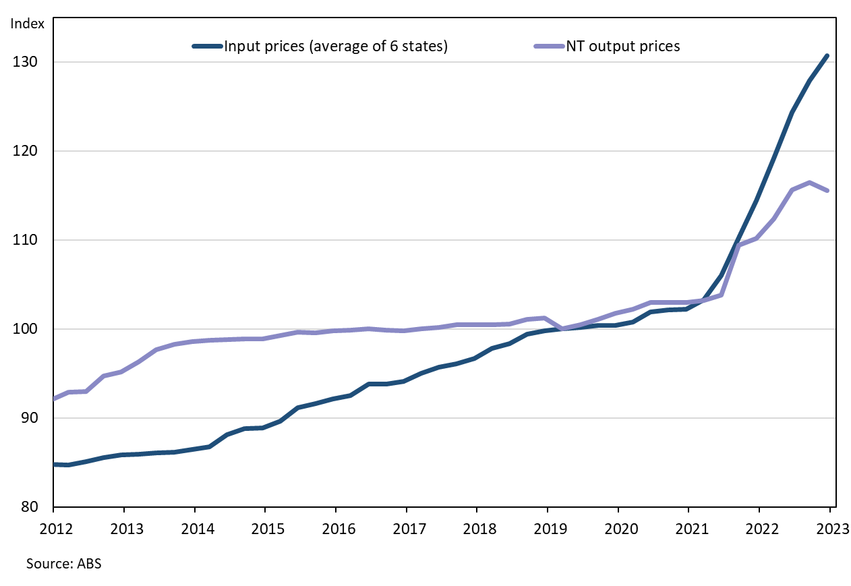

Business confidence and performance vary among the regions
Business confidence and performance varies by region (Table 3). Business confidence was highest in the Barkly region in the quarter with a net balance of +100% (though from a small sample size), unchanged from the previous quarter. Despite this, the Barkly region recorded the weakest result for business performance with 33% of businesses feeling better about their performance this year relative to last year. Please note that small sample size in some regions can contribute to large quarterly movements.
Business confidence in Alice Springs declined by 21 percentage points in the quarter to a net balance of +72%, though this is off the record high reported in the previous quarter. Alice Springs recorded a quarterly decline in business performance (down by 11 percentage points) with 52% of businesses reporting better performance this year compared to last year. In addition to macroeconomic factors impacting businesses across the Territory, confidence and performance in Alice Springs is being impacted by local factors, notably high rates of anti-social behaviour and its reporting by the media, which is having direct flow-on impacts on tourism, an important sector for the region.
Table 3: Business confidence and performance by region
Business Confidence |  |  |  |  | Business Performance
 | Mar qtr 2023 | Quarterly change | Annual change |  |  | Mar qtr 2023 | Quarterly change | Annual change
Territory-wide (n=474) |  |  |  |  | Territory-wide (n=474)
Confident | 74% | -5ppt | +6ppt |  | Better | 56% | -10ppt | +9ppt
Worried | 7% | +2ppt | -2ppt |  | Same | 33% | +5ppt | -3ppt
Net Balance | 67% | -6ppt | +8ppt |  | Worse | 12% | +5ppt | -5ppt
Greater Darwin (n=175) |  |  |  |  | Greater Darwin (n=175)
Confident | 73% | -3ppt | +6ppt |  | Better | 57% | -9ppt | +12ppt
Worried | 7% | +2ppt | -1ppt |  | Same | 32% | +5ppt | -2ppt
Net Balance | 66% | -5ppt | +7ppt |  | Worse | 11% | +4ppt | -9ppt
Daly-Tiwi-West Arnhem (n=31) |  |  |  |  | Daly-Tiwi-West Arnhem (n=31)
Confident | 74% | +6ppt | +11ppt |  | Better | 35% | -24ppt | -1ppt
Worried | 13% | -5ppt | -13ppt |  | Same | 48% | +21ppt | +6ppt
Net Balance | 61% | +11ppt | +24ppt |  | Worse | 16% | +2ppt | -5ppt
East Arnhem (n=14) |  |  |  |  | East Arnhem (n=14)
Confident | 57% | -23ppt | -43ppt |  | Better | 57% | -3ppt | 0ppt
Worried | 14% | +9ppt | +14ppt |  | Same | 29% | +4ppt | -14ppt
Net Balance | 43% | -32ppt | -57ppt |  | Worse | 14% | -1ppt | +14ppt
Katherine (n=51) |  |  |  |  | Katherine (n=51)
Confident | 82% | +3ppt | -8ppt |  | Better | 54% | -9ppt | -4ppt
Worried | 8% | -2ppt | +3ppt |  | Same | 23% | -5ppt | -9ppt
Net Balance | 73% | +5ppt | -11ppt |  | Worse | 23% | +13ppt | +12ppt
Barkly (n=6) |  |  |  |  | Barkly (n=6)
Confident | 100% | 0ppt | +47ppt |  | Better | 33% | -67ppt | -7ppt
Worried | 0% | 0ppt | -47ppt |  | Same | 67% | +67ppt | +60ppt
Net Balance | 100% | 0ppt | +93ppt |  | Worse | 0% | 0ppt | -53ppt
Alice Springs (n=188) |  |  |  |  | Alice Springs (n=188)
Confident | 79% | -15ppt | +29ppt |  | Better | 52% | -11ppt | +26ppt
Worried | 7% | +6ppt | -17ppt |  | Same | 37% | +4ppt | -14ppt
Net Balance | 72% | -21ppt | +45ppt |  | Worse | 12% | +7ppt | -12ppt
Note: Caution should be taken when interpreting these results as the sample size in some regions may be relatively small.

Business confidence varies across industries
Of the 10 industries with the largest number of respondents, manufacturing recorded the strongest business confidence at +100%, while Arts & Recreation Services recorded the lowest at +42% (Chart 8).
Business confidence edged down across many industries in the March quarter 2023, most notably in the Arts & Recreation Services, and Rental, Hiring & Real Estate Services industries. Consistent with the December quarter 2022, at least 50% of businesses in each industry reported as being ‘confident’, though there was an increase in the number of businesses reporting as being ‘worried’.
The Territory’s construction industry reported solid confidence of +83% this quarter after a record high of +97% in the December quarter 2022, with 6% of construction businesses reporting as ‘worried’ this quarter (up from 0%).
Chart 8
Business confidence by industry
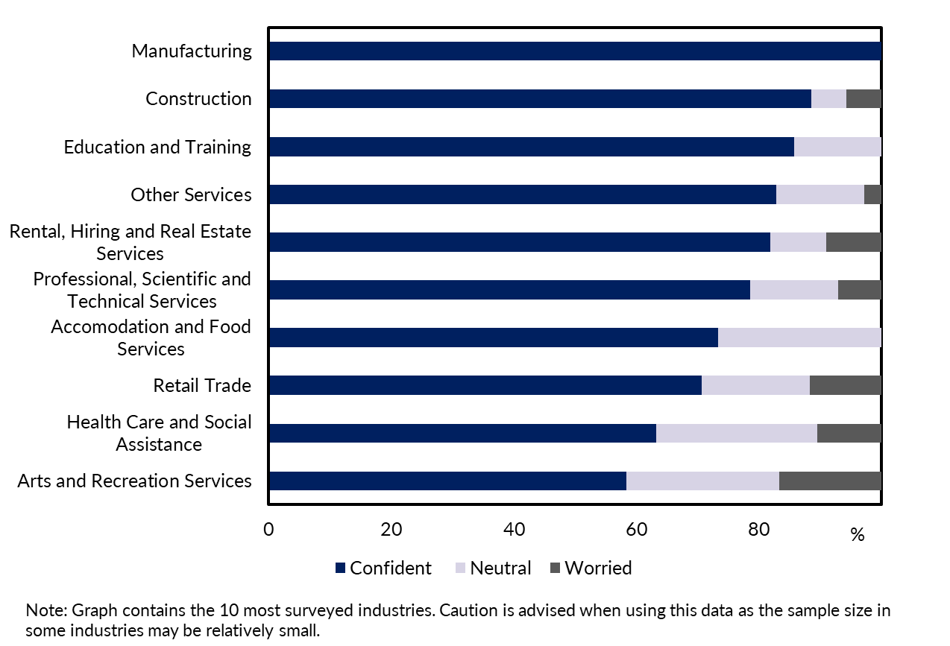

Appendix

Methodology
The Department of Industry, Tourism and Trade conducts a face-to-face survey of businesses operating in the Territory on a quarterly basis. The results have been used to construct a business confidence index.
The business confidence index is calculated as the difference between the proportion of businesses that are ‘confident about their business prospects for the next 12 months' and the proportion of businesses that are ‘worried about their business prospects for the next 12 months’ (net balance approach).
The Territory-wide confidence index is weighted to account for the number of businesses in each region. The weighted result provides a more balanced reflection of overall business confidence. Business confidence results are also presented by region and industry.
474 businesses were surveyed out of 15,777 operating businesses in the Territory (Table 4). For the sample survey to achieve a 95% confidence level with a margin of error of 5%, 376 survey responses are required.
Table 4: Survey Numbers
Region | Total number of businesses | Businesses surveyed | Proportion of total
Greater Darwin | 11,577 | 175 | 1.5%
Daly-Tiwi-West Arnhem | 378 | 31 | 8.2%
East Arnhem | 241 | 14 | 5.8%
Katherine | 960 | 51 | 5.3%
Barkly | 193 | 6 | 3.1%
Alice Springs | 2034 | 188 | 9.2%
Total | 15,777 | 474 | 3.0%

