Mineral Titles Act
NOTICE OF GRANT OF A MINERAL TITLE
Title Type and Number: | Exploration Licence 32999
Granted: | 23 August 2022, for a period of 6 Years
Area: | 167 Blocks, 774.02 km²
Locality: | VAUGHAN
Name of Holder/s: | 100% URO CORPORATION PTY LTD [ACN. 653 927 998]
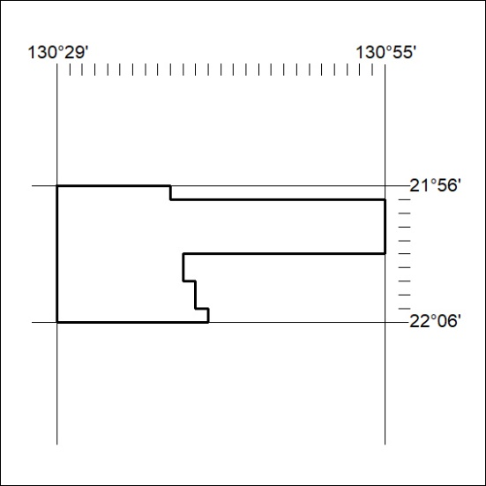
Area granted is indicated above. The titleholder is not permitted to exercise occupational rights on any land that is subject to a development title, or an application for a development title. Any land the subject of a Reserved Land gazettal under the Mineral Titles Act and all land vested in the Commonwealth of Australia is also excluded by description but not excised from the grant area.

298/22

