Mineral Titles Act
NOTICE OF GRANT OF A MINERAL TITLE
Title Type and Number: | Exploration Licence 32884
Granted: | 17 June 2022, for a period of 6 Years
Area: | 124 Blocks, 413.95 km²
Locality: | TIPPERARY
Name of Holder/s: | 100% MANGUSTA MINERALS PTY LTD [ACN. 653 950 522]
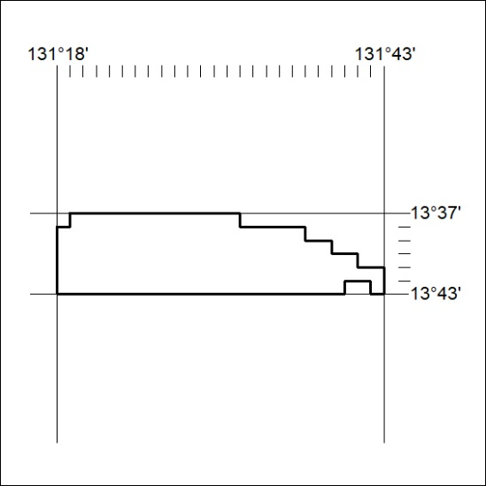
Area granted is indicated above. The titleholder is not permitted to exercise occupational rights on any land that is subject to a development title, or an application for a development title. Any land the subject of a Reserved Land gazettal under the Mineral Titles Act and all land vested in the Commonwealth of Australia is also excluded by description but not excised from the grant area.
199/22

Mineral Titles Act
NOTICE OF GRANT OF A MINERAL TITLE
Title Type and Number: | Exploration Licence 32885
Granted: | 17 June 2022, for a period of 6 Years
Area: | 86 Blocks, 283.89 km²
Locality: | TIPPERARY
Name of Holder/s: | 100% MANGUSTA MINERALS PTY LTD [ACN. 653 950 522]
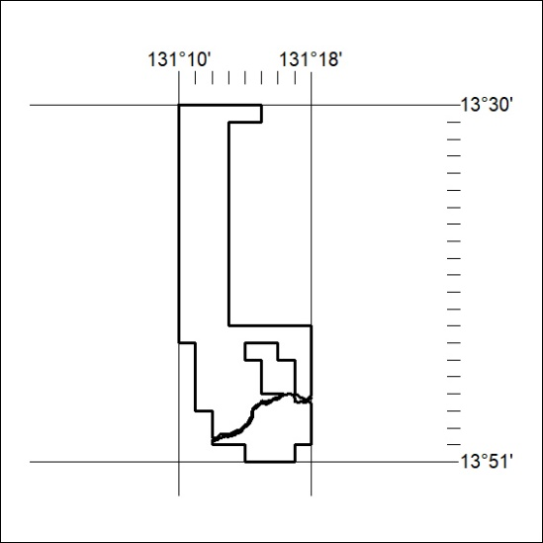
Area granted is indicated above. The titleholder is not permitted to exercise occupational rights on any land that is subject to a development title, or an application for a development title. Any land the subject of a Reserved Land gazettal under the Mineral Titles Act and all land vested in the Commonwealth of Australia is also excluded by description but not excised from the grant area.
200/22

Mineral Titles Act
NOTICE OF GRANT OF A MINERAL TITLE
Title Type and Number: | Exploration Licence 32886
Granted: | 17 June 2022, for a period of 6 Years
Area: | 131 Blocks, 424.33 km²
Locality: | TIPPERARY
Name of Holder/s: | 100% MANGUSTA MINERALS PTY LTD [ACN. 653 950 522]
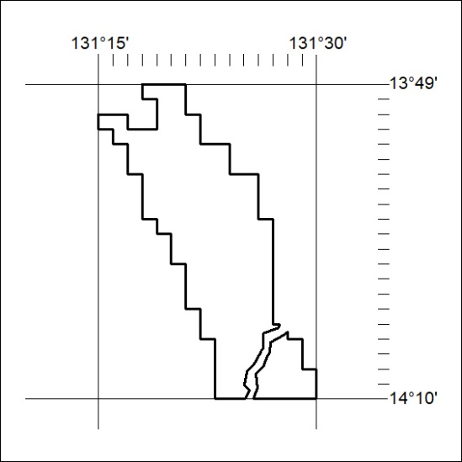
Area granted is indicated above. The titleholder is not permitted to exercise occupational rights on any land that is subject to a development title, or an application for a development title. Any land the subject of a Reserved Land gazettal under the Mineral Titles Act and all land vested in the Commonwealth of Australia is also excluded by description but not excised from the grant area.
201/22

