Mineral Titles Act 2010
NOTICE OF LAND CEASING TO BE A MINERAL TITLE APPLICATION AREA
Title Type and Number: | Exploration Licence 33027
Area Ceased on: | 29 April 2022
Area: | 28 Blocks, 92.21 km²
Locality: | BATTEN
Name of Applicant(s)/Holder(s): | 100% REDBANK OPERATIONS PTY LTD* [ACN. 109 362 165]
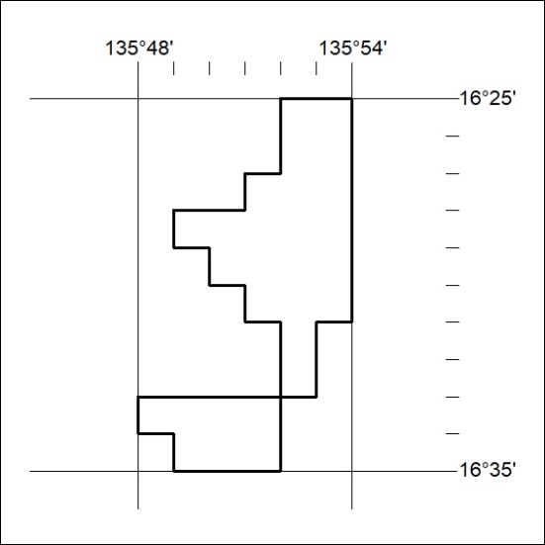

151/22

Mineral Titles Act
NOTICE OF GRANT OF A MINERAL TITLE
Title Type and Number: | Exploration Licence 32721
Granted: | 03 May 2022, for a period of 6 Years
Area: | 250 Blocks, 816.73 km²
Locality: | BAUHINIA DOWNS
Name of Holder/s: | 100% BAUDIN RESOURCES PTY LTD [ACN. 618 455 593]
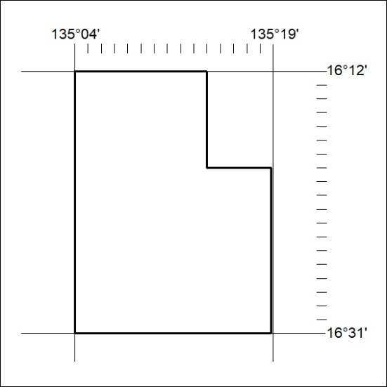
Area granted is indicated above. The titleholder is not permitted to exercise occupational rights on any land that is subject to a development title, or an application for a development title. Any land the subject of a Reserved Land gazettal under the Mineral Titles Act and all land vested in the Commonwealth of Australia is also excluded by description but not excised from the grant area.

152/22

Mineral Titles Act
NOTICE OF GRANT OF A MINERAL TITLE
Title Type and Number: | Exploration Licence 32723
Granted: | 03 May 2022, for a period of 6 Years
Area: | 250 Blocks, 823.05 km²
Locality: | DUNMARRA
Name of Holder/s: | 100% BAUDIN RESOURCES PTY LTD [ACN. 618 455 593]
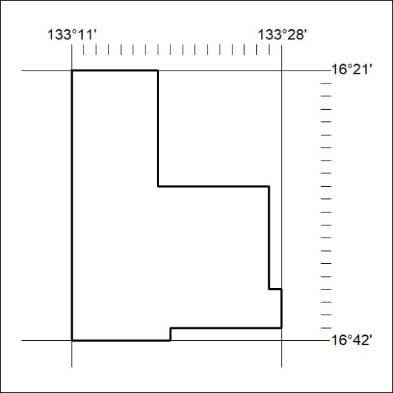
Area granted is indicated above. The titleholder is not permitted to exercise occupational rights on any land that is subject to a development title, or an application for a development title. Any land the subject of a Reserved Land gazettal under the Mineral Titles Act and all land vested in the Commonwealth of Australia is also excluded by description but not excised from the grant area.
153/22

Mineral Titles Act
NOTICE OF GRANT OF A MINERAL TITLE
Title Type and Number: | Exploration Licence 32727
Granted: | 03 May 2022, for a period of 6 Years
Area: | 250 Blocks, 795.65 km²
Locality: | MAIS
Name of Holder/s: | 100% BAUDIN RESOURCES PTY LTD [ACN. 618 455 593]
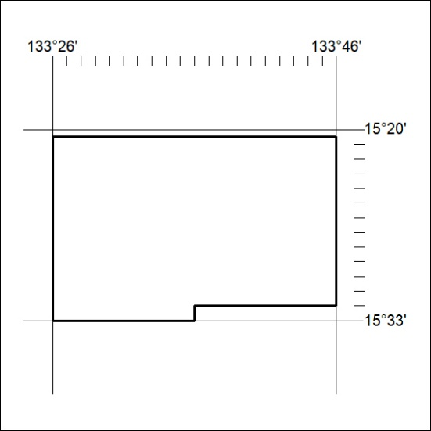
Area granted is indicated above. The titleholder is not permitted to exercise occupational rights on any land that is subject to a development title, or an application for a development title. Any land the subject of a Reserved Land gazettal under the Mineral Titles Act and all land vested in the Commonwealth of Australia is also excluded by description but not excised from the grant area.
154/22

Mineral Titles Act
NOTICE OF GRANT OF A MINERAL TITLE
Title Type and Number: | Exploration Licence 32728
Granted: | 03 May 2022, for a period of 6 Years
Area: | 250 Blocks, 826.95 km²
Locality: | MARYFIELD
Name of Holder/s: | 100% BAUDIN RESOURCES PTY LTD [ACN. 618 455 593]
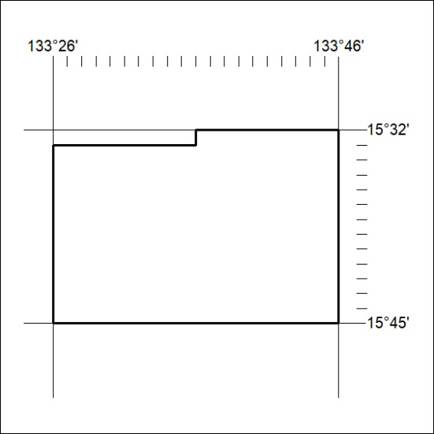
Area granted is indicated above. The titleholder is not permitted to exercise occupational rights on any land that is subject to a development title, or an application for a development title. Any land the subject of a Reserved Land gazettal under the Mineral Titles Act and all land vested in the Commonwealth of Australia is also excluded by description but not excised from the grant area.
155/22

Mineral Titles Act
NOTICE OF GRANT OF A MINERAL TITLE
Title Type and Number: | Exploration Licence 32807
Granted: | 02 May 2022, for a period of 6 Years
Area: | 9 Blocks, 26.62 km²
Locality: | WOLLOGORANG
Name of Holder/s: | 100% REDBANK OPERATIONS PTY LTD* [ACN. 109 362 165]
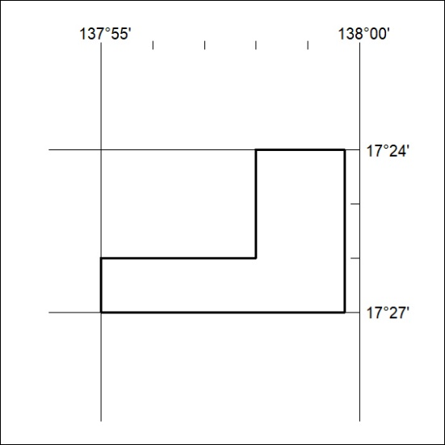
Area granted is indicated above. The titleholder is not permitted to exercise occupational rights on any land that is subject to a development title, or an application for a development title. Any land the subject of a Reserved Land gazettal under the Mineral Titles Act and all land vested in the Commonwealth of Australia is also excluded by description but not excised from the grant area.
156/22

Mineral Titles Act
NOTICE OF GRANT OF A MINERAL TITLE
Title Type and Number: | Exploration Licence 32922
Granted: | 03 May 2022, for a period of 6 Years
Area: | 190 Blocks, 591.84 km²
Locality: | RANKEN
Name of Holder/s: | 100% TECK AUSTRALIA PTY LTD [ACN. 091 271 911]
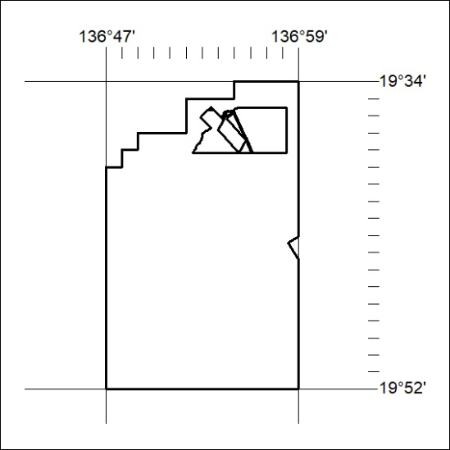
Area granted is indicated above. The titleholder is not permitted to exercise occupational rights on any land that is subject to a development title, or an application for a development title. Any land the subject of a Reserved Land gazettal under the Mineral Titles Act and all land vested in the Commonwealth of Australia is also excluded by description but not excised from the grant area.
157/22

