Mineral Titles Act 2010
NOTICE OF LAND CEASING TO BE A MINERAL TITLE AREA
Title Type and Number: | Exploration Licence 5889
Area Ceased on: | 22 August 2005
Area: | 98 Blocks, 274.15 km²
Locality: | WARE
Name of Applicant(s)/Holder(s): | 100% PRODIGY GOLD NL* [ACN. 009 127 020]
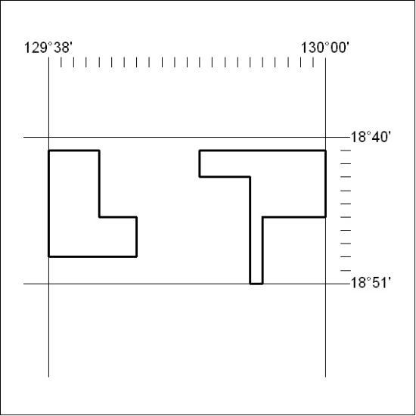

320/21

Mineral Titles Act 2010
NOTICE OF LAND CEASING TO BE A MINERAL TITLE AREA
Title Type and Number: | Exploration Licence 26634
Area Ceased on: | 24 August 2021
Area: | 13 Blocks, 41.94 km²
Locality: | FRANKENIA
Name of Applicant(s)/Holder(s): | 100% PRODIGY GOLD NL* [ACN. 009 127 020]
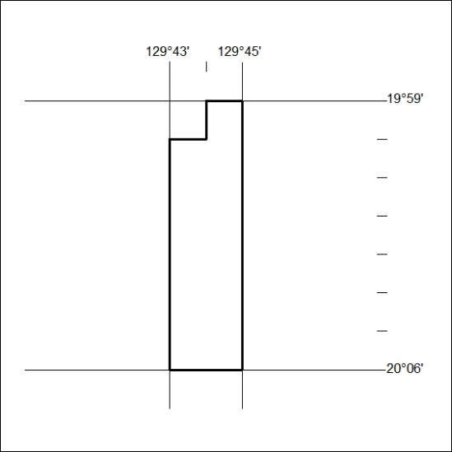

321/21
Mineral Titles Act 2010
NOTICE OF LAND CEASING TO BE A MINERAL TITLE AREA
Title Type and Number: | Exploration Licence 27119
Area Ceased on: | 24 August 2021
Area: | 53 Blocks, 169.61 km²
Locality: | FRANKENIA
Name of Applicant(s)/Holder(s): | 100% PRODIGY GOLD NL* [ACN. 009 127 020]
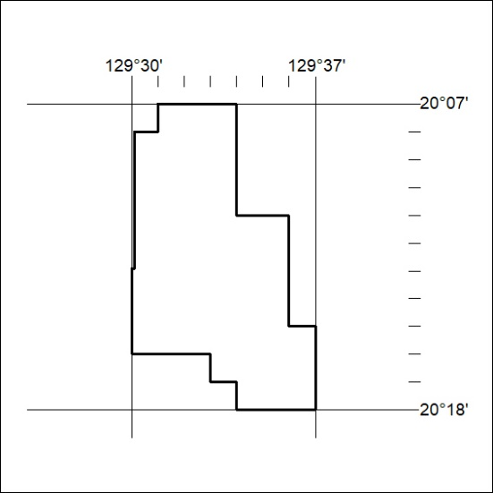

322/21

Mineral Titles Act 2010
NOTICE OF LAND CEASING TO BE A MINERAL TITLE AREA
Title Type and Number: | Exploration Licence 31330
Area Ceased on: | 25 August 2021
Area: | 14 Blocks, 45.20 km²
Locality: | BUCK
Name of Applicant(s)/Holder(s): | 100% PRODIGY GOLD NL* [ACN. 009 127 020]
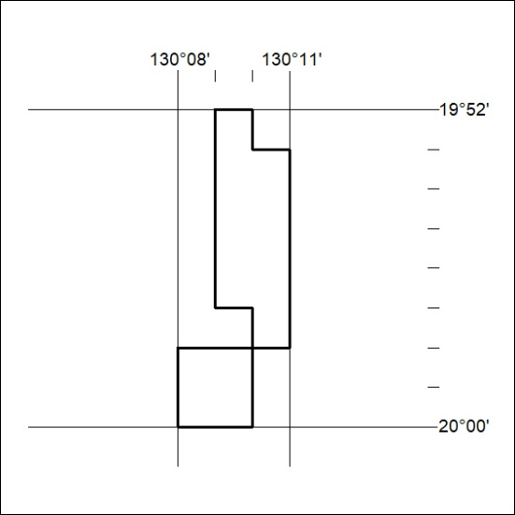

323/21

Mineral Titles Act
NOTICE OF GRANT OF A MINERAL TITLE
Title Type and Number: | Mineral Lease 32351
Granted: | 25 August 2021, for a period of 20 Years
Area: | 3.00 Hectares
Locality: | KILLARNEY
Name of Holder/s: | 100% HEARL Terry Philip
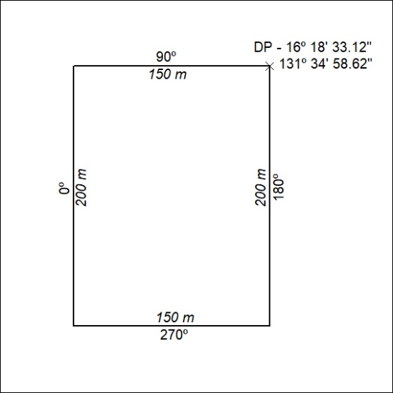

324/21

Mineral Titles Act
NOTICE OF GRANT OF A MINERAL TITLE
Title Type and Number: | Mineral Lease 32352
Granted: | 25 August 2021, for a period of 20 Years
Area: | 9.00 Hectares
Locality: | KILLARNEY
Name of Holder/s: | 100% HEARL Terry Philip
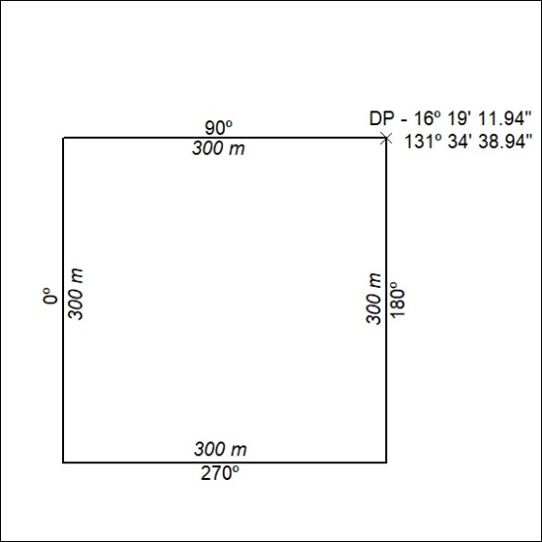

325/21

Mineral Titles Act
NOTICE OF GRANT OF A MINERAL TITLE
Title Type and Number: | Mineral Lease 32353
Granted: | 25 August 2021, for a period of 20 Years
Area: | 4.00 Hectares
Locality: | KILLARNEY
Name of Holder/s: | 100% HEARL Terry Philip
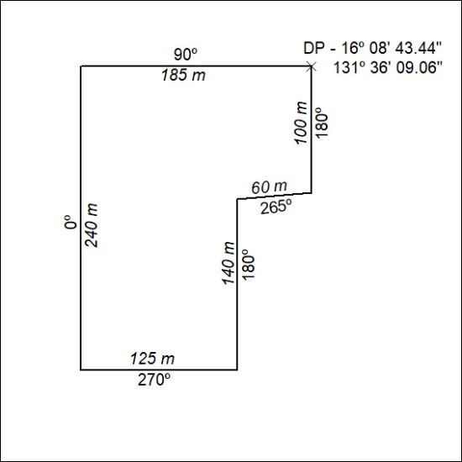

326/21

Mineral Titles Act
NOTICE OF GRANT OF A MINERAL TITLE
Title Type and Number: | Mineral Lease 32354
Granted: | 25 August 2021, for a period of 20 Years
Area: | 2.00 Hectares
Locality: | KILLARNEY
Name of Holder/s: | 100% HEARL Terry Philip
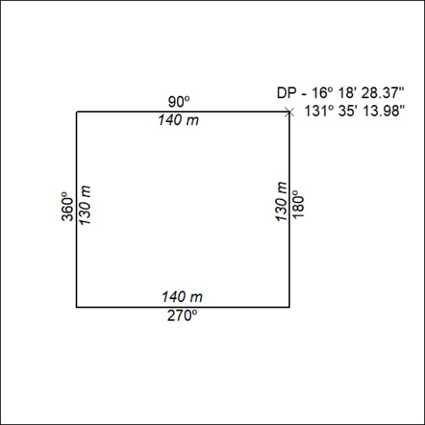

327/21

