Mineral Titles Act
NOTICE OF GRANT OF A MINERAL TITLE
Title Type and Number: | Extractive Mineral Exploration Licence 32383
Granted: | 18 May 2021, for a period of 2 Years
Area: | 3 Blocks, 7.69 km²
Locality: | KOOLPINYAH
Name of Holder/s: | 100% SAGE PROPERTIES (NT) PTY LTD [ACN. 154 373 654]
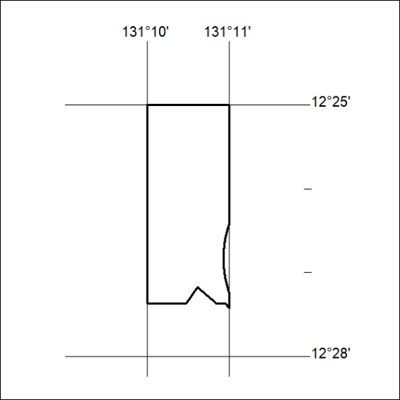
Area granted is indicated above. The titleholder is not permitted to exercise occupational rights on any land that is subject to a development title, or an application for a development title. Any land the subject of a Reserved Land gazettal under the Mineral Titles Act and all land vested in the Commonwealth of Australia is also excluded by description but not excised from the grant area.
168/21

Mineral Titles Act
NOTICE OF GRANT OF A MINERAL TITLE
Title Type and Number: | Extractive Mineral Exploration Licence 32384
Granted: | 18 May 2021, for a period of 2 Years
Area: | 2 Blocks, 1.66 km²
Locality: | KOOLPINYAH
Name of Holder/s: | 100% SAGE PROPERTIES (NT) PTY LTD [ACN. 154 373 654]
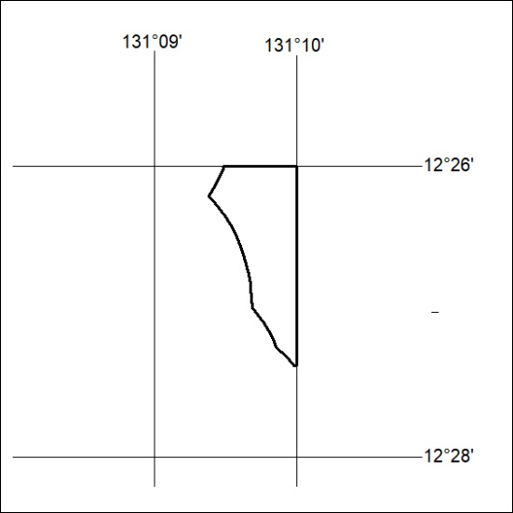
Area granted is indicated above. The titleholder is not permitted to exercise occupational rights on any land that is subject to a development title, or an application for a development title. Any land the subject of a Reserved Land gazettal under the Mineral Titles Act and all land vested in the Commonwealth of Australia is also excluded by description but not excised from the grant area.
169/21

Mineral Titles Act
NOTICE OF GRANT OF A MINERAL TITLE
Title Type and Number: | Extractive Mineral Exploration Licence 32385
Granted: | 18 May 2021, for a period of 2 Years
Area: | 3 Blocks, 7.82 km²
Locality: | KOOLPINYAH
Name of Holder/s: | 100% SAGE PROPERTIES (NT) PTY LTD [ACN. 154 373 654]
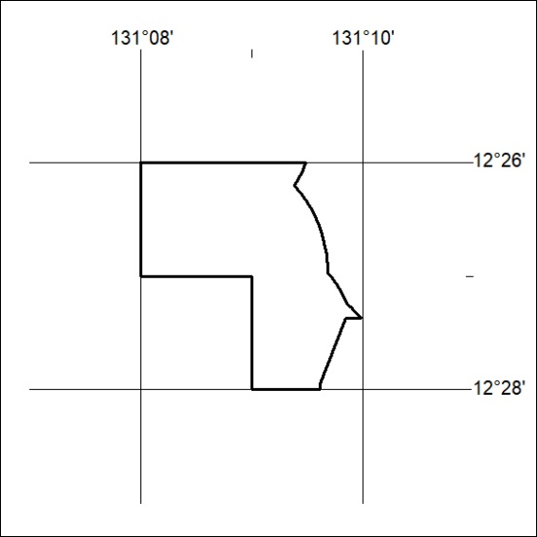
Area granted is indicated above. The titleholder is not permitted to exercise occupational rights on any land that is subject to a development title, or an application for a development title. Any land the subject of a Reserved Land gazettal under the Mineral Titles Act and all land vested in the Commonwealth of Australia is also excluded by description but not excised from the grant area.
170/21

