Mineral Titles Act 2010
NOTICE OF LAND CEASING TO BE A MINERAL TITLE AREA
Title Type and Number: | Exploration Licence 28321
Area Ceased on: | 02 May 2021
Area: | 63 Blocks, 198.43 km²
Locality: | FERGUSSON RIVER
Name of Applicant(s)/Holder(s): | 100% VISTA GOLD AUSTRALIA PTY LTD [ACN. 117 327 509]
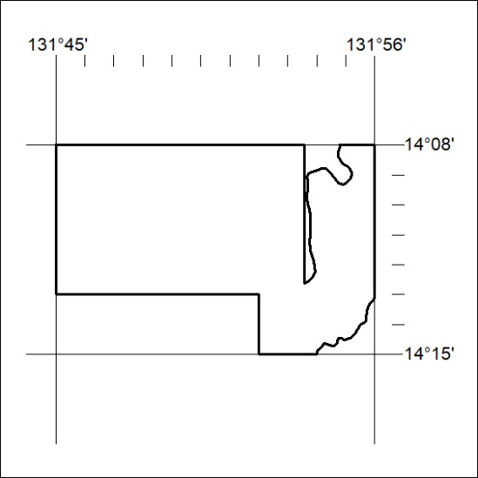

128/21

Mineral Titles Act 2010
NOTICE OF LAND CEASING TO BE A MINERAL TITLE APPLICATION AREA
Title Type and Number: | Mineral Lease 32576
Area ceased on: | 04 May 2021
Area: | 14.00 Hectare
Locality: | KILLARNEY
Name of Applicants(s)Holder(s): | 100% HEARL Terry Philip
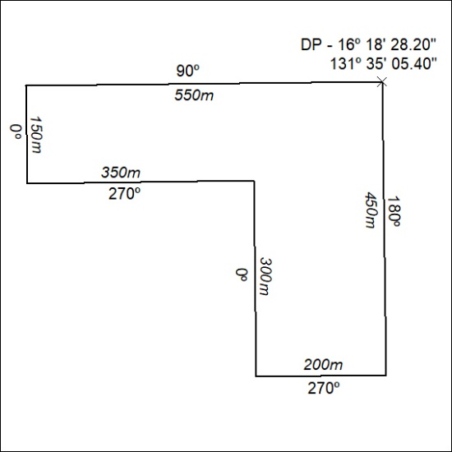

129/21

