Mineral Titles Act 2010
NOTICE OF LAND CEASING TO BE A MINERAL TITLE AREA
Title Type and Number: | Exploration Licence 32133
Area Ceased on: | 13 April 2021
Area: | 52 Blocks, 170.55 km²
Locality: | MARUMBA
Name of Applicant(s)/Holder(s): | 100% ROPER ILMENITE PTY LTD [ACN. 609 843 978]
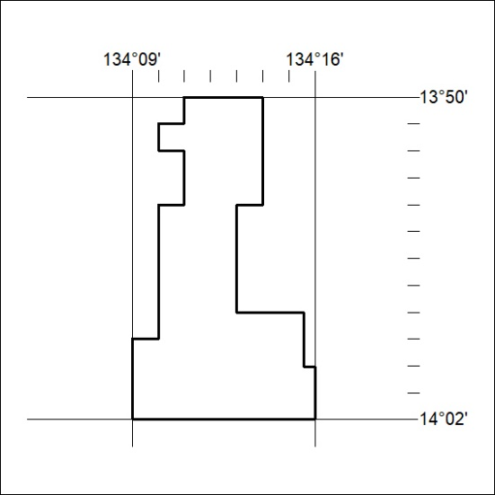

80/21

Mineral Titles Act 2010
NOTICE OF LAND CEASING TO BE A MINERAL TITLE AREA
Title Type and Number: | Exploration Licence 32134
Area Ceased on: | 13 April 2021
Area: | 22 Blocks, 73.33 km²
Locality: | MARUMBA
Name of Applicant(s)/Holder(s): | 100% ROPER ILMENITE PTY LTD [ACN. 609 843 978]
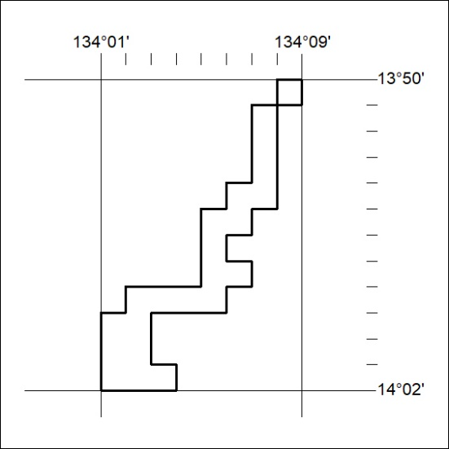

81/21
Mineral Titles Act 2010
NOTICE OF LAND CEASING TO BE A MINERAL TITLE AREA
Title Type and Number: | Exploration Licence 32135
Area Ceased on: | 13 April 2021
Area: | 14 Blocks, 46.62 km²
Locality: | FLYING FOX
Name of Applicant(s)/Holder(s): | 100% ROPER ILMENITE PTY LTD [ACN. 609 843 978]
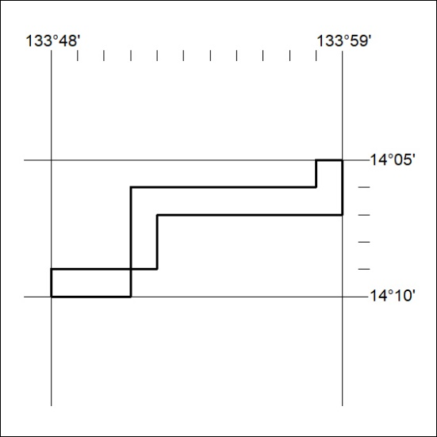

82/21

Mineral Titles Act 2010
NOTICE OF LAND CEASING TO BE A MINERAL TITLE AREA
Title Type and Number: | Exploration Licence 32136
Area Ceased on: | 13 April 2021
Area: | 96 Blocks, 319.68 km²
Locality: | FLYING FOX
Name of Applicant(s)/Holder(s): | 100% ROPER ILMENITE PTY LTD [ACN. 609 843 978]
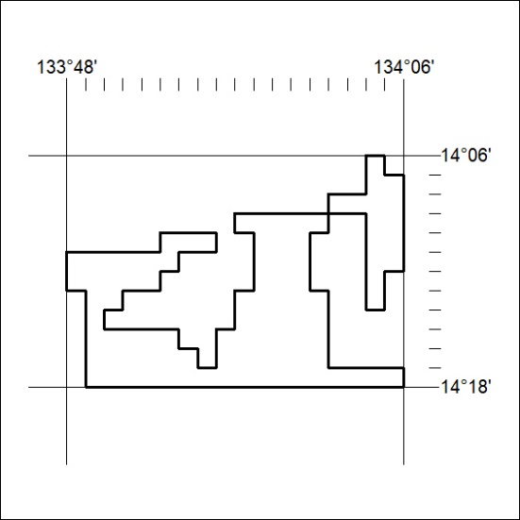

83/21
Mineral Titles Act 2010
NOTICE OF LAND CEASING TO BE A MINERAL TITLE AREA
Title Type and Number: | Exploration Licence 32137
Area Ceased on: | 13 April 2021
Area: | 41 Blocks, 107.29 km²
Locality: | THROSBY
Name of Applicant(s)/Holder(s): | 100% ROPER ILMENITE PTY LTD [ACN. 609 843 978]
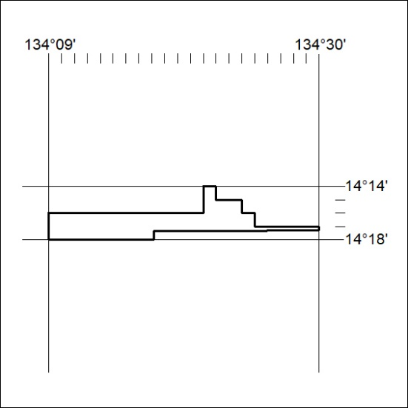

84/21

Mineral Titles Act 2010
NOTICE OF LAND CEASING TO BE A MINERAL TITLE AREA
Title Type and Number: | Exploration Licence 32138
Area Ceased on: | 13 April 2021
Area: | 245 Blocks, 741.21 km²
Locality: | THROSBY
Name of Applicant(s)/Holder(s): | 100% ROPER ILMENITE PTY LTD [ACN. 609 843 978]
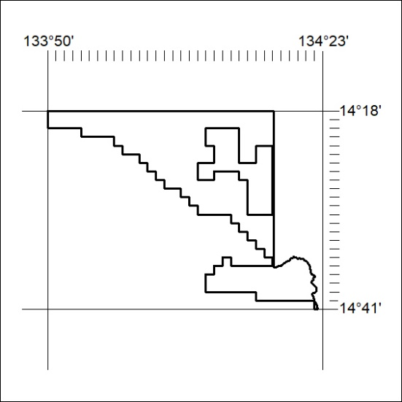

85/21
Mineral Titles Act 2010
NOTICE OF LAND CEASING TO BE A MINERAL TITLE AREA
Title Type and Number: | Exploration Licence 32144
Area Ceased on: | 13 April 2021
Area: | 15 Blocks, 46.46 km²
Locality: | CHAPMAN
Name of Applicant(s)/Holder(s): | 100% ROPER ILMENITE PTY LTD [ACN. 609 843 978]
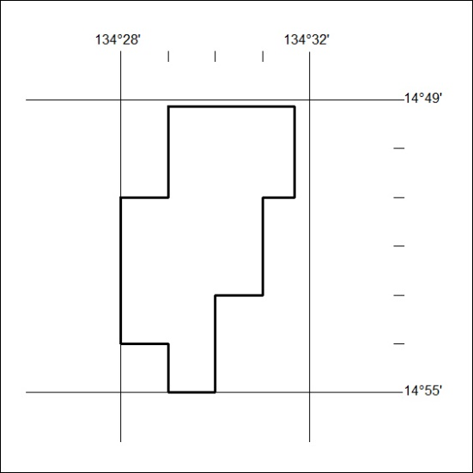

86/21

Mineral Titles Act
NOTICE OF GRANT OF A MINERAL TITLE
Title Type and Number: | Exploration Licence 23094
Granted: | 09 April 2021, for a period of 6 Years
Area: | 28 Blocks, 79.86 km²
Locality: | MUCKATY
Name of Holder/s: | 100% SCRIVEN EXPLORATION PTY LTD [ACN. 006 264 615]
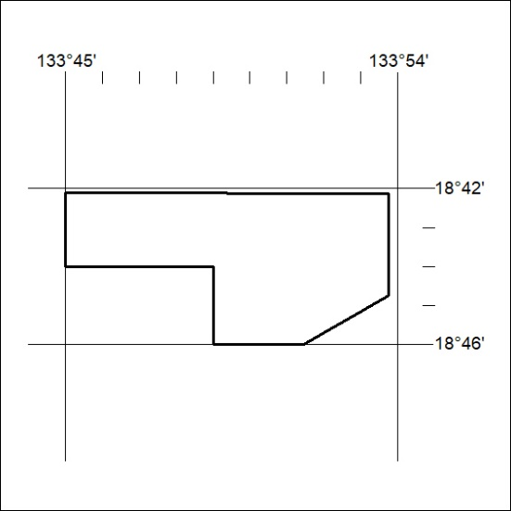
Area granted is indicated above. The titleholder is not permitted to exercise occupational rights on any land that is subject to a development title, or an application for a development title. Any land the subject of a Reserved Land gazettal under the Mineral Titles Act and all land vested in the Commonwealth of Australia is also excluded by description but not excised from the grant area.

87/21

Mineral Titles Act
NOTICE OF GRANT OF A MINERAL TITLE
Title Type and Number: | Exploration Licence 32403
Granted: | 06 April 2021, for a period of 6 Years
Area: | 213 Blocks, 656.89 km²
Locality: | LAUGHLEN
Name of Holder/s: | 100% RED DINGO CORP PTY LTD [ACN. 161 336 081]
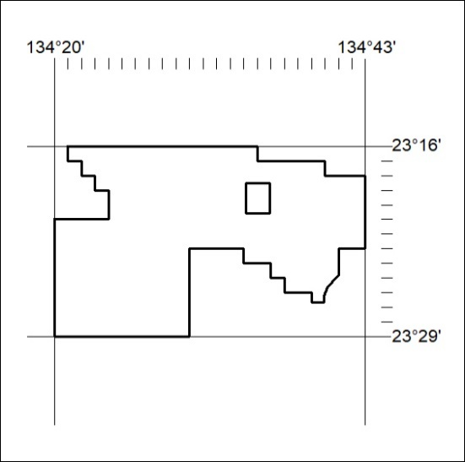
Area granted is indicated above. The titleholder is not permitted to exercise occupational rights on any land that is subject to a development title, or an application for a development title. Any land the subject of a Reserved Land gazettal under the Mineral Titles Act and all land vested in the Commonwealth of Australia is also excluded by description but not excised from the grant area.
88/21

Mineral Titles Act
NOTICE OF GRANT OF A MINERAL TITLE
Title Type and Number: | Exploration Licence 32406
Granted: | 30 March 2021, for a period of 6 Years
Area: | 4 Blocks, 12.63 km²
Locality: | FLORA
Name of Holder/s: | 100% MICRONISED MINERAL SOLUTIONS PTY LTD [ACN. 126 378 318]
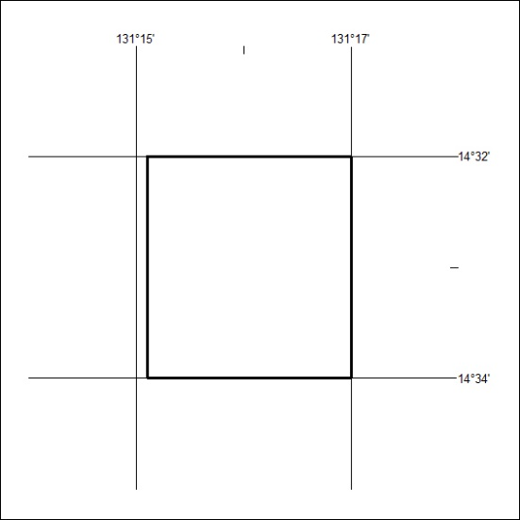
Area granted is indicated above. The titleholder is not permitted to exercise occupational rights on any land that is subject to a development title, or an application for a development title. Any land the subject of a Reserved Land gazettal under the Mineral Titles Act and all land vested in the Commonwealth of Australia is also excluded by description but not excised from the grant area.
89/21

Mineral Titles Act
NOTICE OF GRANT OF A MINERAL TITLE
Title Type and Number: | Exploration Licence 32408
Granted: | 07 April 2021, for a period of 6 Years
Area: | 192 Blocks, 626.28 km²
Locality: | NONGRA
Name of Holder/s: | 100% OAKAJEE EXPLORATION PTY LTD [ACN. 629 544 912]
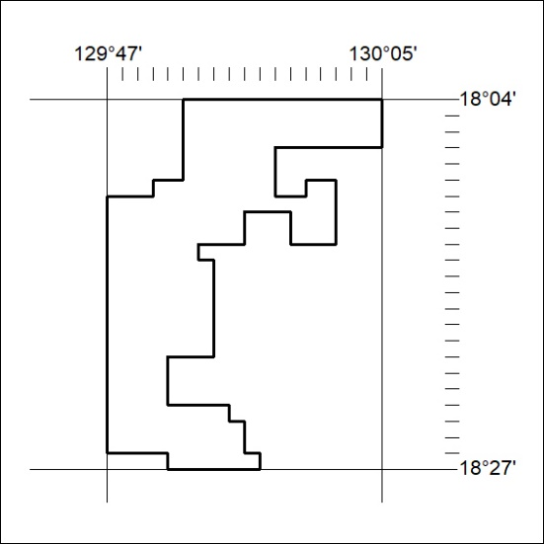
Area granted is indicated above. The titleholder is not permitted to exercise occupational rights on any land that is subject to a development title, or an application for a development title. Any land the subject of a Reserved Land gazettal under the Mineral Titles Act and all land vested in the Commonwealth of Australia is also excluded by description but not excised from the grant area.
90/21

Mineral Titles Act
NOTICE OF GRANT OF A MINERAL TITLE
Title Type and Number: | Exploration Licence 32489
Granted: | 08 April 2021, for a period of 6 Years
Area: | 6 Blocks, 20.05 km²
Locality: | BATCHELOR
Name of Holder/s: | 100% PNX METALS LIMITED* [ACN. 127 446 271]
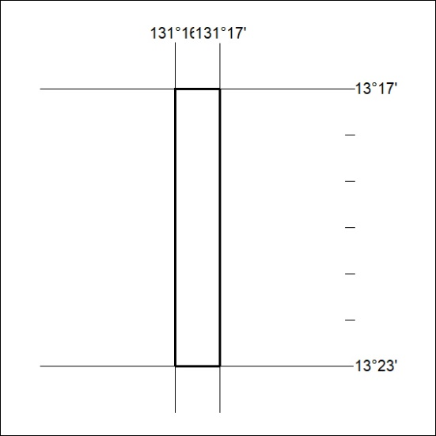
Area granted is indicated above. The titleholder is not permitted to exercise occupational rights on any land that is subject to a development title, or an application for a development title. Any land the subject of a Reserved Land gazettal under the Mineral Titles Act and all land vested in the Commonwealth of Australia is also excluded by description but not excised from the grant area.
91/21

