Mineral Titles Act
NOTICE OF GRANT OF A MINERAL TITLE
Title Type and Number: | Extractive Mineral Permit 32072
Granted: | 22 February 2021, for a period of 5 Years
Area: | 11.00 Hectares
Locality: | MANBULLOO
Name of Holder/s: | 100% RELKETY PTY. LIMITED [ACN. 009 647 296]
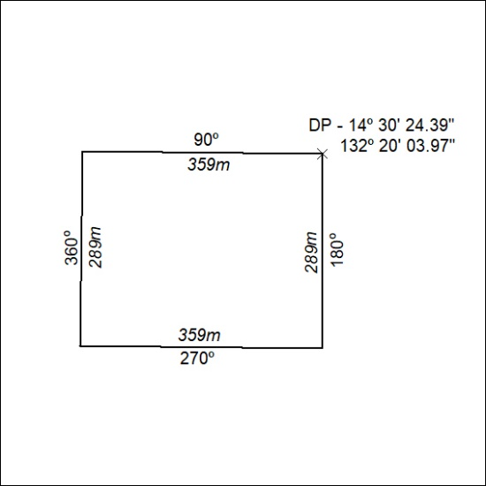

38/21

