Mineral Titles Act 2010
NOTICE OF LAND CEASING TO BE A MINERAL TITLE APPLICATION AREA
Title Type and Number: | Mineral Authority 27323
Area ceased on: | 04 December 2020
Area: | 66.00 Hectare
Locality: | BYNOE
Name of Applicants(s)Holder(s): | 100% DARWIN PORT CORPORATION
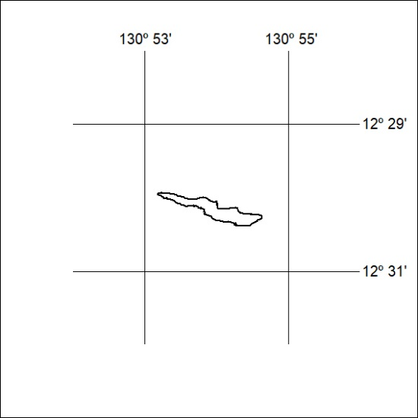

400/20

Mineral Titles Act
NOTICE OF GRANT OF A MINERAL TITLE
Title Type and Number: | Extractive Mineral Exploration Licence 32252
Granted: | 04 December 2020, for a period of 2 Years
Area: | 4 Blocks, 11.27 km²
Locality: | KOOLPINYAH
Name of Holder/s: | 100% YEBNA QUARRIES HOLDINGS PTY LTD [ACN. 600 183 248]
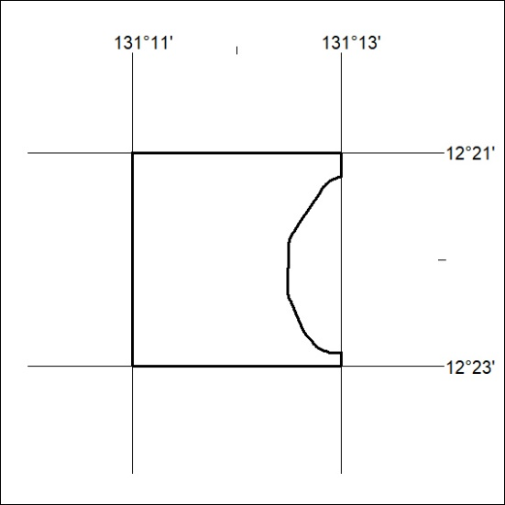
Area granted is indicated above. The titleholder is not permitted to exercise occupational rights on any land that is subject to a development title, or an application for a development title. Any land the subject of a Reserved Land gazettal under the Mineral Titles Act and all land vested in the Commonwealth of Australia is also excluded by description but not excised from the grant area.

401/20

Mineral Titles Act
NOTICE OF GRANT OF A MINERAL TITLE
Title Type and Number: | Extractive Mineral Exploration Licence 32253
Granted: | 04 December 2020, for a period of 2 Years
Area: | 4 Blocks, 8.53 km²
Locality: | KOOLPINYAH
Name of Holder/s: | 100% YEBNA QUARRIES HOLDINGS PTY LTD [ACN. 600 183 248]
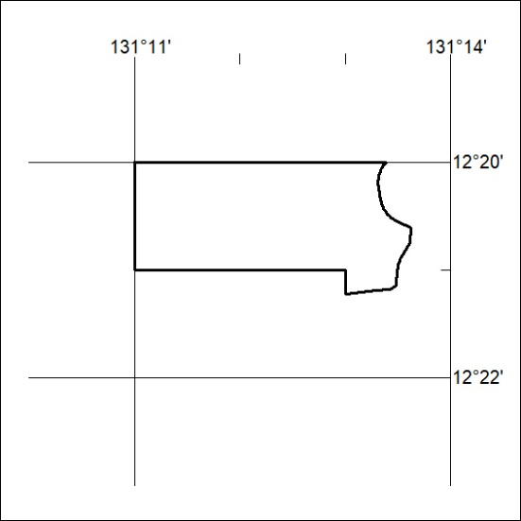
Area granted is indicated above. The titleholder is not permitted to exercise occupational rights on any land that is subject to a development title, or an application for a development title. Any land the subject of a Reserved Land gazettal under the Mineral Titles Act and all land vested in the Commonwealth of Australia is also excluded by description but not excised from the grant area.

402/20

