Mineral Titles Act 2010
NOTICE OF LAND CEASING TO BE A MINERAL TITLE AREA
Title Type and Number: | Extractive Mineral Permit 24036
Area ceased on: | 20 May 2020
Area: | 11.00 Hectare
Locality: | NOONAMAH
Name of Applicants(s)Holder(s): | 100% OSTOJIC GROUP PTY LTD* [ACN. 009 629 805]
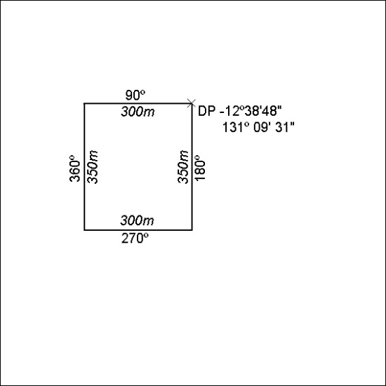

182/20

Mineral Titles Act 2010
NOTICE OF LAND CEASING TO BE A MINERAL TITLE AREA
Title Type and Number: | Extractive Mineral Permit 27760
Area ceased on: | 20 May 2020
Area: | 7.00 Hectare
Locality: | NOONAMAH
Name of Applicants(s)Holder(s): | 100% OSTOJIC GROUP PTY LTD* [ACN. 009 629 805]
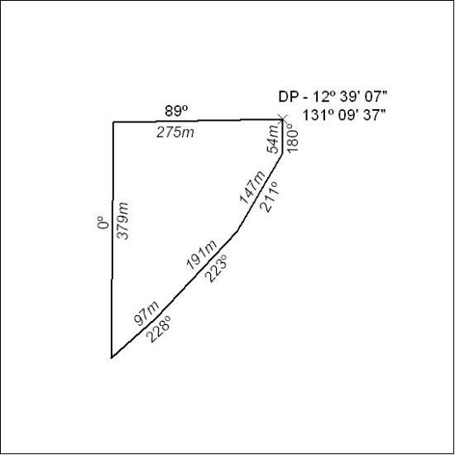

183/20

Mineral Titles Act 2010
NOTICE OF LAND CEASING TO BE A MINERAL TITLE AREA
Title Type and Number: | Extractive Mineral Permit 27761
Area ceased on: | 20 May 2020
Area: | 71.00 Hectare
Locality: | NOONAMAH
Name of Applicants(s)Holder(s): | 100% OSTOJIC GROUP PTY LTD* [ACN. 009 629 805]
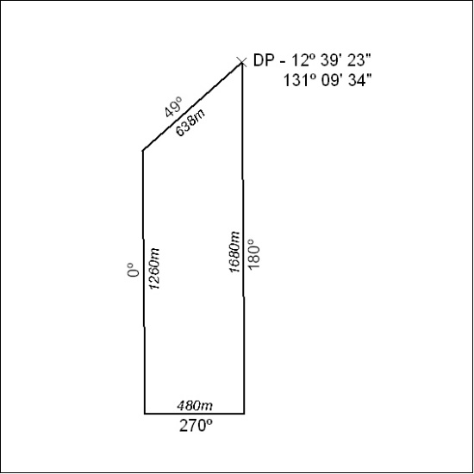

184/20

Mineral Titles Act 2010
NOTICE OF LAND CEASING TO BE A MINERAL TITLE AREA
Title Type and Number: | Exploration Licence 27709
Area Ceased on: | 19 May 2020
Area: | 33 Blocks, 103.91 km²
Locality: | RIDDOCH
Name of Applicant(s)/Holder(s): | 100% DBL BLUES PTY LTD [ACN. 140 024 442]
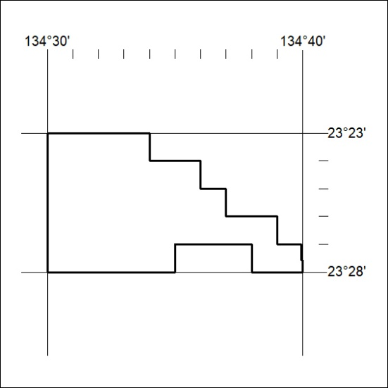

185/20

