Mineral Titles Act 2010
NOTICE OF LAND CEASING TO BE A MINERAL TITLE AREA
Title Type and Number: | Mineral Authority 29030
Area ceased on: | 21 February 2020
Area: | 42.00 Hectare
Locality: | BYNOE
Name of Applicants(s)Holder(s): | 100% INPEX OPERATIONS AUSTRALIA PTY LTD [ACN. 150 217 262]
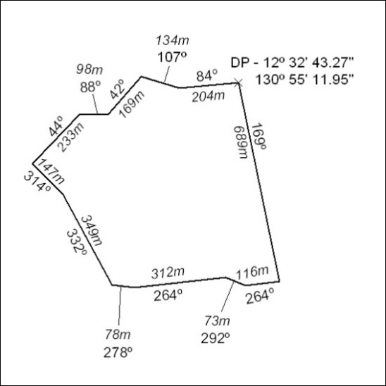

112/20

Mineral Titles Act 2010
NOTICE OF LAND CEASING TO BE A MINERAL TITLE AREA
Title Type and Number: | Exploration Licence 31130
Area Ceased on: | 24 February 2020
Area: | 3 Blocks, 9.51 km²
Locality: | JERVOIS RANGE
Name of Applicant(s)/Holder(s): | 100% MOLYHIL MINING PTY LTD [ACN. 112 922 497]
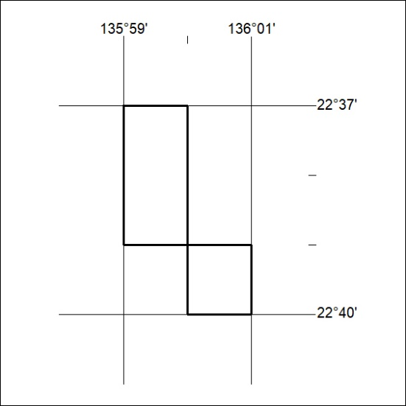

113/20

Mineral Titles Act
NOTICE OF GRANT OF A MINERAL TITLE
Title Type and Number: | Extractive Mineral Exploration Licence 32193
Granted: | 21 February 2020, for a period of 2 Years
Area: | 1 Block, 2.58 km²
Locality: | BYNOE
Name of Holder/s: | 100% ALLAN KING & SONS CONSTRUCTION PTY LTD [ACN. 068 688 148]
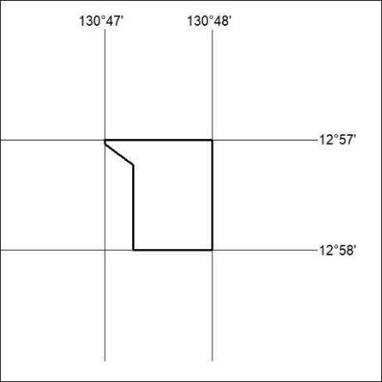
Area granted is indicated above. The titleholder is not permitted to exercise occupational rights on any land that is subject to a development title, or an application for a development title. Any land the subject of a Reserved Land gazettal under the Mineral Titles Act and all land vested in the Commonwealth of Australia is also excluded by description but not excised from the grant area.

114/20

Mineral Titles Act
NOTICE OF GRANT OF A MINERAL TITLE
Title Type and Number: | Exploration Licence 32178
Granted: | 21 February 2020, for a period of 6 Years
Area: | 206 Blocks, 650.13 km²
Locality: | NARWIETOOMA
Name of Holder/s: | 100% NEW AGE RESOURCES PTY LTD [ACN. 622 780 072]
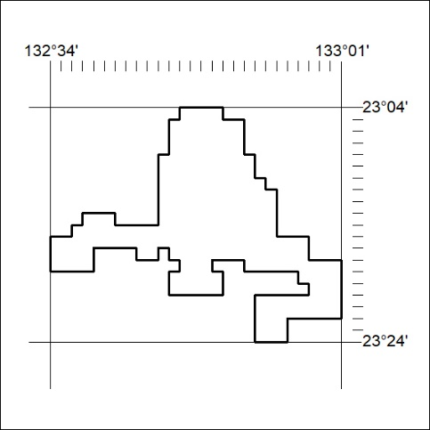
Area granted is indicated above. The titleholder is not permitted to exercise occupational rights on any land that is subject to a development title, or an application for a development title. Any land the subject of a Reserved Land gazettal under the Mineral Titles Act and all land vested in the Commonwealth of Australia is also excluded by description but not excised from the grant area.

115/20

Mineral Titles Act
NOTICE OF GRANT OF A MINERAL TITLE
Title Type and Number: | Exploration Licence 32179
Granted: | 21 February 2020, for a period of 6 Years
Area: | 250 Blocks, 785.39 km²
Locality: | TEA TREE
Name of Holder/s: | 100% NEW AGE RESOURCES PTY LTD [ACN. 622 780 072]
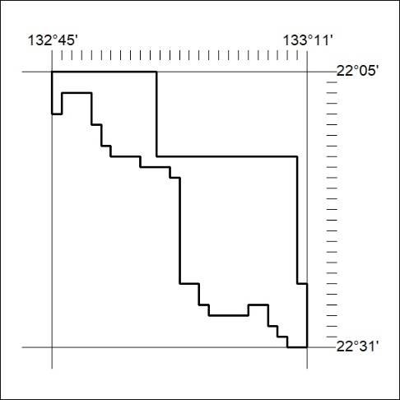
Area granted is indicated above. The titleholder is not permitted to exercise occupational rights on any land that is subject to a development title, or an application for a development title. Any land the subject of a Reserved Land gazettal under the Mineral Titles Act and all land vested in the Commonwealth of Australia is also excluded by description but not excised from the grant area.

116/20

