Mineral Titles Act 2010
NOTICE OF LAND CEASING TO BE A MINERAL TITLE APPLICATION AREA
Title Type and Number: | Exploration Licence 31063
Area Ceased on: | 24 May 2019
Area: | 250 Blocks, 833.19 km²
Locality: | PARSONS
Name of Applicant(s)/Holder(s): | 100% MMG EXPLORATION PTY LTD* [ACN. 119 136 659]
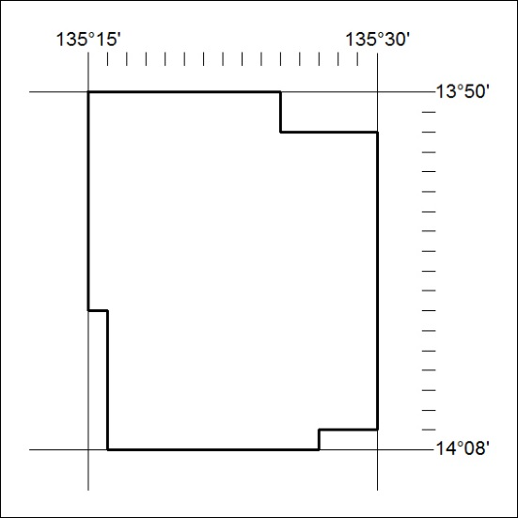

187/19

Mineral Titles Act 2010
NOTICE OF LAND CEASING TO BE A MINERAL TITLE APPLICATION AREA
Title Type and Number: | Exploration Licence 31064
Area Ceased on: | 24 May 2019
Area: | 250 Blocks, 833.24 km²
Locality: | PHELP
Name of Applicant(s)/Holder(s): | 100% MMG EXPLORATION PTY LTD* [ACN. 119 136 659]
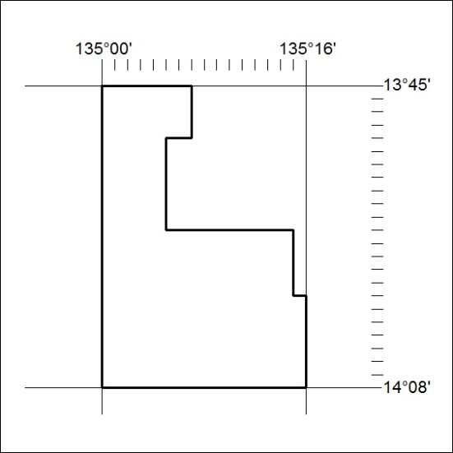

188/19
Mineral Titles Act 2010
NOTICE OF LAND CEASING TO BE A MINERAL TITLE APPLICATION AREA
Title Type and Number: | Exploration Licence 31210
Area Ceased on: | 24 May 2019
Area: | 165 Blocks, 542.32 km²
Locality: | OT DOWNS
Name of Applicant(s)/Holder(s): | 100% MMG EXPLORATION PTY LTD* [ACN. 119 136 659]
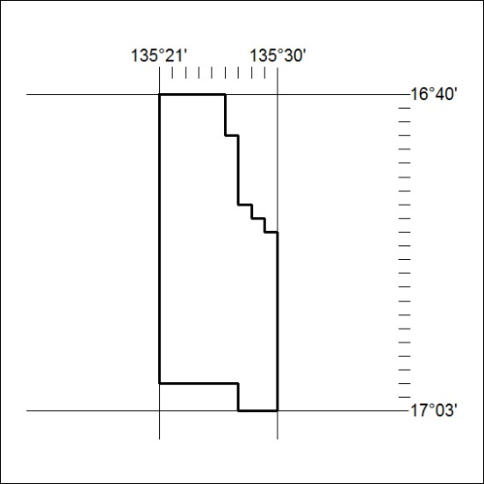

189/19

Mineral Titles Act 2010
NOTICE OF LAND CEASING TO BE A MINERAL TITLE APPLICATION AREA
Title Type and Number: | Exploration Licence 31215
Area Ceased on: | 24 May 2019
Area: | 250 Blocks, 835.44 km²
Locality: | FLEMING
Name of Applicant(s)/Holder(s): | 100% MMG EXPLORATION PTY LTD* [ACN. 119 136 659]
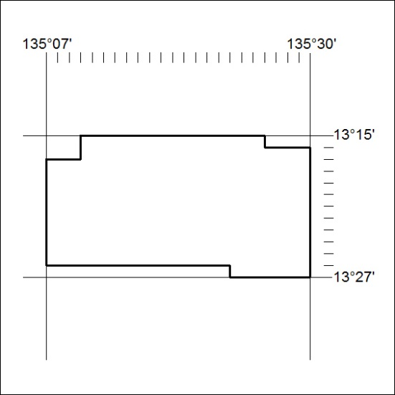

190/19
Mineral Titles Act 2010
NOTICE OF LAND CEASING TO BE A MINERAL TITLE APPLICATION AREA
Title Type and Number: | Exploration Licence 31216
Area Ceased on: | 24 May 2019
Area: | 247 Blocks, 827.13 km²
Locality: | MIRRNGADJA
Name of Applicant(s)/Holder(s): | 100% MMG EXPLORATION PTY LTD* [ACN. 119 136 659]
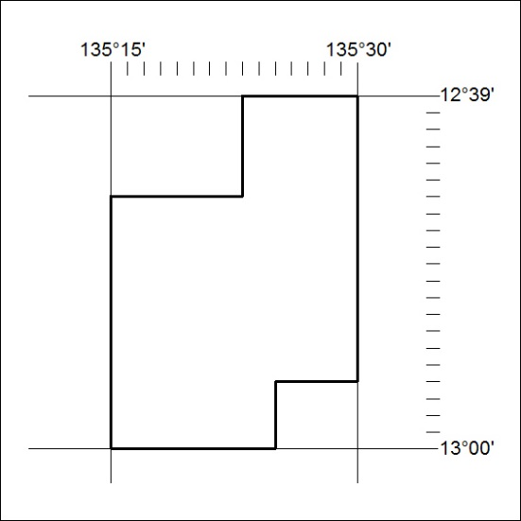

191/19

Mineral Titles Act 2010
NOTICE OF LAND CEASING TO BE A MINERAL TITLE APPLICATION AREA
Title Type and Number: | Exploration Licence 31217
Area Ceased on: | 24 May 2019
Area: | 249 Blocks, 832.90 km²
Locality: | FLEMING
Name of Applicant(s)/Holder(s): | 100% MMG EXPLORATION PTY LTD* [ACN. 119 136 659]
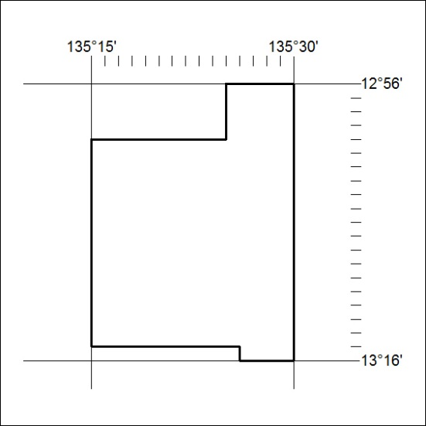

192/19
Mineral Titles Act 2010
NOTICE OF LAND CEASING TO BE A MINERAL TITLE APPLICATION AREA
Title Type and Number: | Exploration Licence 31218
Area Ceased on: | 24 May 2019
Area: | 250 Blocks, 834.67 km²
Locality: | PARSONS
Name of Applicant(s)/Holder(s): | 100% MMG EXPLORATION PTY LTD* [ACN. 119 136 659]
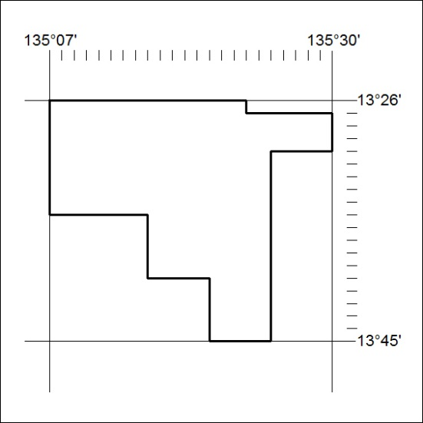

193/19

Mineral Titles Act 2010
NOTICE OF LAND CEASING TO BE A MINERAL TITLE APPLICATION AREA
Title Type and Number: | Exploration Licence 31255
Area Ceased on: | 24 May 2019
Area: | 206 Blocks, 686.93 km²
Locality: | BLUE MUD BAY
Name of Applicant(s)/Holder(s): | 100% MMG EXPLORATION PTY LTD* [ACN. 119 136 659]
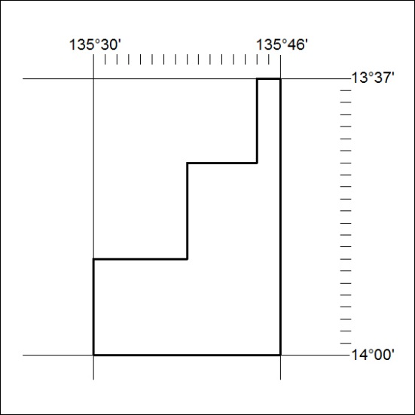

194/19
Mineral Titles Act 2010
NOTICE OF LAND CEASING TO BE A MINERAL TITLE APPLICATION AREA
Title Type and Number: | Exploration Licence 31296
Area Ceased on: | 24 May 2019
Area: | 12 Blocks, 25.89 km²
Locality: | PARSONS
Name of Applicant(s)/Holder(s): | 100% MMG EXPLORATION PTY LTD* [ACN. 119 136 659]
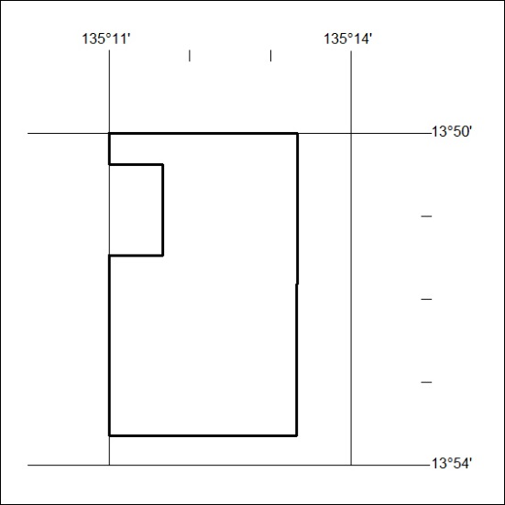

195/19

Mineral Titles Act 2010
NOTICE OF LAND CEASING TO BE A MINERAL TITLE APPLICATION AREA
Title Type and Number: | Exploration Licence 31812
Area Ceased on: | 24 May 2019
Area: | 234 Blocks, 762.30 km²
Locality: | BENMARA
Name of Applicant(s)/Holder(s): | 100% MMG EXPLORATION PTY LTD* [ACN. 119 136 659]
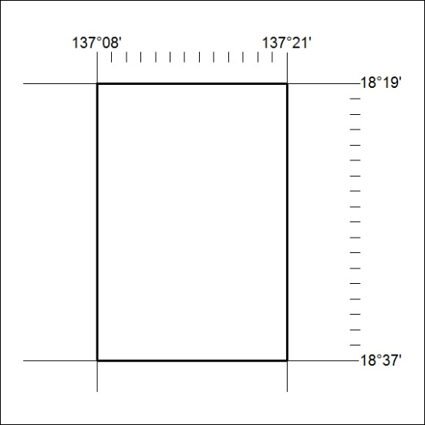

196/19
Mineral Titles Act 2010
NOTICE OF LAND CEASING TO BE A MINERAL TITLE APPLICATION AREA
Title Type and Number: | Exploration Licence 31813
Area Ceased on: | 24 May 2019
Area: | 234 Blocks, 762.30 km²
Locality: | BENMARA
Name of Applicant(s)/Holder(s): | 100% MMG EXPLORATION PTY LTD* [ACN. 119 136 659]
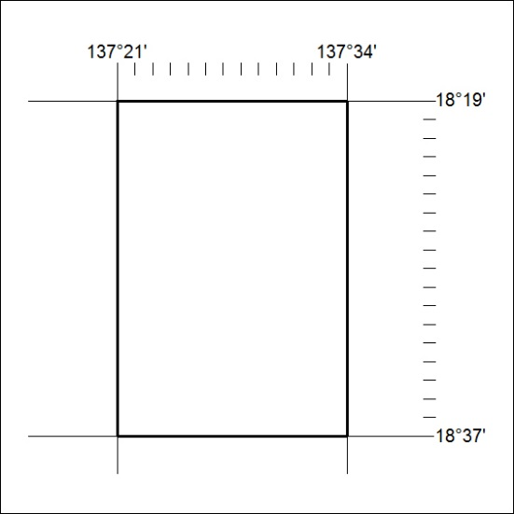

197/19

Mineral Titles Act 2010
NOTICE OF LAND CEASING TO BE A MINERAL TITLE APPLICATION AREA
Title Type and Number: | Exploration Licence 31814
Area Ceased on: | 24 May 2019
Area: | 234 Blocks, 762.30 km²
Locality: | CLEANSKIN
Name of Applicant(s)/Holder(s): | 100% MMG EXPLORATION PTY LTD* [ACN. 119 136 659]
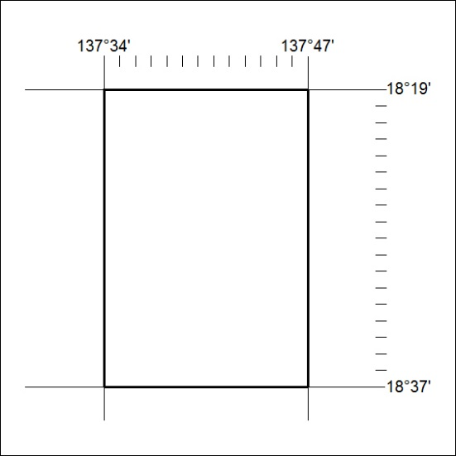

198/19
Mineral Titles Act 2010
NOTICE OF LAND CEASING TO BE A MINERAL TITLE APPLICATION AREA
Title Type and Number: | Exploration Licence 31815
Area Ceased on: | 24 May 2019
Area: | 234 Blocks, 747.06 km²
Locality: | CLEANSKIN
Name of Applicant(s)/Holder(s): | 100% MMG EXPLORATION PTY LTD* [ACN. 119 136 659]
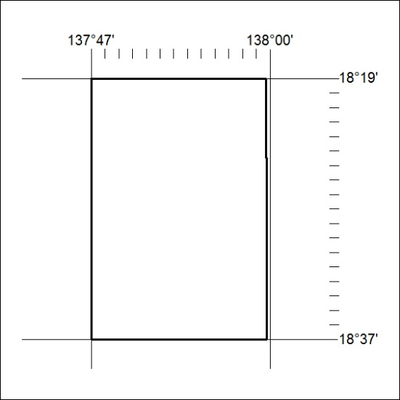

199/19

Mineral Titles Act 2010
NOTICE OF LAND CEASING TO BE A MINERAL TITLE APPLICATION AREA
Title Type and Number: | Exploration Licence 31816
Area Ceased on: | 24 May 2019
Area: | 214 Blocks, 710.21 km²
Locality: | URAPUNGA
Name of Applicant(s)/Holder(s): | 100% MMG EXPLORATION PTY LTD* [ACN. 119 136 659]
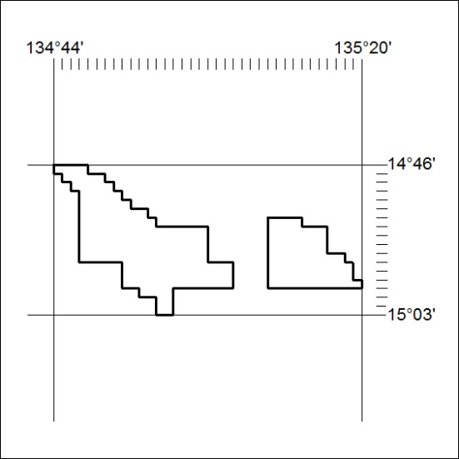

200/19

