Mineral Titles Act 2010
NOTICE OF LAND CEASING TO BE A MINERAL TITLE AREA
Title Type and Number: | Exploration Licence 30359
Area Ceased on: | 05 April 2019
Area: | 10 Blocks, 32.59 km²
Locality: | HELEN
Name of Applicant(s)/Holder(s): | 100% TODD RIVER METALS PTY LTD [ACN. 600 314 038]
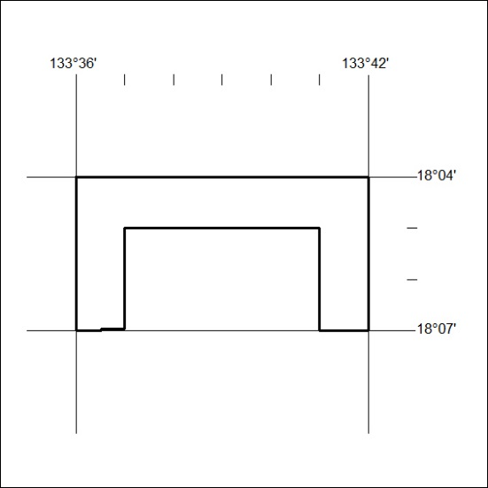

118/19

