Mineral Titles Act
NOTICE OF LAND CEASING TO BE A MINERAL TITLE
Title Type and Number: | Mineral Authority 24687
Area ceased on: | 27 February 2019
Area: | 23.00 Hectare
Locality: | KOOLPINYAH
Name of Applicants(s)Holder(s): | 100% EARTHWORKS NT PTY LTD [ACN. 145 461 169]
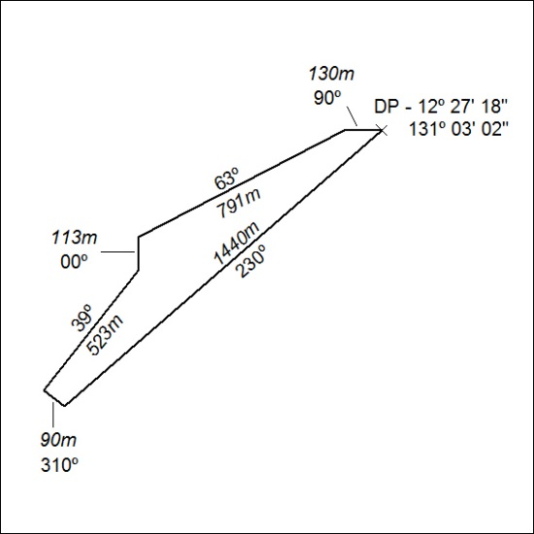

67/19

