Mineral Titles Act
NOTICE OF LAND CEASING TO BE A MINERAL TITLE
Title Type and Number: | Mineral Authority 29462
Area ceased on: | 21 September 2018
Area: | 42.90 Hectare
Locality: | KOOLPINYAH
Name of Applicants(s)Holder(s): | 100% CITY EARTHMOVING PTY LTD [ACN. 168 078 742]
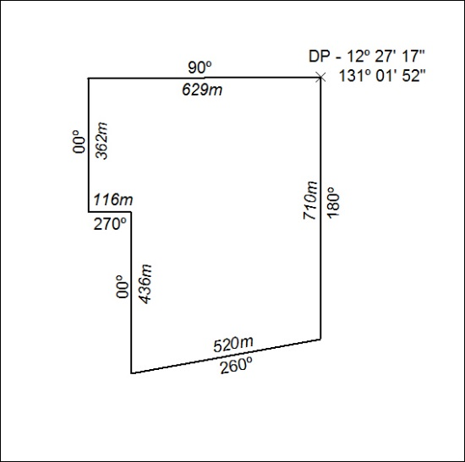

471/18

Mineral Titles Act
NOTICE OF LAND CEASING TO BE A MINERAL TITLE
Title Type and Number: | Extractive Mineral Permit 29707
Area ceased on: | 23 October 2018
Area: | 10.59 Hectare
Locality: | NOONAMAH
Name of Applicants(s)Holder(s): | 100% KIGILIA PTY LTD [ACN. 113 822 343]
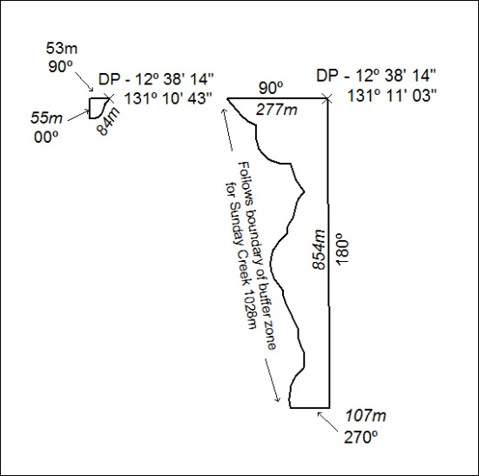

472/18

