Mineral Titles Act 2010
NOTICE OF LAND CEASING TO BE A MINERAL TITLE AREA
Title Type and Number: | Exploration Licence 31545
Area Ceased on: | 27 April 2022
Area: | 86 Blocks, 283.35 km²
Locality: | KILLARNEY
Name of Applicant(s)/Holder(s): | 100% WRIGHT Anthony
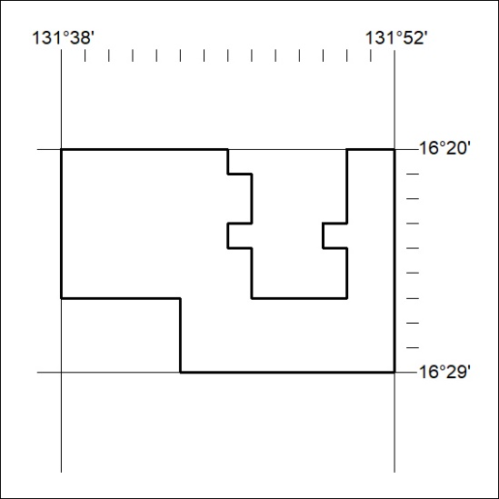

148/22

Mineral Titles Act 2010
NOTICE OF LAND CEASING TO BE A MINERAL TITLE AREA
Title Type and Number: | Exploration Licence 32248
Area Ceased on: | 27 April 2022
Area: | 128 Blocks, 420.56 km²
Locality: | FLAT TOP HILL
Name of Applicant(s)/Holder(s): | 100% SANTONIAN RESOURCES LIMITED* [ACN. 627 611 563]
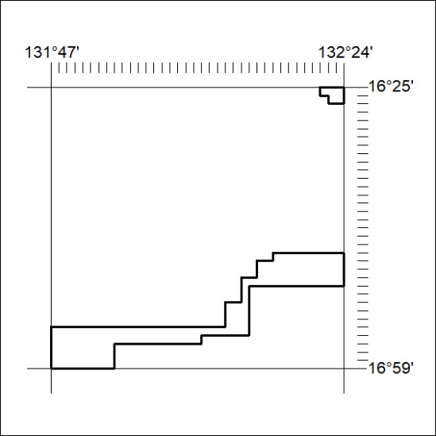

149/22
Mineral Titles Act 2010
NOTICE OF LAND CEASING TO BE A MINERAL TITLE APPLICATION AREA
Title Type and Number: | Exploration Licence 32823
Area Ceased on: | 27 April 2022
Area: | 7 Blocks, 23.40 km²
Locality: | McKINLAY RIVER
Name of Applicant(s)/Holder(s): | 100% TRENDSHEER HOLDINGS PTY LTD [ACN. 621 426 515]
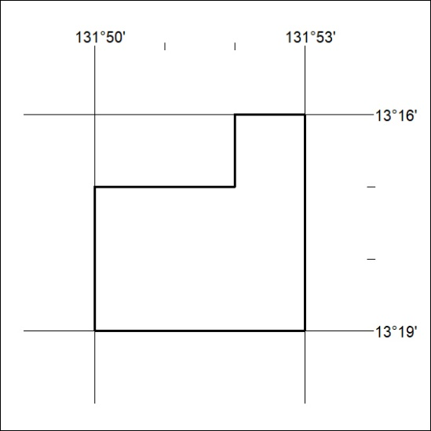

150/22

