Mineral Titles Act 2010
NOTICE OF LAND CEASING TO BE A MINERAL TITLE APPLICATION AREA
Title Type and Number: | Exploration Licence 32891
Area Ceased on: | 19 April 2022
Area: | 249 Blocks, 752.01 km²
Locality: | AREYONGA
Name of Applicant(s)/Holder(s): | 100% FMG RESOURCES PTY LTD [ACN. 095 546 428]
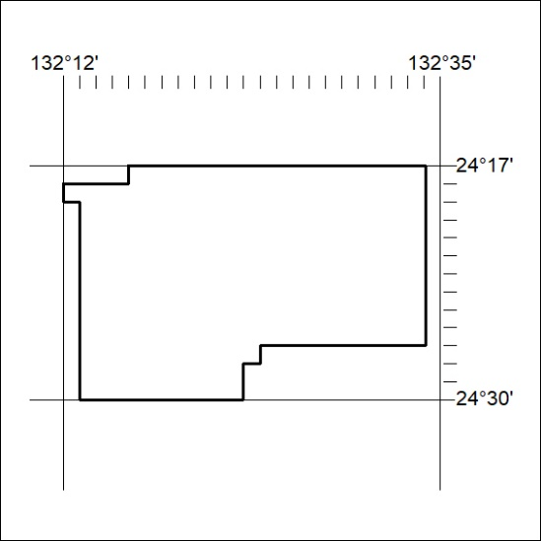

119/22

Mineral Titles Act 2010
NOTICE OF LAND CEASING TO BE A MINERAL TITLE APPLICATION AREA
Title Type and Number: | Exploration Licence 32892
Area Ceased on: | 19 April 2022
Area: | 250 Blocks, 754.72 km²
Locality: | WALLERA
Name of Applicant(s)/Holder(s): | 100% FMG RESOURCES PTY LTD [ACN. 095 546 428]
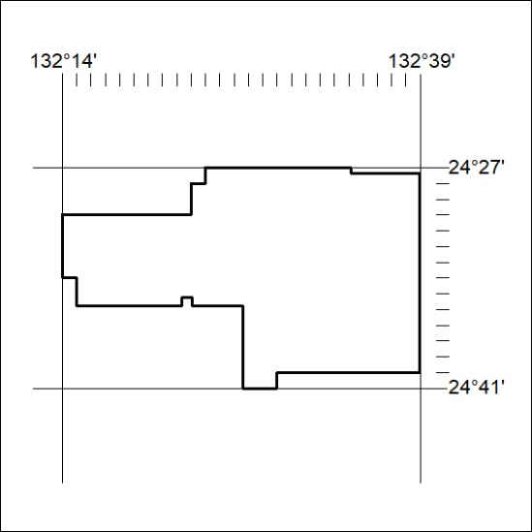

120/22
Mineral Titles Act 2010
NOTICE OF LAND CEASING TO BE A MINERAL TITLE APPLICATION AREA
Title Type and Number: | Exploration Licence 32893
Area Ceased on: | 19 April 2022
Area: | 62 Blocks, 178.01 km²
Locality: | SEYMOUR
Name of Applicant(s)/Holder(s): | 100% FMG RESOURCES PTY LTD [ACN. 095 546 428]
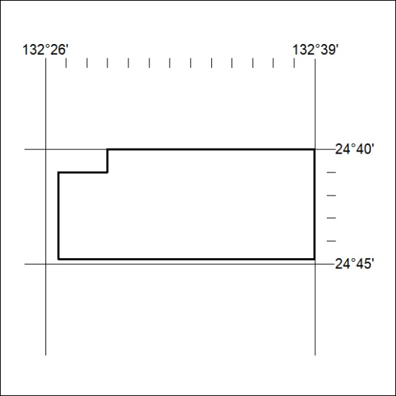

121/22

Mineral Titles Act 2010
NOTICE OF LAND CEASING TO BE A MINERAL TITLE APPLICATION AREA
Title Type and Number: | Exploration Licence 32894
Area Ceased on: | 19 April 2022
Area: | 248 Blocks, 670.71 km²
Locality: | WALLERA
Name of Applicant(s)/Holder(s): | 100% FMG RESOURCES PTY LTD [ACN. 095 546 428]
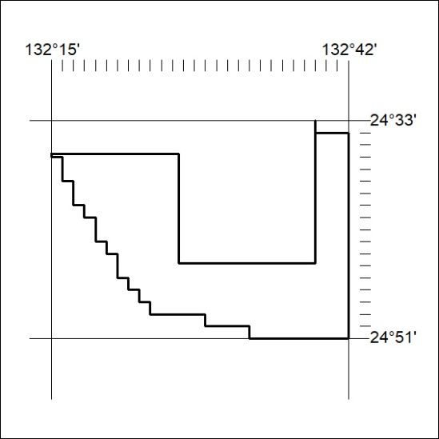

122/22
Mineral Titles Act 2010
NOTICE OF LAND CEASING TO BE A MINERAL TITLE APPLICATION AREA
Title Type and Number: | Exploration Licence 32895
Area Ceased on: | 19 April 2022
Area: | 240 Blocks, 716.56 km²
Locality: | PALM VALLEY
Name of Applicant(s)/Holder(s): | 100% FMG RESOURCES PTY LTD [ACN. 095 546 428]
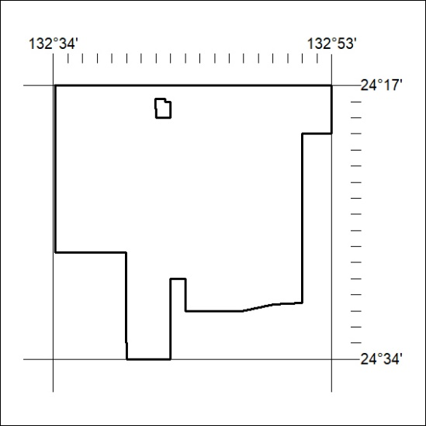

123/22

Mineral Titles Act 2010
NOTICE OF LAND CEASING TO BE A MINERAL TITLE APPLICATION AREA
Title Type and Number: | Exploration Licence 32896
Area Ceased on: | 19 April 2022
Area: | 236 Blocks, 710.72 km²
Locality: | JAMES
Name of Applicant(s)/Holder(s): | 100% FMG RESOURCES PTY LTD [ACN. 095 546 428]
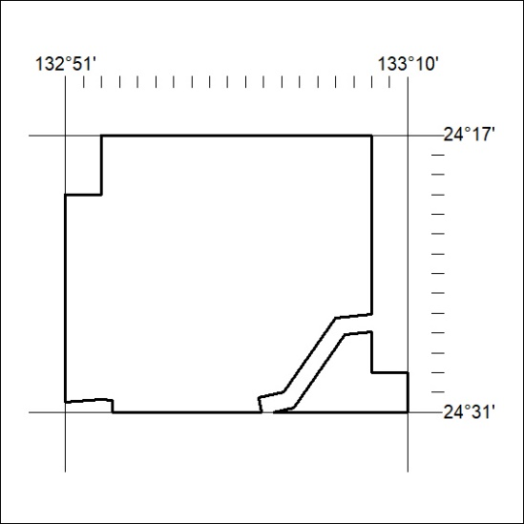

124/22
Mineral Titles Act 2010
NOTICE OF LAND CEASING TO BE A MINERAL TITLE APPLICATION AREA
Title Type and Number: | Exploration Licence 32897
Area Ceased on: | 19 April 2022
Area: | 89 Blocks, 272.26 km²
Locality: | JAMES
Name of Applicant(s)/Holder(s): | 100% FMG RESOURCES PTY LTD [ACN. 095 546 428]
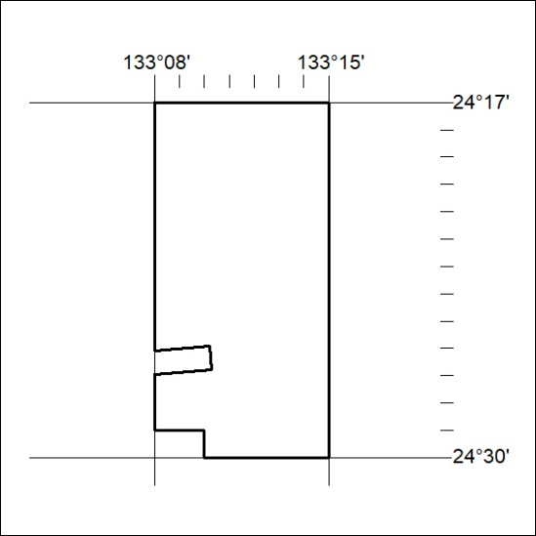

125/22

Mineral Titles Act 2010
NOTICE OF LAND CEASING TO BE A MINERAL TITLE APPLICATION AREA
Title Type and Number: | Exploration Licence 32898
Area Ceased on: | 19 April 2022
Area: | 151 Blocks, 428.42 km²
Locality: | FERGUSSON RANGE
Name of Applicant(s)/Holder(s): | 100% FMG RESOURCES PTY LTD [ACN. 095 546 428]
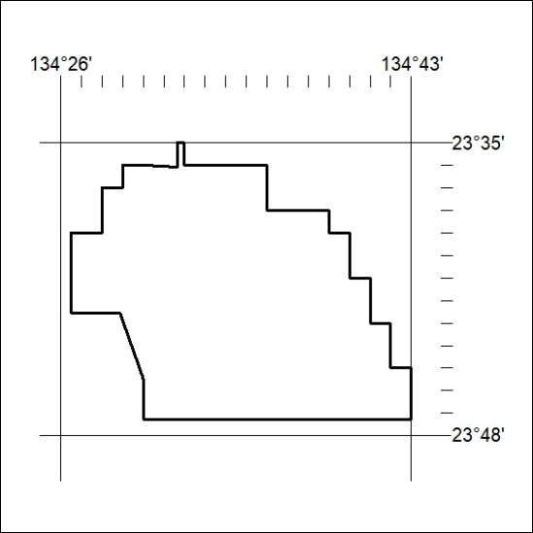

126/22
Mineral Titles Act 2010
NOTICE OF LAND CEASING TO BE A MINERAL TITLE APPLICATION AREA
Title Type and Number: | Exploration Licence 32899
Area Ceased on: | 19 April 2022
Area: | 250 Blocks, 736.26 km²
Locality: | SANTA TERESA
Name of Applicant(s)/Holder(s): | 100% FMG RESOURCES PTY LTD [ACN. 095 546 428]
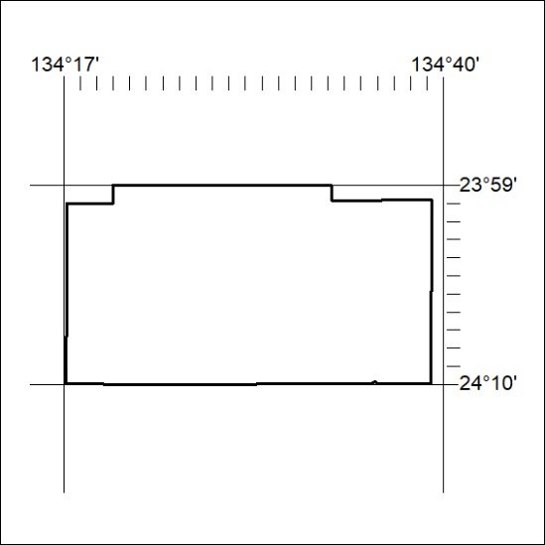

127/22

Mineral Titles Act 2010
NOTICE OF LAND CEASING TO BE A MINERAL TITLE APPLICATION AREA
Title Type and Number: | Exploration Licence 32900
Area Ceased on: | 19 April 2022
Area: | 175 Blocks, 513.64 km²
Locality: | UNDOOLYA
Name of Applicant(s)/Holder(s): | 100% FMG RESOURCES PTY LTD [ACN. 095 546 428]
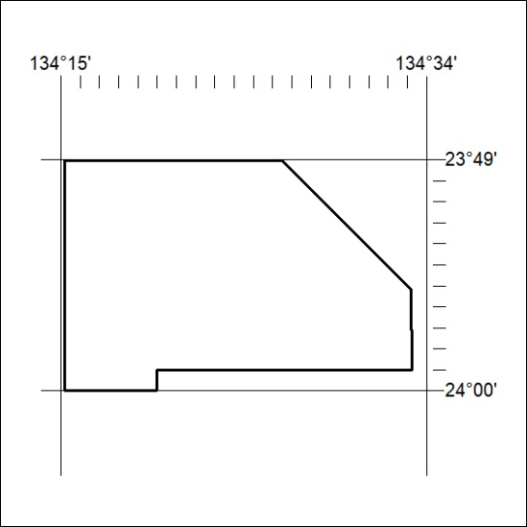

128/22
Mineral Titles Act 2010
NOTICE OF LAND CEASING TO BE A MINERAL TITLE APPLICATION AREA
Title Type and Number: | Exploration Licence 32901
Area Ceased on: | 19 April 2022
Area: | 229 Blocks, 665.90 km²
Locality: | UNDOOLYA
Name of Applicant(s)/Holder(s): | 100% FMG RESOURCES PTY LTD [ACN. 095 546 428]
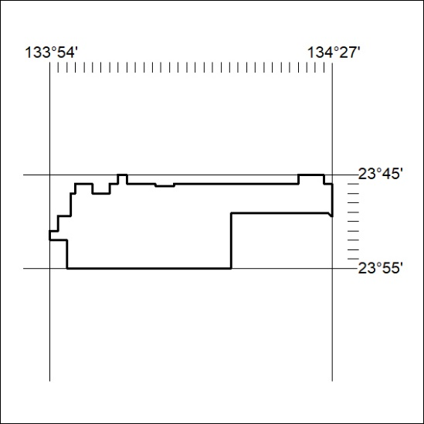

129/22

Mineral Titles Act 2010
NOTICE OF LAND CEASING TO BE A MINERAL TITLE APPLICATION AREA
Title Type and Number: | Exploration Licence 32902
Area Ceased on: | 19 April 2022
Area: | 237 Blocks, 739.56 km²
Locality: | PEACHY
Name of Applicant(s)/Holder(s): | 100% FMG RESOURCES PTY LTD [ACN. 095 546 428]
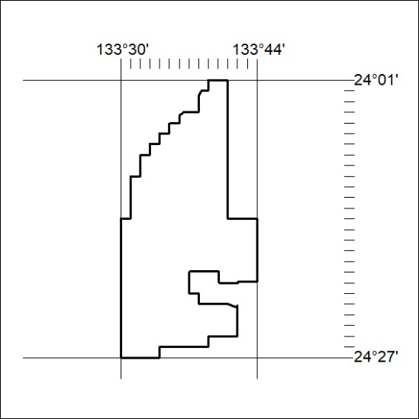

130/22
Mineral Titles Act 2010
NOTICE OF LAND CEASING TO BE A MINERAL TITLE APPLICATION AREA
Title Type and Number: | Exploration Licence 32903
Area Ceased on: | 19 April 2022
Area: | 120 Blocks, 358.58 km²
Locality: | ALICE SPRINGS
Name of Applicant(s)/Holder(s): | 100% FMG RESOURCES PTY LTD [ACN. 095 546 428]
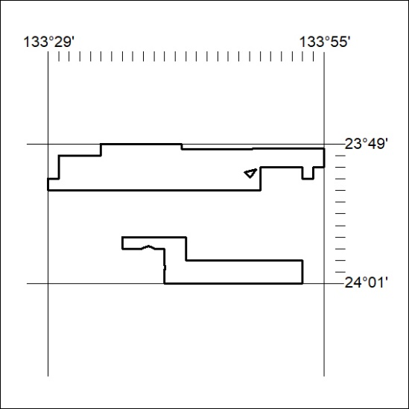

131/22

Mineral Titles Act 2010
NOTICE OF LAND CEASING TO BE A MINERAL TITLE APPLICATION AREA
Title Type and Number: | Exploration Licence 32904
Area Ceased on: | 19 April 2022
Area: | 237 Blocks, 733.43 km²
Locality: | PEACHY
Name of Applicant(s)/Holder(s): | 100% FMG RESOURCES PTY LTD [ACN. 095 546 428]
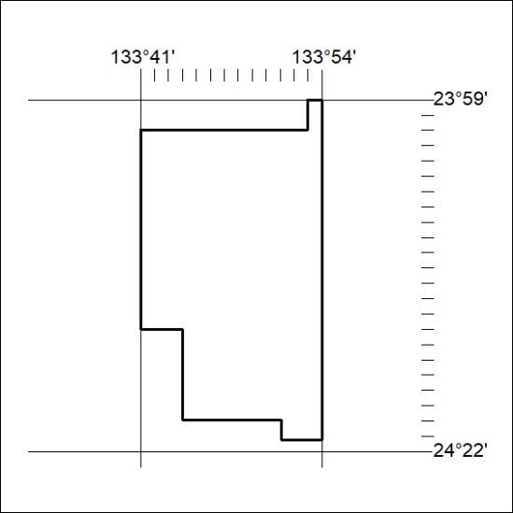

132/22
Mineral Titles Act 2010
NOTICE OF LAND CEASING TO BE A MINERAL TITLE APPLICATION AREA
Title Type and Number: | Exploration Licence 32905
Area Ceased on: | 19 April 2022
Area: | 250 Blocks, 712.64 km²
Locality: | FERGUSSON RANGE
Name of Applicant(s)/Holder(s): | 100% FMG RESOURCES PTY LTD [ACN. 095 546 428]
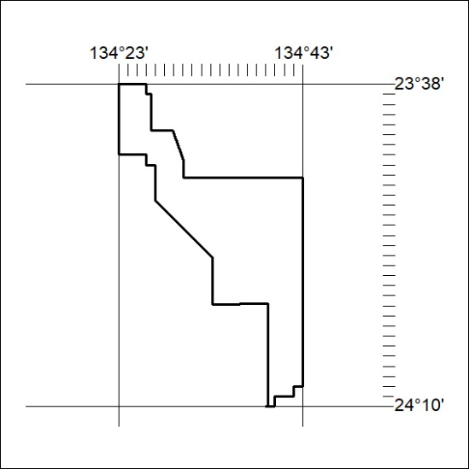

133/22

Mineral Titles Act 2010
NOTICE OF LAND CEASING TO BE A MINERAL TITLE APPLICATION AREA
Title Type and Number: | Exploration Licence 32906
Area Ceased on: | 19 April 2022
Area: | 250 Blocks, 708.96 km²
Locality: | SANTA TERESA
Name of Applicant(s)/Holder(s): | 100% FMG RESOURCES PTY LTD [ACN. 095 546 428]
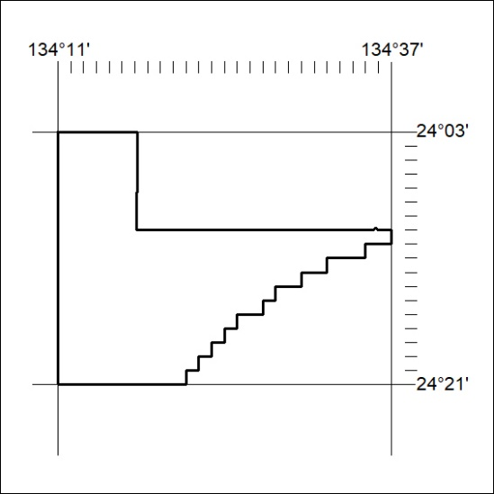

134/22
Mineral Titles Act 2010
NOTICE OF LAND CEASING TO BE A MINERAL TITLE APPLICATION AREA
Title Type and Number: | Exploration Licence 32907
Area Ceased on: | 19 April 2022
Area: | 250 Blocks, 781.09 km²
Locality: | SANTA TERESA
Name of Applicant(s)/Holder(s): | 100% FMG RESOURCES PTY LTD [ACN. 095 546 428]
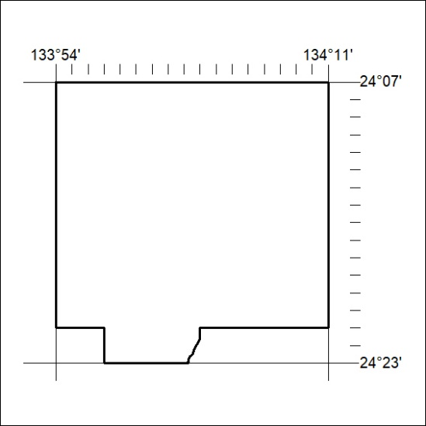

135/22

Mineral Titles Act 2010
NOTICE OF LAND CEASING TO BE A MINERAL TITLE APPLICATION AREA
Title Type and Number: | Exploration Licence 32908
Area Ceased on: | 19 April 2022
Area: | 244 Blocks, 738.84 km²
Locality: | SANTA TERESA
Name of Applicant(s)/Holder(s): | 100% FMG RESOURCES PTY LTD [ACN. 095 546 428]
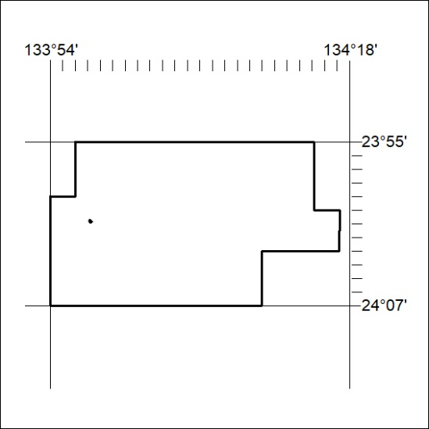

136/22
Mineral Titles Act 2010
NOTICE OF LAND CEASING TO BE A MINERAL TITLE APPLICATION AREA
Title Type and Number: | Exploration Licence 32909
Area Ceased on: | 19 April 2022
Area: | 249 Blocks, 758.51 km²
Locality: | JAMES
Name of Applicant(s)/Holder(s): | 100% FMG RESOURCES PTY LTD [ACN. 095 546 428]
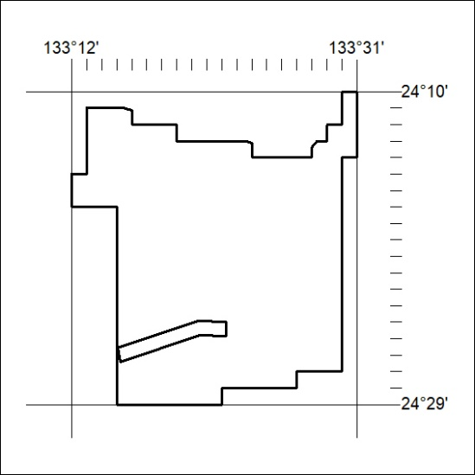

137/22

Mineral Titles Act 2010
NOTICE OF LAND CEASING TO BE A MINERAL TITLE APPLICATION AREA
Title Type and Number: | Exploration Licence 32910
Area Ceased on: | 19 April 2022
Area: | 250 Blocks, 759.60 km²
Locality: | AREYONGA
Name of Applicant(s)/Holder(s): | 100% FMG RESOURCES PTY LTD [ACN. 095 546 428]
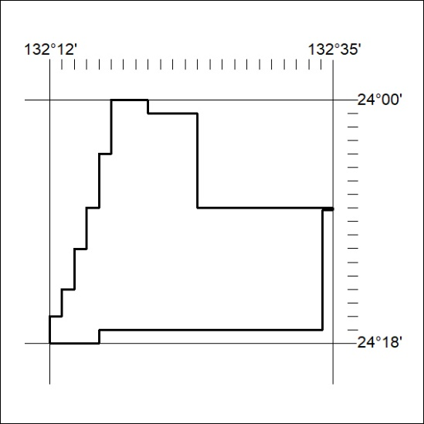

138/22
Mineral Titles Act 2010
NOTICE OF LAND CEASING TO BE A MINERAL TITLE APPLICATION AREA
Title Type and Number: | Exploration Licence 32911
Area Ceased on: | 19 April 2022
Area: | 249 Blocks, 755.59 km²
Locality: | GOSSES BLUFF
Name of Applicant(s)/Holder(s): | 100% FMG RESOURCES PTY LTD [ACN. 095 546 428]
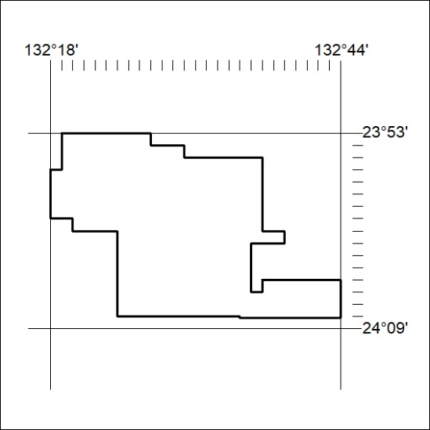

139/22

Mineral Titles Act 2010
NOTICE OF LAND CEASING TO BE A MINERAL TITLE APPLICATION AREA
Title Type and Number: | Exploration Licence 32912
Area Ceased on: | 19 April 2022
Area: | 250 Blocks, 785.03 km²
Locality: | HERMANNSBURG
Name of Applicant(s)/Holder(s): | 100% FMG RESOURCES PTY LTD [ACN. 095 546 428]
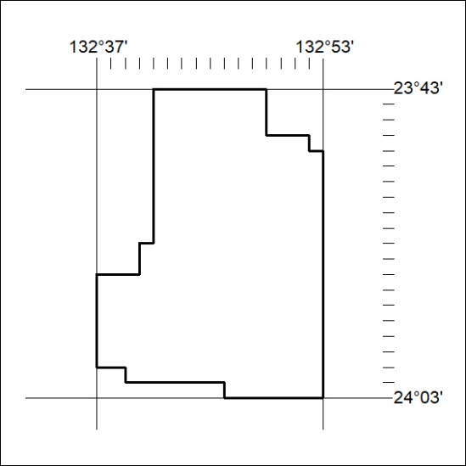

140/22
Mineral Titles Act 2010
NOTICE OF LAND CEASING TO BE A MINERAL TITLE APPLICATION AREA
Title Type and Number: | Exploration Licence 32913
Area Ceased on: | 19 April 2022
Area: | 250 Blocks, 785.12 km²
Locality: | GOSSES BLUFF
Name of Applicant(s)/Holder(s): | 100% FMG RESOURCES PTY LTD [ACN. 095 546 428]
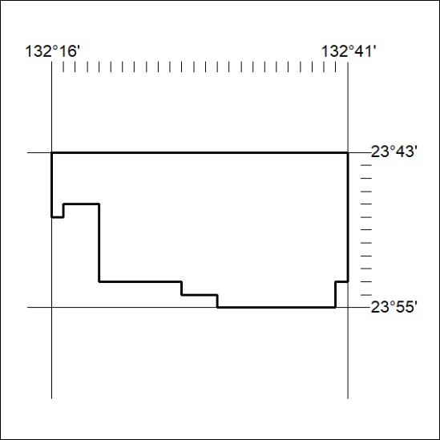

141/22

Mineral Titles Act 2010
NOTICE OF LAND CEASING TO BE A MINERAL TITLE APPLICATION AREA
Title Type and Number: | Exploration Licence 32914
Area Ceased on: | 19 April 2022
Area: | 130 Blocks, 391.26 km²
Locality: | MACDONNELL RANGES
Name of Applicant(s)/Holder(s): | 100% FMG RESOURCES PTY LTD [ACN. 095 546 428]
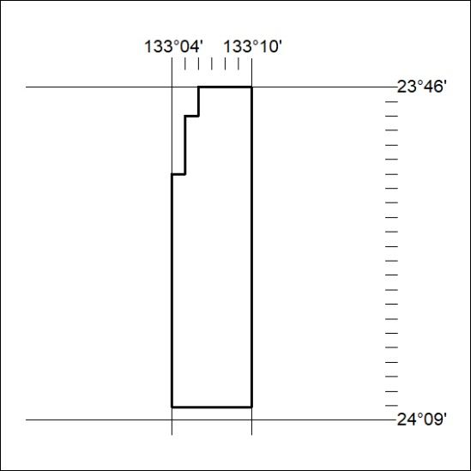

142/22
Mineral Titles Act 2010
NOTICE OF LAND CEASING TO BE A MINERAL TITLE APPLICATION AREA
Title Type and Number: | Exploration Licence 32915
Area Ceased on: | 19 April 2022
Area: | 250 Blocks, 756.79 km²
Locality: | HERMANNSBURG
Name of Applicant(s)/Holder(s): | 100% FMG RESOURCES PTY LTD [ACN. 095 546 428]
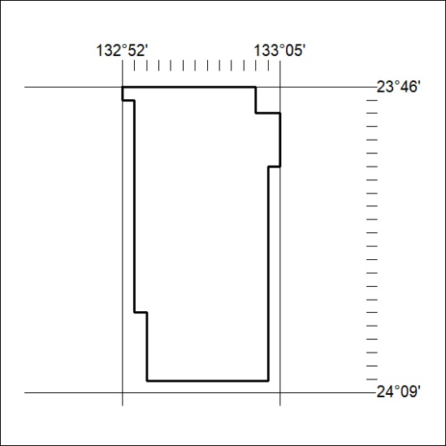

143/22

Mineral Titles Act 2010
NOTICE OF LAND CEASING TO BE A MINERAL TITLE APPLICATION AREA
Title Type and Number: | Exploration Licence 32916
Area Ceased on: | 19 April 2022
Area: | 250 Blocks, 770.02 km²
Locality: | PALM VALLEY
Name of Applicant(s)/Holder(s): | 100% FMG RESOURCES PTY LTD [ACN. 095 546 428]
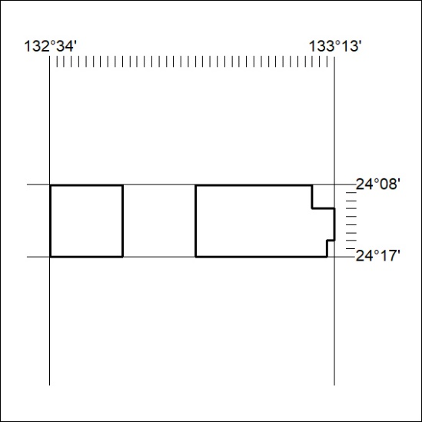

144/22
Mineral Titles Act 2010
NOTICE OF LAND CEASING TO BE A MINERAL TITLE APPLICATION AREA
Title Type and Number: | Exploration Licence 32949
Area Ceased on: | 19 April 2022
Area: | 168 Blocks, 512.20 km²
Locality: | KEATS
Name of Applicant(s)/Holder(s): | 100% FMG RESOURCES PTY LTD [ACN. 095 546 428]
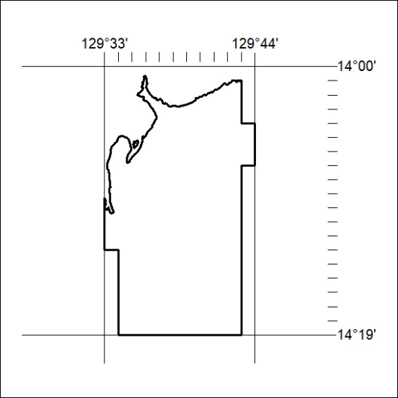

145/22

Mineral Titles Act 2010
NOTICE OF LAND CEASING TO BE A MINERAL TITLE APPLICATION AREA
Title Type and Number: | Exploration Licence 32950
Area Ceased on: | 19 April 2022
Area: | 250 Blocks, 779.68 km²
Locality: | KEATS
Name of Applicant(s)/Holder(s): | 100% FMG RESOURCES PTY LTD [ACN. 095 546 428]
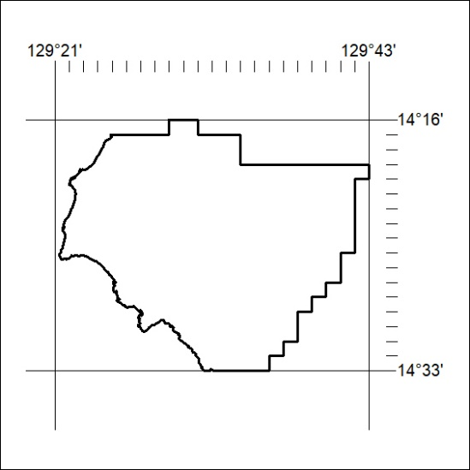

146/22
Mineral Titles Act 2010
NOTICE OF LAND CEASING TO BE A MINERAL TITLE APPLICATION AREA
Title Type and Number: | Exploration Licence 32951
Area Ceased on: | 19 April 2022
Area: | 10 Blocks, 28.26 km²
Locality: | PEARCE
Name of Applicant(s)/Holder(s): | 100% FMG RESOURCES PTY LTD [ACN. 095 546 428]
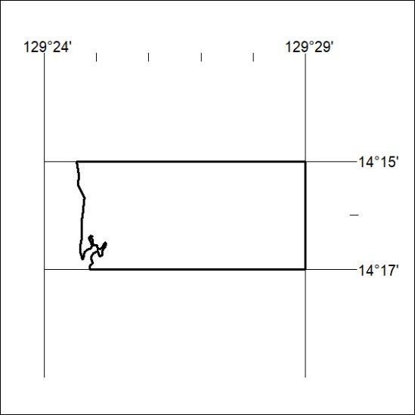

147/22

