Mineral Titles Act
NOTICE OF GRANT OF A MINERAL TITLE
Title Type and Number: | Exploration Licence 32715
Granted: | 18 June 2021, for a period of 2 Years
Area: | 227 Blocks, 715.79 km²
Locality: | WOLLOGORANG
Name of Holder/s: | 100% REDBANK OPERATIONS PTY LTD* [ACN. 109 362 165]
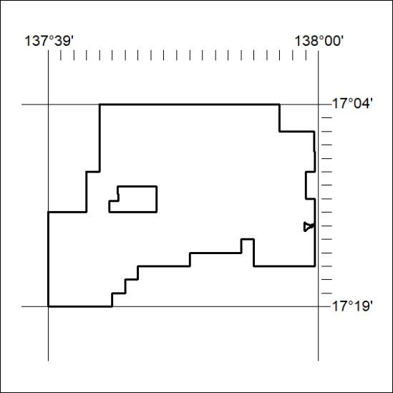
Area granted is indicated above. The titleholder is not permitted to exercise occupational rights on any land that is subject to a development title, or an application for a development title. Any land the subject of a Reserved Land gazettal under the Mineral Titles Act and all land vested in the Commonwealth of Australia is also excluded by description but not excised from the grant area.

218/21

