Mineral Titles Act 2010
NOTICE OF LAND CEASING TO BE A MINERAL TITLE APPLICATION AREA
Title Type and Number: | Exploration Licence in Retention 22
Area ceased on: | 18 May 2021
Area: | 207.00 Hectares
Locality: | NAPPERBY
Name of Applicants(s)Holder(s): | 100% JACKSON CAGE PTY LTD [ACN. 614 042 189]
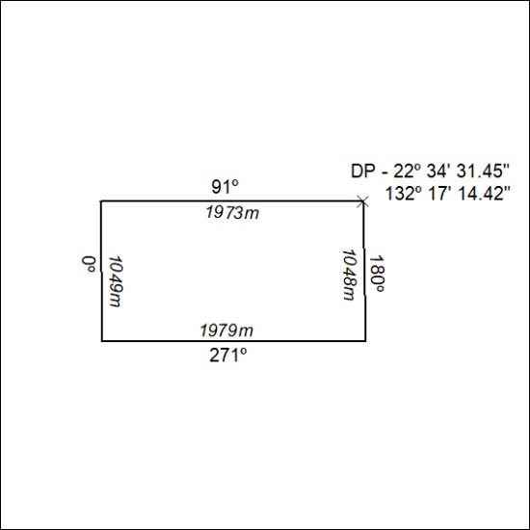

191/21

Mineral Titles Act 2010
NOTICE OF LAND CEASING TO BE A MINERAL TITLE APPLICATION AREA
Title Type and Number: | Exploration Licence in Retention 23
Area ceased on: | 18 May 2021
Area: | 208.00 Hectares
Locality: | NAPPERBY
Name of Applicants(s)Holder(s): | 100% JACKSON CAGE PTY LTD [ACN. 614 042 189]
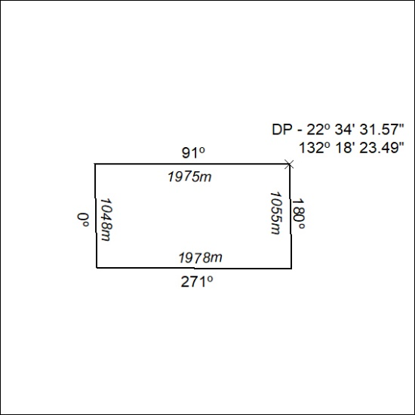

192/21

Mineral Titles Act 2010
NOTICE OF LAND CEASING TO BE A MINERAL TITLE APPLICATION AREA
Title Type and Number: | Exploration Licence in Retention 24
Area ceased on: | 18 May 2021
Area: | 199.00 Hectares
Locality: | NAPPERBY
Name of Applicants(s)Holder(s): | 100% JACKSON CAGE PTY LTD [ACN. 614 042 189]
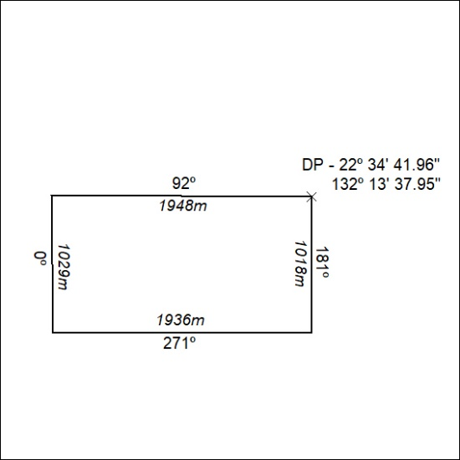

193/21

Mineral Titles Act 2010
NOTICE OF LAND CEASING TO BE A MINERAL TITLE APPLICATION AREA
Title Type and Number: | Exploration Licence in Retention 25
Area ceased on: | 18 May 2021
Area: | 200.00 Hectares
Locality: | NAPPERBY
Name of Applicants(s)Holder(s): | 100% JACKSON CAGE PTY LTD [ACN. 614 042 189]
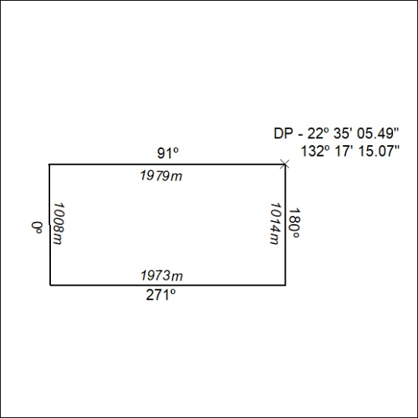

194/21

Mineral Titles Act 2010
NOTICE OF LAND CEASING TO BE A MINERAL TITLE APPLICATION AREA
Title Type and Number: | Exploration Licence in Retention 26
Area ceased on: | 18 May 2021
Area: | 201.00 Hectares
Locality: | NAPPERBY
Name of Applicants(s)Holder(s): | 100% JACKSON CAGE PTY LTD [ACN. 614 042 189]
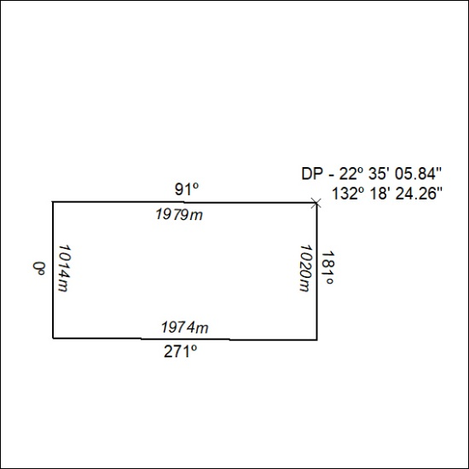

195/21

