Mineral Titles Act
NOTICE OF GRANT OF A MINERAL TITLE
Title Type and Number: | Exploration Licence 32015
Granted: | 15 March 2021, for a period of 6 Years
Area: | 35 Blocks, 112.37 km²
Locality: | PEDESTAL HILLS
Name of Holder/s: | 100% FERDIES FIND PTY LTD [ACN. 168 969 971]
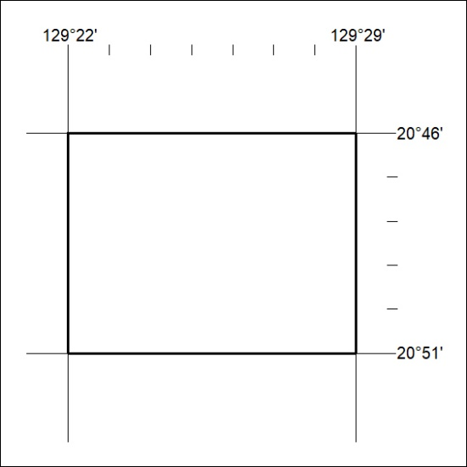
Area granted is indicated above. The titleholder is not permitted to exercise occupational rights on any land that is subject to a development title, or an application for a development title. Any land the subject of a Reserved Land gazettal under the Mineral Titles Act and all land vested in the Commonwealth of Australia is also excluded by description but not excised from the grant area.

49/21

