Mineral Titles Act 2010
NOTICE OF LAND CEASING TO BE A MINERAL TITLE AREA
Title Type and Number: | Exploration Licence 32128
Area Ceased on: | 10 February 2021
Area: | 56 Blocks, 158.76 km²
Locality: | RIDDOCH
Name of Applicant(s)/Holder(s): | 100% YACIMIENTO PTY LTD [ACN. 633 215 782]
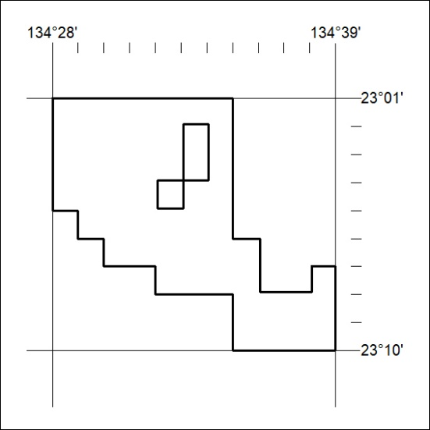

33/21

